Chapter 5 Mental Status Assessment

Mental status is a person’s emotional and cognitive function.

Mental disorder is apparent when a person’s response is much greater than the expected reaction to a traumatic life event. Significant behavioral or psychological pattern that is associated with distress (a painful symptom) or disability (impaired functioning) and a has a significant risk of pain, disability, or death or a loss of freedom.
Organic disorders caused by brain disease of known specific organic cause (i.e., delirium, dementia, alcohol and drug intoxication, and withdrawal)
Psychiatric mental disorders in which an organic etiology has not yet been established (i.e., anxiety disorder or schizophrenia)

Assessment of mental status – inferred through an assessment of an individual’s behaviors
Consciousness – being aware of one’s own existence
Language – Using voice to communicate thoughts and feelings
Mood – a prolonged display of feelings that color the whole emotional life
Affect – temporary expression of feelings or state of mind
Orientation – Person, place, and time
Attention – the power of concentration
Memory – the ability to store experiences for later recall
Abstract reasoning – pondering a deeper meaning beyond the concrete and literal
Thought Process – the way a person thinks, the logical train of thought
Thought content – what the person thinks – specific ideas, beliefs, the use of words
Perceptions – an awareness of objects through the five senses

Mental status progresses from simple reflex to complex logical and abstract thought.
*By 18 – 24 months the child learns that he is separate from the objects in the environment
*Crying 4 weeks
*Cooing 6 weeks
*One-word sentences – 1 y/0
*Multi word sentences – 2 y/o
*Language as social tool of communication – 4-5 y/o
*Thinking becomes logical and systematic – 7 y/o
*Abstract thinking, consider hypotheticals – 12 and 15 y/o

Children
1 in 7 children (14%) ages 2 to 8 has a mental, behavioral, or developmental disorder.
1 in 5 children (20%) agers 9 – 17 has a mental, behavioral, or developmental disorder.

Adults
Aging doesn’t affect mental status, but the response time is slower. No decrease in knowledge, and little or no decrease in vocabulary.
*Recent memory is somewhat decreased with age.
*Remote memory is not affected
*The slower response affects new learning
*18.3% of US adults aged 18 and over were affected by mental disorders.
*4.2% suffer from serious mental illness
*Age related changes in sensory perception can affect mental status
*More potential for loss

Factors that can affect interpretation of findings
*Known illnesses or health problems such as alcohol use disorders or chronic renal disease
*Current medications with side effects that may cause confusion or depression
*The usual educational and behavioral level – note that factor as the normal baseline, and do not expect performance on the mental status examination to exceed it
*Responses to personal history questions indicating current stress, social interaction patterns, sleep habits, drug and alcohol use

Assessment of Mental Status (Emotional and Cognitive Function): Systematic check of emotional and cognitive functioning. Can be integrated into the health history interview

*A full mental status exam is required if the nurse discovers any abnormalities in:
1. Affect and behavior
2. anxiety disorders and depression
3. Memory loss, inappropriate social interactions
4. Emotional or cognitive changes associated with a lesion
5. Language dysfunction
6. Symptoms of a psychiatric illness, especially with acute onset

ABCT
Appearance
Posture: erect and relaxed (objective data)
Body movements: voluntary, deliberate, coordinated, smooth and even (objective data)
Dress: appropriate for setting, season, age, gender, and social group. Clothing fits and is worn appropriately. (Objective data)
Grooming and Hygiene: clean and well groomed, hair is neat and clean, clean nails (objective data)
Pupils: note size and reaction to light

Behavior
Level of consciousness: awake, alert, responds appropriately and reasonably to stimuli from environment (objective data)
Facial expression: the look is appropriate to the situation and changes appropriately with the topic. (Objective data)
Speech: makes laryngeal sounds effortlessly and shares conversation appropriately, pace is moderate and stream of talking is fluent, ability to form words is clear and understandable, word choice is effortless and appropriate to educational level (objective data)
Mood and affect: judge this by body language and facial expression and by asking “How do you feel today?” (Objective data)

Cognition
Orientation: (objective data)
Time: day of the week, date, year, season.
Place: where person lives, present location.
Person: own name age
Attention Span: checks person’s ability to concentrate noting whether he or she completes a thought without wandering (objective data)
Recent memory: 24-hour diet recall or time they arrived at the facility (objective data)
Remote memory: ask verifiable past events (objective data)
New Learning: give patient 4 words and tell them I will ask you to recall them later. After 5 minutes, 10 minutes and 30 minutes ask for the recall (objective data)
*Normal response time for people younger than 60 y/o is an accurate 3- or 4-word recall after a 5, 10 or 30 minutes delay.

Clients with Aphasia
Word Comprehension – points to items around the room or parts of the body and ask patient to name them. (Objective data)
Reading – ask the person to read available print. Make modifications for educational level, ensure they have reading glasses if needed, and use large print if possible. (Objective data)
Writing – ask the person to make up and write a sentence about the weather or their job. Note coherence, spelling, and parts of speech. (Objective data)

Thought Process
Thought process: Does this person make sense? The way a person thinks should be logical, goal directed, coherent, and relevant (objective data)
Thought content: What the person says should be consistent and logical. (Objective data)
Perceptions: The person should be consistently aware of reality. (Objective data)
*Screen for anxiety disorders (objective data)
Two most common mental health disorders in people seeking medical care: Anxiety and Depression

4 most common anxiety disorders
- GAD – Generalized anxiety disorder
- Panic disorder
- Social anxiety disorder
- PTSD

Scores
- 10 = GAD
- 5 – mild anxiety
- 10 – moderate anxiety
- 15 – severe anxiety

*Screen for depression (objective data)
Shorter screening method is the Patient Health Questionnaire – 2 (PHQ-2) which entails asking two questions about depressed mood and anhedonia (little interest or pleasure in doing things) that will detect a majority of depressed patients. If they answer several days or higher administer the full PHQ-9

*Screen for suicidal thoughts (objective data)
Begin with general questions and if you hear affirmative answers continue with more specific questions.

Judgement: To assess in the context of the interview note what the person says about job plans, social or family obligations, and plans for the future.

Mini Mental Status: can be done in 5 – 10 minutes and focuses on cognitive functioning. It is a valid detector of organic disease.

Delirium: acute confused thinking or loss of consciousness and perceptual disturbance.

Dementia: a gradual, progressive process, causing decreased cognitive function even though the person is fully conscious and awake.
*The development of multiple cognitive deficits manifested by both memory impairment and one of the following:
1. aphasia
2. apraxia
3. agnosia
4. disturbance in executive functioning

The cognitive deficits must be so severe that they affect occupational or social functioning and are clearly a decline from higher level functioning.

Additional Assessment for aging adult
Behavior

Cognitive Function

New Learning

Abnormal Findings: Levels of consciousness
- Alert
- Lethargic of somnolent
- Obtunded
- Stupor or semi coma
- Coma
- Acute confused state (delirium)

Abnormal Findings: Aphasia
- Global aphasia
- Broca’s aphasia
- Wernicke’s aphasia

Abnormalities of mood and affect
- Flat affect
- Depression
- Anxiety
- Lability
- Inappropriate affect

Abnormal findings: Delirium
- Disturbance of consciousness
- Change in cognition
- Develops over a short period of time

Lab Manual
Abstract reasoning .......... pondering a deeper meaning beyond the concrete and literal

Attention ................... concentration, ability to focus on one specific thing

Bereavement ................ state of loss, sorrow, and/or grief due to the death of a loved one, decline in personal or a loved one’s health, or the end of an important relationship
Consciousness .............. being aware of one’s own existence, feelings, and thoughts and being aware of the environment
Delirium ...................an acute confusional change or loss of consciousness and perceptual disturbance that may accompany acute illness; usually resolves when the underlying cause is treated
Dementia .................. a gradual progressive process, causing decreased cognitive function even though the person is fully conscious and awake; not reversible
Executive function .......... high-level cognitive skills, including organizational and regulatory ability

Language ................... using the voice to communicate one’s thoughts and feelings

Memory .................... ability to lay down and store experiences and perceptions for later recall

Mood ...................... prolonged display of a person’s feelings

Orientation ................. awareness of the objective world in relation to the self

Perceptions ................. awareness of objects through any of the five senses

Thought content ............what the person thinks—specific ideas, beliefs, the use of words

Thought process ............ the way a person thinks, the logical train of thought
Visuospatial ................ ability to process visual information and perceive relationships between objects in space

STUDY GUIDE
1. Define the term mental disorder: when a person’s response is much greater than the expected response.

2. Differentiate organic brain disorder from psychiatric mental disorder. Organic is caused by brain disease. Psychiatric: the etiology has not been established.

3. List 4 situations in which it would be necessary to perform a complete mental status examination.
1. When behavior and affect are abnormal
2. anxiety disorders and depression
3. lesion on the brain
4. language dysfunction

4. Explain 4 factors that could affect a patient’s response to the mental status examination but have nothing to do with mental disorders.
1. Medication side affects
2. Known illness
3. education level
4. responses to personal history questions about current stress

5. State convenient ways to assess a person’s recent memory within the context of the initial health history

6. Which mental function is the Four Unrelated Words Test intended to test? New Learning

7. List at least 4 questions you could ask a patient that would screen for suicide ideation.
1. Have you ever felt that life is not worth living?
2. Have you ever thought of hurting yourself? If so, how often?
3. Do you feel like hurting yourself now?
4. Do you have a plan to hurt yourself?

8. Describe the patient response level of consciousness that would be graded as:
Lethargic or somnolent not fully alert; drifts off to sleep when not stimulated; inattentive; loses train of thought; spontaneous movements are decreased

Obtunded transitional state between lethargy and stupor. Sleeps most of the time; difficult to arouse – needs loud shout or vigorous shake; acts confused when is aroused

Stupor or semicoma spontaneously unconscious; responds only to persistent and vigorous shake or pain, has appropriate motor response; can only groan, mumble, or move restlessly

Coma completely unconscious; no response to pain or any external or internal stimuli

Delirium acute confusional state. Clouding of consciousness; inattentive; incoherent conversation; impaired recent memory and confabulatory for recent events; agitated and having visual hallucinations

REVIEW QUESTIONS
1. Although a full mental status examination may not be required, you must be aware of the 4 main headings of the assessment while performing the interview and physical examination. These headings are:
a. Mood, affect, consciousness, and orientation.
b. Memory, attention, thought content, and perceptions.
c. Language, orientation, attention, and abstract reasoning.
d. Appearance, behavior, cognition, and thought process.
2. Select the finding that most accurately describes appearance of a patient.
a. Tense posture and restless activity. Clothing clean but not appropriate for season (e.g., patient wearing T-shirt and shorts in cold weather).
b. Oriented × 3. Affect appropriate for circumstances.
c. Alert and responds to verbal stimuli. Tearful when diagnosis discussed.
d. Laughing inappropriately, oriented × 3.
3. You are assessing short-term cognitive function. Which assessment shows the ability to lay down new memories?
a. Noting whether the patient completes a thought without wandering
b. A test of general knowledge
c. A description of past medical history
d. Use of the Four Unrelated Words Test
4. You are preparing the discharge plan for a patient with aphasia. What assessment should you include in the plan?
a. Ask the patient to calculate serial 7s.
b. Ask the patient to name his or her grandchildren and their birthdays.
c. Ask the patient to demonstrate word comprehension by naming articles in the room or on the body as you point to them.
d. Ask the patient to interpret a proverb.
5. During an interview with a patient diagnosed with a seizure disorder, the patient states, “I plan to be an airline pilot.” If the patient continues to have this as a career goal after teaching regarding seizure disorders has been provided, you might question the patient’s:
a. Thought processes.
b. Judgment.
c. Attention span.
d. Recent memory.
6. On a patient’s second day in an acute care hospital, the patient complains about the “bugs” on the bed. The bed is clean. This would be an example of altered:
a. Thought processes.
b. Orientation.
c. Perception.
d. Higher intellectual function.
7. One way to assess cognitive function and to screen dementia is with:
a. The Proverb Interpretation Test.
b. The Mini-Cog.
c. The Denver II.
d. The Older Adult Behavioral Checklist.

8. A major characteristic of dementia is:
a. Impairment of short-and long-term memory.
b. Hallucinations.
c. Sudden onset of symptoms.
d. Substance-induced.
9. What statement is an example of a patient with dysarthria?
a. When asked a question, the patient responds fluently but uses words incorrectly or makes up words so that speech may be incomprehensible.
b. The word choice and grammar are appropriate, but the sounds are distorted so speech is unintelligible.
c. The pitch and volume of words are difficult, and the voice may be hoarse, but language is intact.
d. Comprehension is intact but there is difficulty in expressing thoughts, with nouns and verbs being the dominant word choices.
10. You are leading a discussion of the planned activities for the day at an adult living center and state, “We will be having snacks at 9:30 and lunch will be at noon.” One of the participants responds in a very monotone manner, “Snacks at 9:30, lunch at noon, snacks at 9:30, lunch at noon.” This patient is exhibiting signs of:
a. Echolalia.
b. Confabulation.
c. Flight of ideas.
d. Neologisms.
11. You are performing a mental status examination. Which assessments would be most appropriate?
a. Examining the patient’s EEG
b. Observing the patient as he or she takes an IQ test
c. Observing the patient and inferring health or dysfunction
d. Examining the patient’s response to a specific set of questions
12. What is a priority assessment for aging adults?
a. Phobias
b. General intelligence
c. Irrational thinking patterns
d. Sensory perceptive abilities
13. You are assessing a 75-year-old man. What is an expected finding?
a. He will have no decrease in any of his abilities, including response time.
b. He will have difficulty on tests of remote memory because this typically decreases with age.
c. It may take him a little longer to respond but his general knowledge and abilities should not have declined.
d. He will have had a decrease in his response time due to language loss and a decrease in general knowledge.
14. When assessing mental status in children, what statement is true?
a. All aspects of mental status in children are interrelated.
b. Children are highly labile and unstable until the age of 2.
c. Children’s mental status is largely a function of their parents’ level of functioning until the age of 7.
d. A child’s mental status is impossible to assess until the child develops the ability to concentrate.

Match column B to column A. Column A—Definition
15. _______ Lack of emotional response
a. Depression
b. Anxiety
c. Flat affect
d. Euphoria
e. Lability
f. Rage
g. Irritability
h. Fear
i. Depersonalization
16. _______ Loss of identity
17. _______ Excessive well-being
18. _______ Apprehensive from the anticipation of a danger
whose source is unknown
19. _______ Annoyed, easily provoked
20. _______ Loss of control
21. _______ Sad, gloomy, dejected
22. _______ Rapid shift of emotions
23. _______ Worried about known external danger

Answers
Chapter 5: Mental Status Assessment
1. d 2. a 3. d 4. c 5. b
6. c 7. b 8. a 9. B 10. a
11. c 12. d 13. c 14. a 15. C
16. i 17. d 18. b 19. g 20. f
21. a 22. e 23. h

Chapter 14 – Head, Face, Neck, and Regional Lymphatics
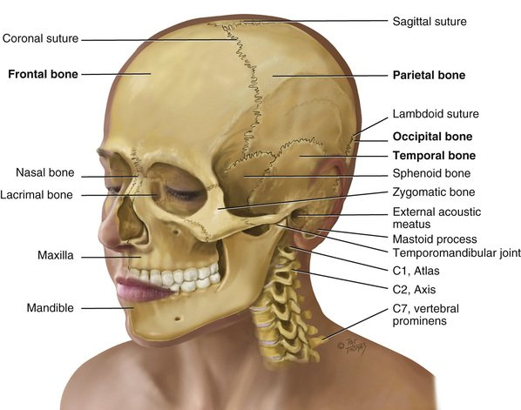
The Head
The skull is the rigid bony box that protects the brain and special sense organs, and it includes the bones of the cranium and the face.

Cranial Bones:
- Frontal
- Parietal
- Occipital
- Temporal

Sutures: meshed immovable joints. This is where the cranial bones meet.
- Coronal suture: ear to ear connecting frontal and parietal bones.
- Sagittal suture: separates the head lengthwise between the two parietal bones.
- Lamboid suture: separates parietal and occipital bones.
*14 facial bones.
*Cranial Nerve VII – facial nerve which allow the face to show expressions that reflect mood.
*Cranial Nerve V – trigeminal nerve allow facial sensations of pain and touch.
The Neck
Major neck muscles: sternomastoid and trapezius
*Innervated by cranial nerve X1 – spinal accessory
Thyroid gland
*Stimulates the rate of cellular metabolism
Lymphatics
The head and neck have 60 – 70 lymph nodes

Lab Manual
Bruit ....................... blowing, swooshing sound heard through the stethoscope over an area of abnormal blood flow
Dysphagia .................. difficulty in swallowing
Goiter ...................... increase in size of thyroid gland that occurs with hyperthyroidism
Lymphadenopathy ........... enlargement of the lymph nodes due to infection, allergy, or neoplasm
Macrocephalic .............. refers to abnormally large head
Microcephalic ............... refers to abnormally small head
Normocephalic .............. refers to round symmetric skull that is appropriately related to body size
Torticollis .................. head tilt due to shortening or spasm of one sternomastoid muscle
Vertigo ..................... illusory sensation of either the room or one’s own body spinning; not the same as dizziness

STUDY GUIDE
1. The major neck muscles are the sternomastoid and trapezius.

2. Name the borders of two regions in the neck—the anterior triangle and the posterior triangle.

3. List the facial structures that should appear symmetric when inspecting the head.
Eyes, ears, eyebrows, nose, and mouth.

4. Describe the characteristics of lymph nodes often associated with:
Acute infection ____________________________________________________________________
Chronic inflammation _______________________________________________________________
Cancer ___________________________________________________________________________

5. Differentiate caput succedaneum from cephalhematoma in the newborn infant.
6. Describe the tonic neck reflex in the infant.

7. Describe the characteristics of normal cervical lymph nodes during childhood.

8. List the condition(s) associated with parotid gland enlargement.

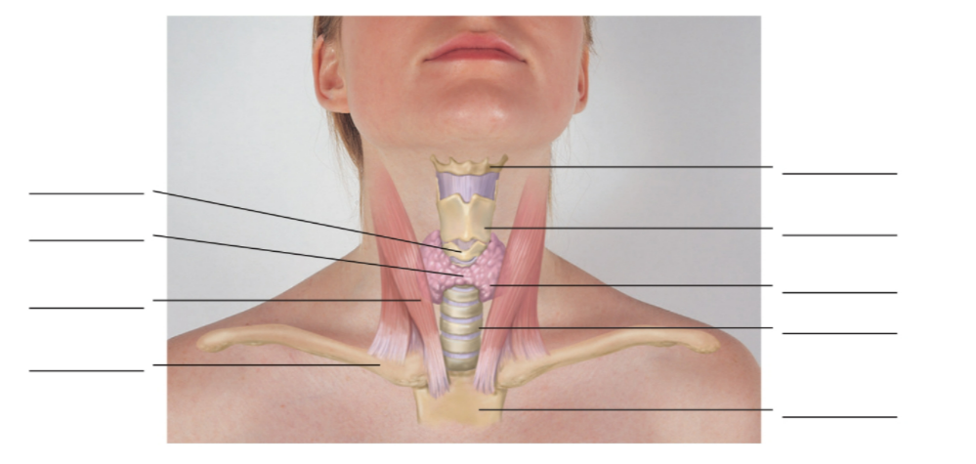
9. Describe the facial characteristics that occur with Down syndrome.
10. Contrast the facial characteristics of hyperthyroidism versus hypothyroidism.

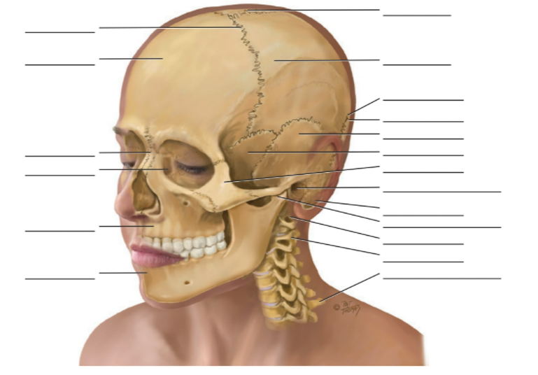
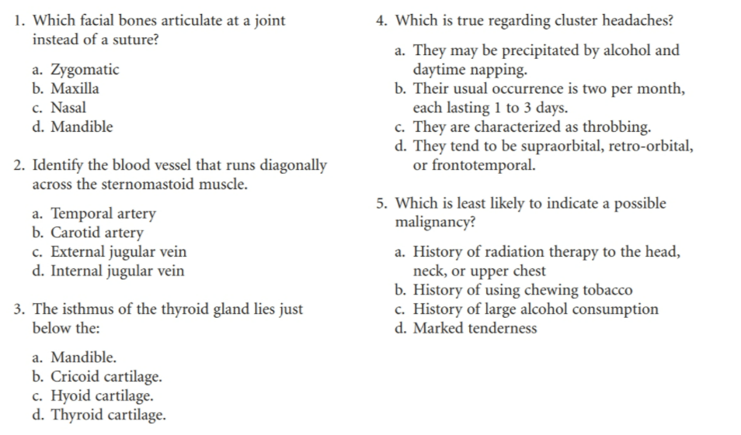

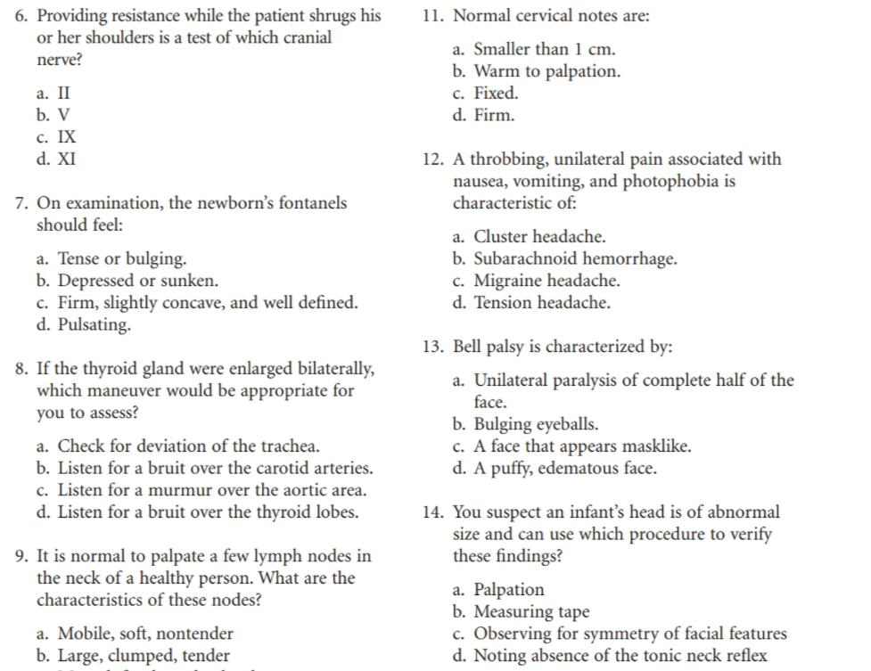

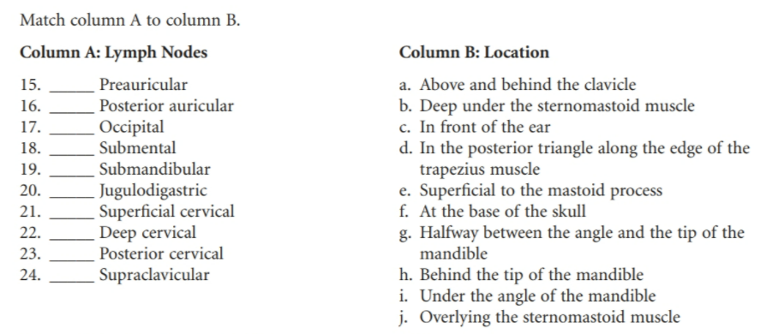

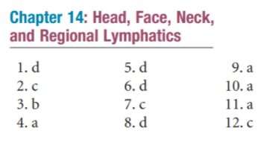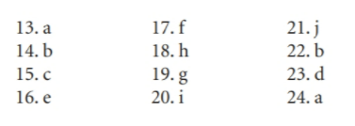
When accessing mental status what do you assess first? Consciousness and language

What is lethargy/ stupor/obtunded?
Lethargy – Not fully alert. Drifts off to sleep when not stimulated. Fuzzy thinking. Spontaneous movements decreased

Obtunded – Transitional state between lethargy and stupor. Sleeps most of the time. Difficult to arouse. Speech is mumbled and incoherent.

Stupor – Spontaneously unconscious. Responds only to vigorous and persistent shaking. Can only groan, mumble or move restlessly.

How do you assess cognitive function when conducting a mental status exam?
1. Oriented x 3 or x4: person, place, time, situation
2. Attention span
3. Recent Memory: 24-hour diet recall
4. Remote memory: ask about past events that can be verified
5. New Learning: the 4 unrelated words test

What is Wernicke /Broca’s / Global aphasia?
Global aphasia – most common and most severe. Caused by a large lesion on anterior and posterior language areas.

Broca’s aphasia – expressive aphasia. Lesion is in the anterior language area: Motor speech cortex or Broca area. Language is understood but cannot express themselves using language. Repetition and reading aloud are severely impaired. Auditory and reading comprehension are intact.

Wernicke’s aphasia – receptive aphasia. Lesion is in posterior language area: Association auditory cortex or Wernicke area. The person can speak but since they cannot relate words and sounds to previous experiences their speech is incomprehensible.

Additional testing for people with aphasia
1. Word comprehension: point to articles in the or parts of the body and ask the person to name them.

2. Reading: Ask the person to read available print at their educational level.

3. Writing: Ask the person to make up and write a sentence about something simple like the weather or their job.

What is circumlocution
Round-about expression, substituting a phrase when unable to think of name of object. Example. The person says “the thing you open the door with” instead of “key”

Mental Status Examination
Appearance

Behavior

Cognition

Thought Process

Clanging
Word choice based on sound, not meaning; includes nonsense rhymes and puns.

Signs and symptoms of vitamin C deficiency, riboflavin deficiency
Vitamin C deficiency results from inadequate diet. S/s weakness, irritability, weight loss, scurvy.
Riboflavin deficiency S/s = skin disorders, hyperemia, edema of mouth and throat, swollen and cracked lips, hair loss

Obesity
Initial nutritional screening what it entails

Soft spot
Fontanels: the spaces where the sutures intersect. Allow for growth of the brain during the 1st year.

Proportion of head and neck for newborn
Head size is greater than chest circumference at birth. Head size is 90% of final size by age 6.
Neck: looks short and it lengthens during the first 3 – 4 years.

Migraine headaches
*Headaches are a leading cause of acute pain and lost productivity.
* 3 types: Tension, migraine, and sinus. Migraine is often misdiagnosed as tension or sinus.
*Chronic migraine is 15 or more days / month
*More common in women and peaks in mid life for both sexes and more prevalent amongst whites and Hispanics.
*Caused by stimulation of Trigeminal nerve (V) with neurotransmitter changes in the central nervous system and changes in vessel tone.
LOCATION
Tension Headache: occipital, frontal or with band like tightness
Migraine: supraorbital, retroorbital or frontotemporal
Sinus: pain around eye or cheek

Signs and symptoms of CVA or stroke
Stroke – an acute neurologic deficit caused by blood clot of a cerebral vessel, as in atherosclerosis (ischemic stroke), or a rupture in a cerebral vessel (hemorrhagic stroke).
*Complete paralysis of one half of the face
*can’t wrinkle forehead
*can’t raise eyebrow
*can’t close eyelid
*can’t whistle
*can’t show teeth on the left side
Presents with
*Smooth forehead
*Wide palpebral fissure
*Flat nasolabial fold
*Drooling
*Pain behind the ear

Assessment of bruit
Occurs with accelerated or turbulent blood flow, indicating hyperplasia of the thyroid.
*If thyroid is enlarged, auscultate for the presence of a bruit. This a soft, pulsatile whooshing, blowing sound heard best with the bell of the stethoscope.

Developmental competence aging adult (Nose, mouth, and throat)
*Sense of smell may diminish after 60 because of decrease in in the number of olfactory nerve fibers
*Loss of taste buds due to epithelial thinning especially in cheeks and tongue. 80% reduction in taste functioning.
*Dental issues: tooth surface abrades, gums recede, and teeth erode at gum line.

What is hordeolum
Stye – acute localized staphylococcal infection of the hair follicles at the lid margin. Painful, red, swollen. Managed with warm compress, topical antibiotic ointment, may be combined with steroid treatment.

How to use and interpret Snellen eye chart
Snellen eye chart: most commonly used and accurate measure of visual acuity.
- Place chart in well lit area at eye level
- Position person exactly 20 feet away.
- Shield one eye
- Ask the person to read the smallest line of letters possible
- Record result using numeric fraction. Indicate whether any letters were missed and if corrective lenses were worn.
*The numerator is the distance from the chart the person
*The denominator is the distance at which a normal eye could have read the line.

Visual reflexes- accommodation
*Accommodation is adaption of the eye for near vision. It is accomplished by increasing the curvature of the lens through the muscles of the ciliary body.

Visual Pathways and visual fields
1. Objects reflect light
2. The light rays are refracted through the transparent media and strike the retina
3. The retina transforms the light stimulus into nerve impulses that are conducted through the optic nerve to the occipital lobe

Color of optic disc on examination
Normal: Creamy yellow-orange to pink
Abnormal: Pallor. Hyperemia

Tinnitus
Perception of sound without an external source. It occurs with sensorineural hearing loss, cerumen impaction, middle ear infection and other ear disorders.

Equilibrium
The ear is the sensory organ for hearing and maintain equilibrium. The inner ear contains the bony labyrinth which hold the sensory organs for hearing and equilibrium.

Fungal infection of ear
Colony of black or white dots on drum or canal wall suggest yeast or fungal infection

Developmental competence infants -Ears
*At birth the patency of the ear canal is determined.
*Eardrum is more horizontal making it difficult to examine.

Behavioral manifestation of hearing loss- Aging adult
*Loss of elasticity in the pinna
*Eardrum may appear whiter, opaquer, and more thickened.
*Presbycusis – hearing loss that occurs with aging.

Voice test to assess hearing
*From 2 feet away whisper a combination of letters and numbers.

purpose of cerumen
*Lubricate, waterproof, and clean the external auditory canal.
*Antibacterial and traps foreign bodies.

Candidiasis
*Thrush
*Oral infection
*White, cheesy, curdlike patch on the buccal mucosa and tongue.
*Opportunistic infection that occurs after the use of antibiotics and corticosteroids and in immunosuppressed people.

Inspection of throat
*With light observe tonsils
Normal: same pink as oral mucosa with no exudate
Abnormal: acute infection, bright red and swollen and may have exudate or large white spots
1+ - visible
2+ - halfway between tonsillar pillars and uvula
3+ - touching the uvula
4+ - touching one another
*Using tongue blade scan posterior wall for color, exudate, and lesions.

how do you document normal findings when palpating the sinus area
*Press thumbs on frontal sinus by pressing firmly up and under the eyebrows
*Over maxillary sinus below the cheekbones
*The person should feel firm pressure but no pain.

What are turbinates? Function of ciliated mucous membrane in nose, Frenulum
Turbinates – the lateral walls of each nasal cavity contain three bony parallel projections – superior, middle and inferior turbinates.
Frenulum is the midline fold of tissue that connects the tongue to the floor of the mouth.
Ciliated mucous membrane lines the posterior portion of the nose.

Chorea, Acute alcohol intoxication, Parkinson
Chorea – sudden, rapid, jerky, purposeless movement involving limbs, trunk or face. Irregular intervals, more convulsive than a tic. Disappears with sleep. Common with Huntington’s Disease.
Acute alcohol intoxication -
Parkinson’s -

How to test cranial nerve XI
*Spinal Accessory Nerve
*Ask person to rotate head against pressure of examiners hand.
*Ask person to shrug shoulders against resistance from examiners hands.

Normal response of Triceps reflex
*Extension of the forearm

Two parts of the nervous system
1. Central Nervous System (CNS) – Includes the brain and spinal cord.
2. Peripheral Nervous System – Includes nerve fibers outside the brain and spinal cord
a. 12 pairs of cranial nerves
b. 31 pairs of spinal nerves
c. All their branches

Peripheral nervous system carries sensory (afferent) messages to the CNS from sensory receptors.
Motor (efferent) messages from the CNS out to muscles and glands, and autonomic messages that govern the internal organs and blood vessels.

Moro reflex, severe nystagmus in both eyes indicate?
*Nystagmus is the back-and-forth oscillation of the eyes. Involuntary eye movement which may cause the eye to rapidly move from side to side, up and down, or in a circle, and may slightly blur vision.
*Occurs with disease of the vestibular system, cerebellum, or brainstem.
*Moro reflex – startle reflex in newborns

