NUR1211
Test # 3
Immunology and Muscoloskeletal
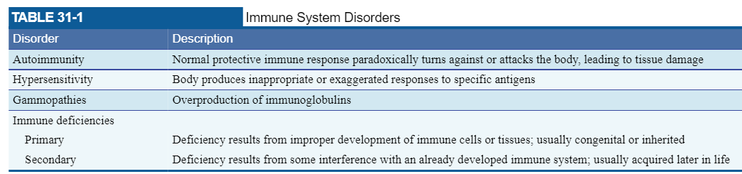
-white blood cells are produced in the bone marrow
-lymphocytes are generated from stem cells
- B cells – b lymphocytes
- T cells – t lymphocytes
-lymphoid tissues
- Red pulp: site where old and injured RBCs are destroyed
- White pulp: contains concentrations of lymphocytes
-Natural immunity is the first line of defense.
- Initial response to pathogens is production of cytokines or promote developing the acquired immune response.
The immune system
HIV / AIDS
HIV TRANSMISSION
-transmitted through body fluids that contain infected cells
-blood products or organ transplants from infected persons

Risk Factor for HIV infection
-sharing needles
-unprotected sex
-infants born to infected mothers or breast fed by infected mothers

Prevention of HIV Infection
-encourage the use of condoms
-PrEP: preexposure prophylaxis
-ART: antiretroviral therapy – when used as prescribed and if maintaining viral suppression there is no risk of transmission HIV through sex.

Prevent Transmission to Health Care Providers
-standard precautions
-hand hygiene

Post-Exposure Prophylaxis for Health Care Providers
-PEP: taken within 72 hours of exposure

Stages of HIV infection
Stage 0 – period from infection with HIV to development of HIV specific antibodies
Stage 1 – acute HIV infection. Develops within 2-4 weeks. Flu like symptoms such as fever, headache, and rash – 500-1500 cells
Stage 2 – CD4+ T-lymphocyte cells count are between 200 and 499 – chronic HIV infection
Stage 3 – count drops below 200 – considered to have AIDS

Assessment and Diagnostic Findings
There are three types of HIV diagnostic tests:
-Antibody tests = Antibody tests detect antibodies
-Antigen/antibody tests = Antigen tests directly detect HIV
-Nucleic acid (RNA) tests = RNA tests directly detect HIV

Treatment of HIV Infection
ART – antiretroviral therapy – suppresses HIV replication

Clinical Manifestations
-comorbidities: pancreatitis, hepatitis, and cardio-metabolic abnormalities

Respiratory Manifestations
-SOB, dyspnea, cough, chest pain, fever

Pneumocystis Pneumonia
-caused by P. jirovecil
s/s: dyspnea, fever, nonproductive cough, oral thrush, hypoxemia

Oral Candidiasis – painless, creamy white, plaque like lesions. Easily scraped off with a tongue depressor
Kaposi Sarcoma – brownish pink to deep purple, flat or raised and surrounded by ecchymosis and edema.

Nutrition Therapy
-goal: maintain and increase ideal weight

pharmacology therapy

Protease Inhibitors – prevent HIV from being assembled and released from infected CD4+ cells.
ritonavir (Norvir®)

(HAART)

Systemic Lupus Erythematosus (SLE) – inflammatory autoimmune disorder that affects almost every organ in the body.
Pathophysiology-the body incorrectly identifies cell nucleus as foreign, an antigen
-the body creates antibodies for the antigen
-B cells overproduce the antibodies
Clinical manifestations
-fever, fatigue, skin rashes, joint pain, and swelling
-baldness
-butterfly rash
-oral ulcers
-pleuritis pneumonia

Assessment and Diagnostic Findings

Medical Management.
-pain management and immunosuppression

-monoclonal antibodies

-corticosteroids

-Antimalarial agents

-NSAIDs

Rheumatoid Arthritis – autoimmune disease
-affects females 3 times more than males.
-onset is typically between the 30’s and 60’s
Clinical Manifestations
-symmetric joint pain and morning joint stiffness lasting longer than 1 hour
-swelling
-warmth
-erythema
-lack of function
-symptoms start in hands, wrist, and feet and progress to knees, shoulders, hips, elbows, ankles, cervical spine, and temporomandibular joints.
-fever, weight loss, fatigue, anemia, lymph node enlargement, and Raynaud’s phenomenon.
Assessment and Diagnostic Findings
-a score of 6 or greater is necessary to diagnose RA.
Nutrition Therapy

Scleroderma – autoimmune disease affecting the connective tissue of the skin, blood vessels, and internal organs.
Clinical Manifestations
-skin and subq tissues become increasingly hard and rigid
-extremities stiffen and lose mobility
-esophagus hardens, lung scars, intestinal mucosa hardens.

Medical Management
-ACE inhibitors
-pain management
-moderate exercise

Hypersensitivity

Types
1. Localized – affecting only cutaneous system
2. Diffuse – aka systemic sclerosis – affects multiple organ systems.

Assessment and Diagnostic Evaluation

Nursing Management.
-meticulous skin care and preventing Raynaud’s phenomenon

Care of the Patient with Specific Infectious and Metabolic Bone Diseases:

Musculoskeletal System:
Amputation: severing or removal of part of the body involving the extremities

Types of amputations
Traumatic: blunt force from MVA, gunshot wound, industrial jobs
*Upper extremity amputation seen in MVA
*Lower extremity amputations seen in motorcycle crashes and pedestrian injuries
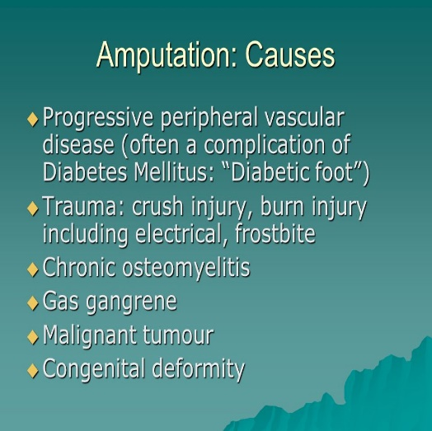
Elective: typically, due to vascular compromise
*Diabetes
*Smoking
*Venous stasis ulcers

Nursing management pre-post operation

Complications
Hemorrhage in traumatic amputations is caused by destruction of large blood vessels
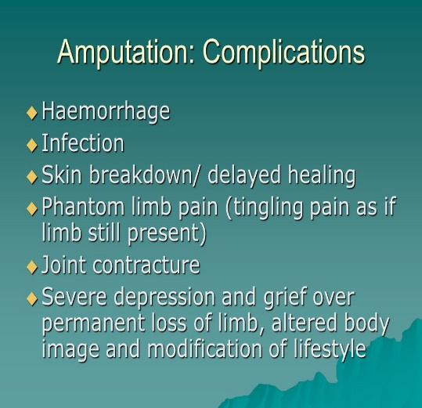
-if not controlled leads to hypovolemic shock and death

Infection

Contractures
-encourage patient to perform active ROM exercises and participate in physical therapy

Phantom limb pain: numbness, tingling, sharp burning pain, muscle pain, muscle cramps

Neuromas: clumps of nerve axons that regenerate after amputation.
*Occurs mostly in upper limb amputation
*Interferes with proper fit and use of prosthetic devices
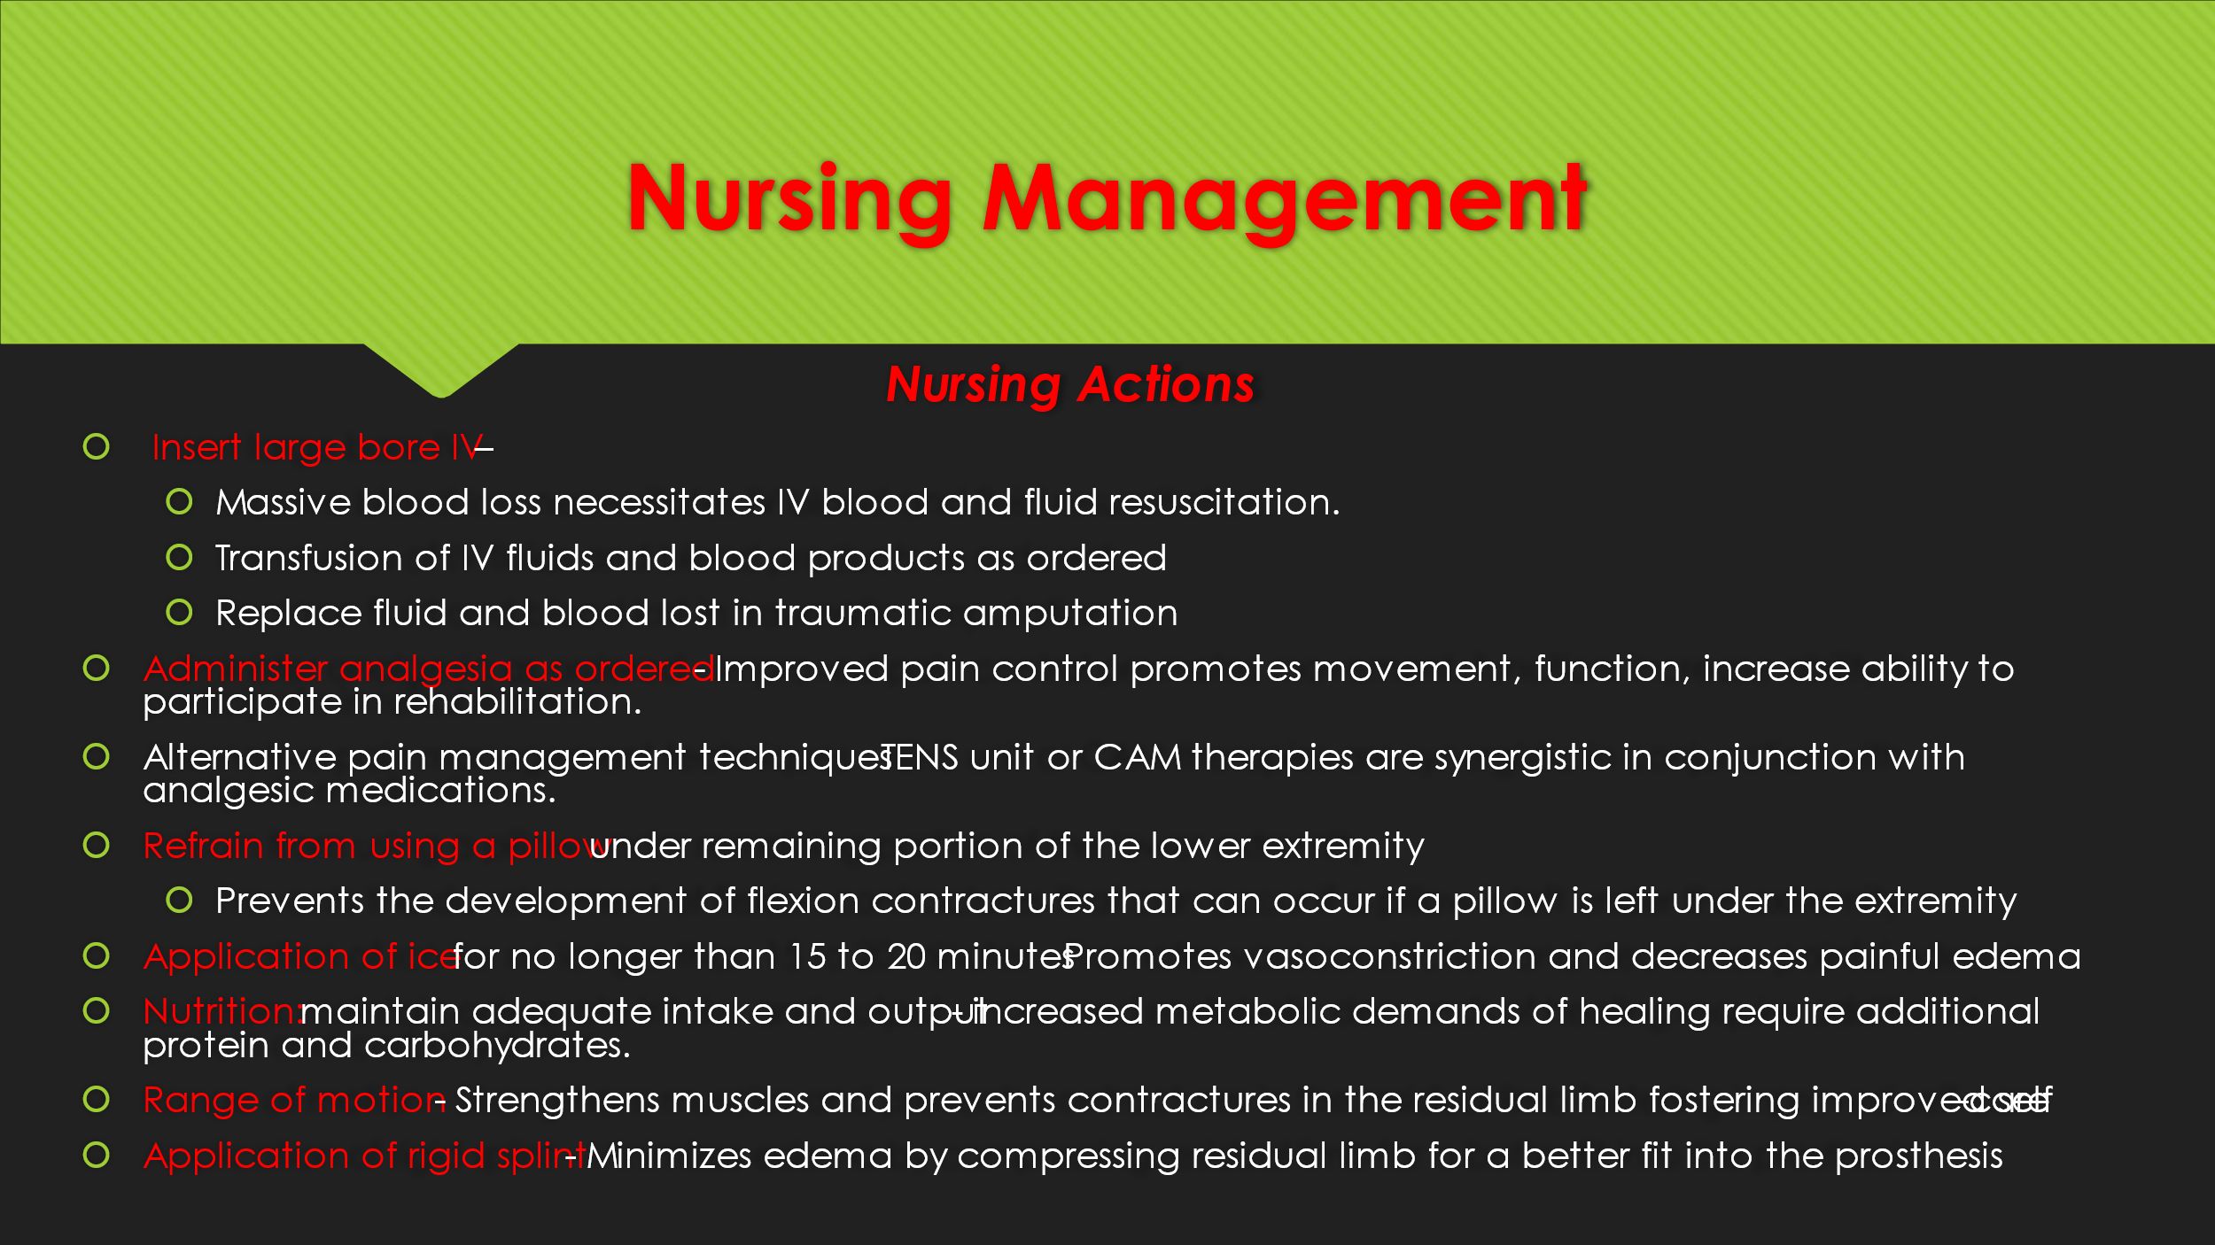
Nursing intervention
Vitals:
*hypotension and tachycardia may occur secondary to hemorrhage and sepsis
*increased temp may be infection
*decreased SPO2 – problems with oxygenation

Wound incision / site: warm, red tissue with purulent drainage is a sign of wound infection.
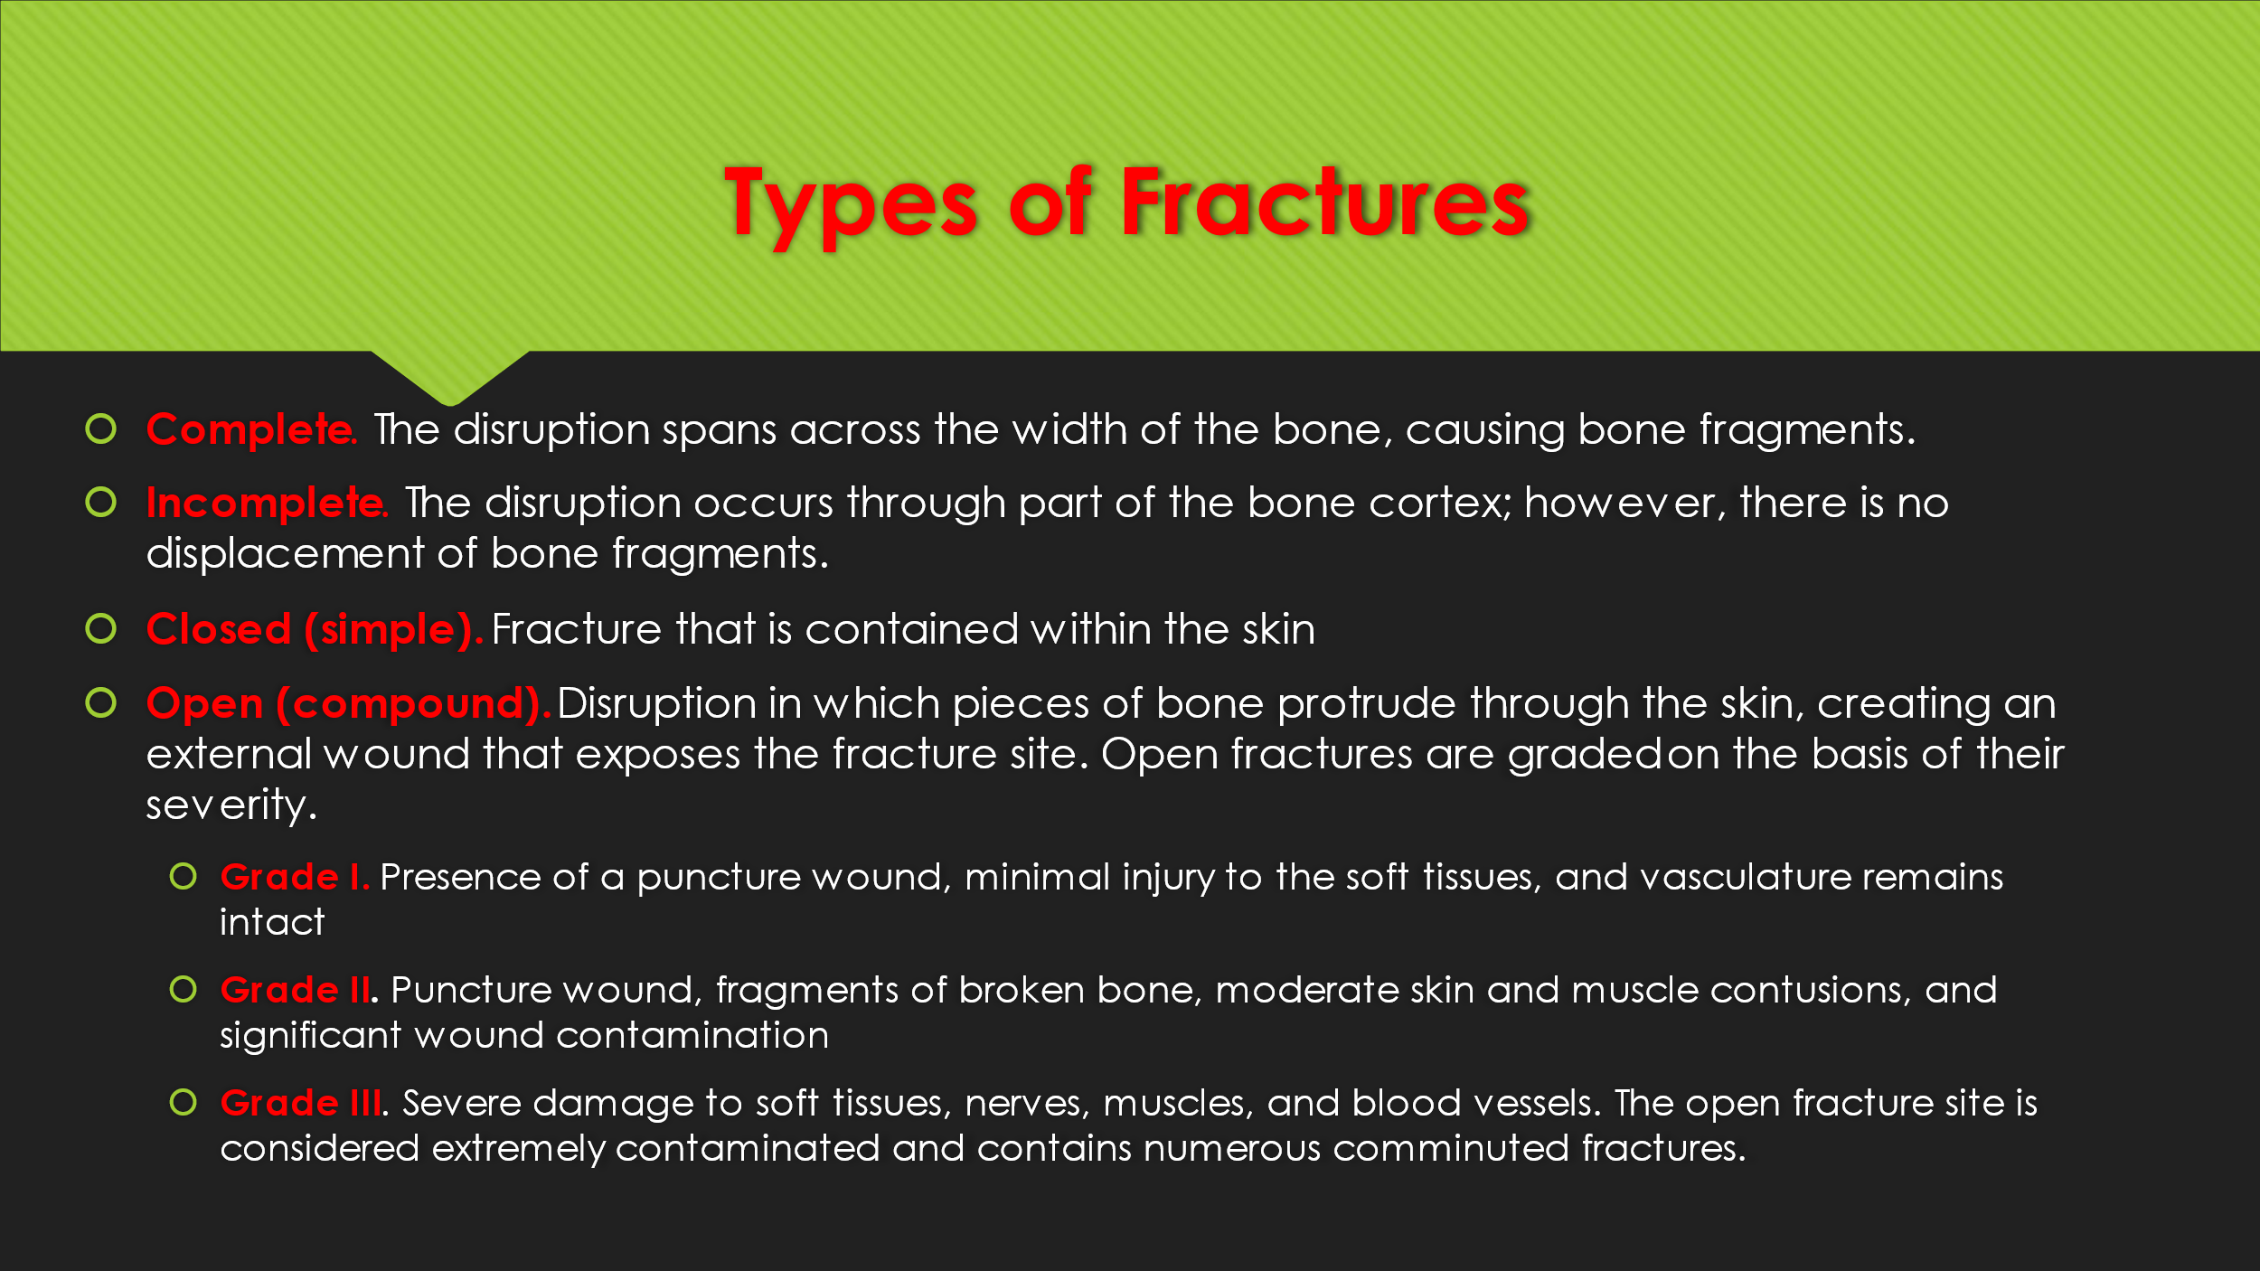
Fractures (e.g.,) strains/ sprains; medical intervention/ nursing intervention/ complications; cast care
A fracture defined as a disruption or break in the continuity of a bone.

-Fractures of flat bones (pelvis, sternum, and scapula) heal rapidly
-Blood supply to the fractured area is necessary for the healing process. The closer the fracture is to the blood supply the quicker it heals.
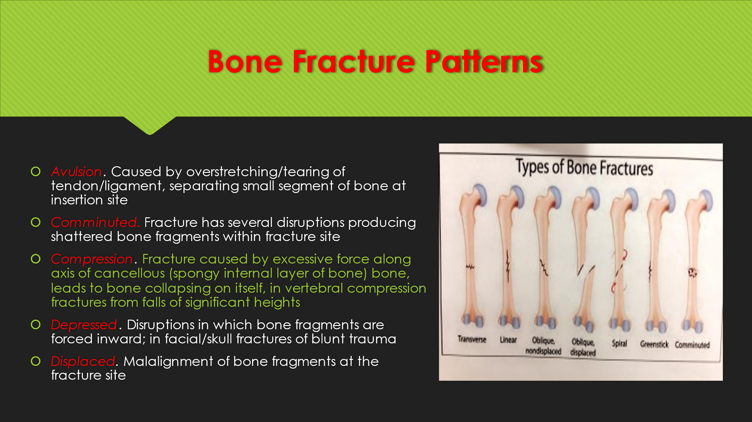
Early Complications of fractures: shock (more common in open or pelvic fractures), fat embolism (more frequent in long bone fractures), acute compartment syndrome, VTE (DVT), pulmonary embolism (PE), disseminated intravascular coagulation (DIC), and infection.
Late complications of fractures: delayed union, malunion, nonunion, avascular necrosis of bone, complex regional pain syndrome (CRPS), and heterotopic ossification.
5P’s
Pain
Pallor
Pulselessness
Paresthesia
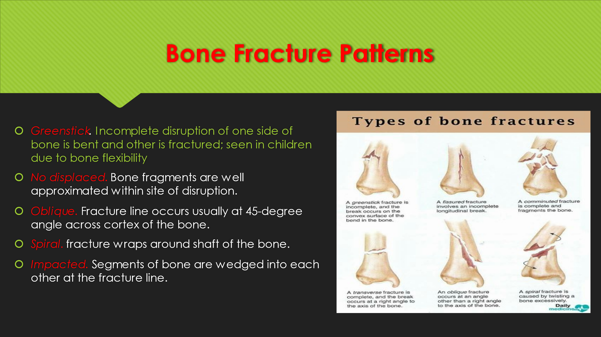
Paralysis
Closed Fracture (simple fracture) – does not cause the skin to break
Open Fracture (compound or complex) – skin or mucous membrane wound extends to the fractured bone
Type 1: clean wound < 1 cm and simple fracture pattern
Type 2: large wound with minimal soft tissue damage and no flap or avulsions
Type 3: severe, highly contaminated, extensive tissue damage
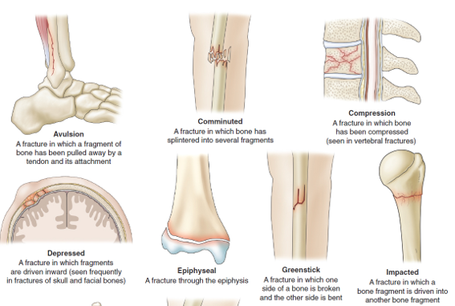
Comminuted: the bone splits into many fractures.

Cast Care
-a cast is a rigid external immobilizing device that is molded to the contours of the body. It immobilizes a reduced fracture.
-materials used: fiber glass and plaster of Paris.

Medical Management
Fracture reduction: restoration of bone fragments
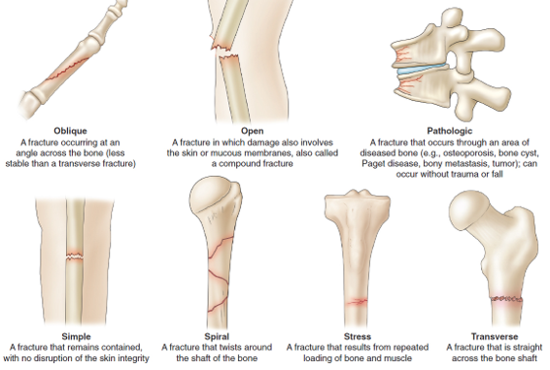
Closed: alignment through manipulation and manual traction.
Open: surgical intervention.
Immobilization: ensures proper position until union of the bone.
External: bandage, cast, splint
Internal: plates and screws
Maintaining and restoring function
Reduction, immobilization, frequent neurovascular checks, controlling edema, meds, participation in ADL’s,

Nursing Management

Tendons: connect muscle to bone
Ligaments: connect bone to bone.

Strain: injury to a muscle or tendon from overuse, overstretching, or excessive stress; commonly known as
1st degree: mild stretching of muscle or tendon with no loss of ROM.
2nd degree: moderate stretching / partial tearing of the muscle or tendon
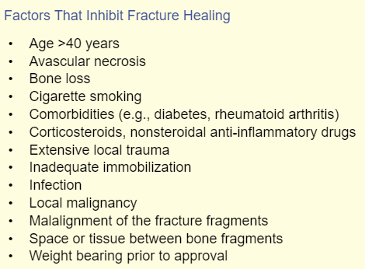
3rd degree: severe stretching with rupture and complete tearing of muscle or tendon

Sprain: injury to the ligaments and tendons that surround a joint. Caused by twisting or hyperextension of a joint.
-injured ligaments cause joint instability.
Grade 1: stretching or slight tearing of ligament. Mild pain, edema, and local tenderness.
Grade 2: partial tearing of the ligament. Pain with motion and joint instability.
Grade 3: complete tear or rupture of ligament. Severe pain and abnormal joint motion.

Treatment
Rest – prevents additional injury and promotes healing
Ice – vasoconstriction. Decreases bleeding, edema, and discomfort.
Compression – controls bleeding, reduces edema, and provides support to injured tissues.
Elevation – at or above the level of the hear controls swelling.

*NSAIDS: pain management
*Neurovascular assessment: Q15 minutes for the first 1-2 hours after injury, and then every 30 minutes until stable.
*Antibiotics for open fractures with contaminated wounds
*External fixation: rods and pins
*Internal fixation: plates and screws
*** Report decrease in sensation or motion and increase in pain to provider as that compartment syndrome can be prevented ***
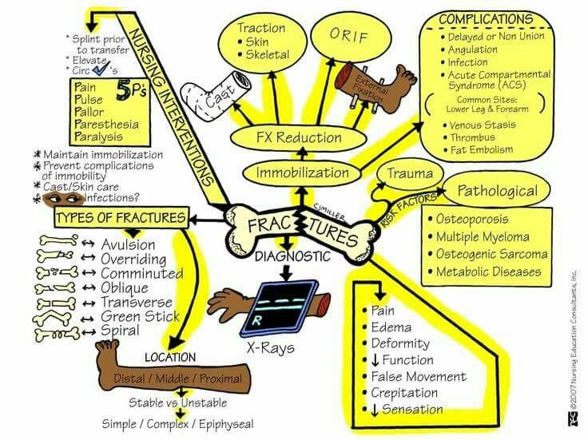

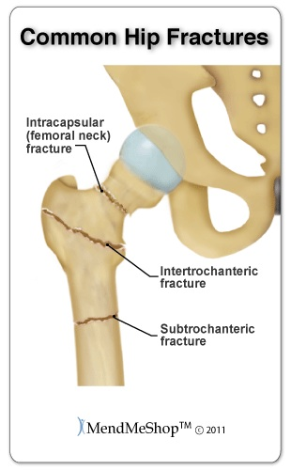
Hip Fracture; types; clinical manifestations; types of traction; care of patients on tractions, complications/ medical management; types of surgery; nursing actions
Extracapsular – fractures of trochanteric region (between based of the neck and the lesser trochanter of the femur) and of subtrochanteric region
-extremity significantly shortened
-greater external rotation than intra
-muscle spasm
-ecchymosis

Intracapsular – fractures of the neck of the femur
-leg shortened, adducted, and externally rotated
-pain in hip and groin and medial side of knee
-Increased pain with movement

Periprosthetic – fractures to the regions surrounding prosthetic joints

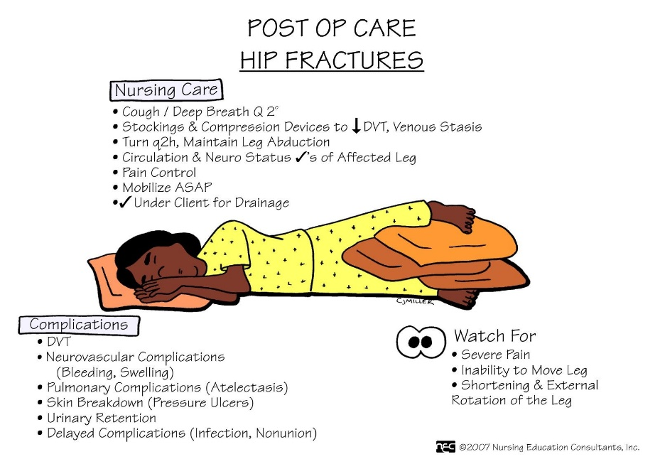
Nursing Management
-pain management
-prevention of secondary medical problems
-early mobilization
-24-48 hours of continuous neurovascular assessments
-encourage deep breathing, dorsiflexion, and plantar flexion exercises Q1-2 hours.
-compression stockings or anticoagulants for VTE prophylaxis
-monitor nutrition, hydration, and output

Complications
-neurovascular
-VTE
-atelectasis
-pneumonia
-skin breakdown
-loss of bladder control

Medical Management
-Buck’s extension traction: temporary skin traction – reduce muscle spasm, immobilize extremity, and relieve pain.
-Surgery: open or closed reduction with internal fixation.
*Hemiarthroplasty: replacement of the femoral head with a prosthesis
-Closed reduction with percutaneous stabilization for an intracapsular fracture

Osteomyelitis: infection of the bone that results in inflammation, necrosis, and formation of new bone.
-50% of cases caused by MRSA
Clinical Manifestations
-bloodborne: sepsis – chills, high fever, rapid pulse, and malaise as well as pain, swelling, and tenderness
-adjacent infection or direct contamination: skin over infected bone is swollen, warm, painful, and tender to touch
Diagnostic Findings
Xray: soft tissue edema
Radioisotope bone scans and MRI: early definitive diagnosis
Blood studies: leukocytosis and elevated ESR
Wound and blood culture:
Treatment
Long term antibiotic therapy: 6 – 12 weeks
Surgical debridement

Deep Vein Thrombosis (DVT) medical management Diagnostic findings, risk factors and preventions

Osteoporosis – most prevalent bone disease in the world. Consequence of osteoporosis is bone fracture.
Primary occurs in women after menopause. Risk factors include failing to achieve optimal peak bone mass, low vit D and calcium, excessive caffeine, tobacco use, and alcohol

Secondary is a result of medications or diseases that affect bone metabolism (i.e., corticosteroids, thyroid replacements, PPIs, and SSRI’s)

Pathophysiology: normal bone turnover is altered, and rate of bone resorption is greater that rate of bone formation, resulting in loss of total bone mass. Reduced bone mass, deterioration of bone matrix, and diminished bone architectural strength.

Clinical Manifestations
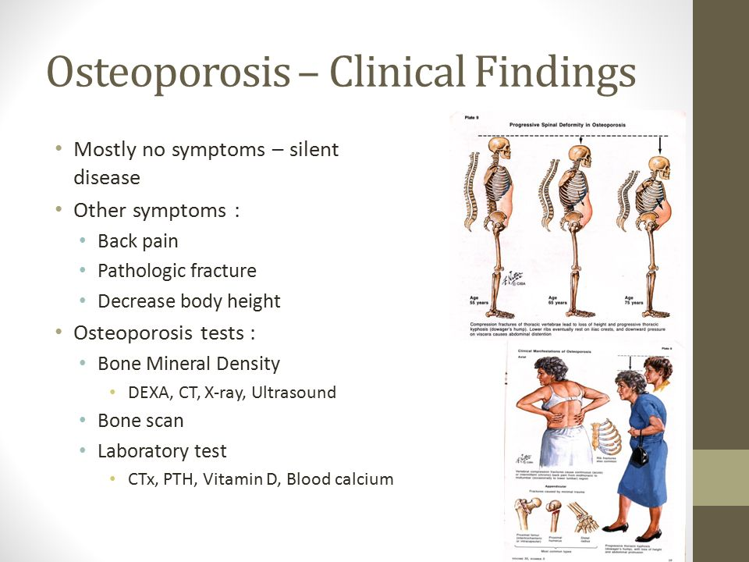
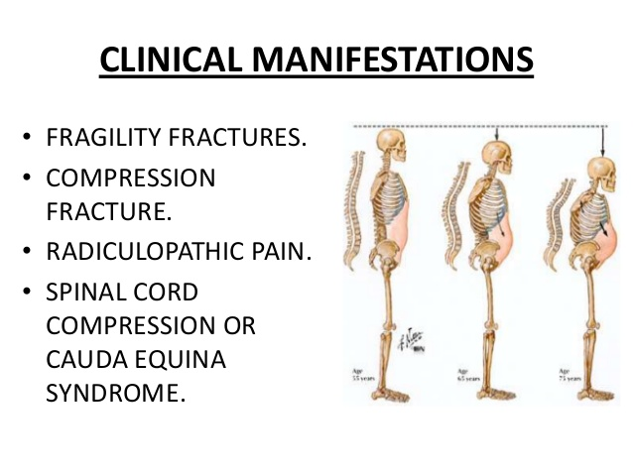
-fragility fractures in spine, hip, and distal radius

Diagnosis (e.g., DEXA scan, CT, MRI)
BMD measurement which is obtained through a DEXA scan (dual energy xray absorptiometry)
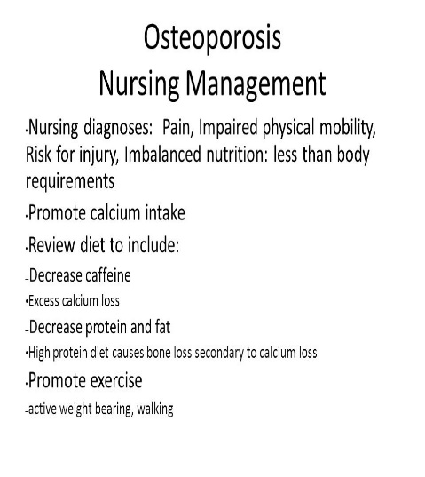
-low BMD is 2.5 standard deviations below the mean
Condition: | T-Score:
Normal | 1 SD below
Osteoporosis | 2.5 SD below
Osteopenia c | 1 – 2.5 SD below

Medical management
Calcium 1200 mg/day
Vit D 800-1000 IU
Bisphosphates: inhibits bone resorption. Take on empty stomach, sit up for 30 minutes after taking
Parathyroid hormone: stimulators of bone formation

Nursing Management: Assessment
Fall risk, pain, nutritional status, level of activity/exercise, body image disturbance, and physical appearance

Gout – most common form of inflammatory arthritis. Heterogenous group of conditions related to a genetic defect of purine metabolism that results in hyperuricemia
Signs and symptoms: pain, redness, swelling, production of tophi, and joint destruction

Diagnosis: Thorough history, physical assessment & laboratory studies
*Serum uric acid levels > 6.5mg/dL
*Elevated ESR
*Elevated urinary uric acid
*Elevated BUN & serum creatinine

Pharmacological management
Indocin / colchicine: decrease build up of uric acid crystals in joint
Glucocorticoids: reduce inflammation and provide pain relief
Allopurinol: reduce serum uric acid by inhibiting production of uric acid

Medical management

Nursing interventions
-monitor uric acid levels
-assess pain levels
-assess for red, swollen, and painful joints
-administer meds
-teach patient to avoid alcohol especially beer use meds as directed, report flares promptly, proper nutrition

Diet
-avoid alcohol especially beer
-restrict foods high in purine: organ meats

Practice Questions
1.) Physical assessment for the musculoskeletal function includes assessment of which of the following?
- ROM, posture, and symmetry
- Balance, symmetry, and bone strength
- Muscle tone, strength, and balance
- ROM, palpitation, and symmetry

ROM, posture, and symmetry evaluations can prove the most comprehensive information regarding the current function of a patient’s musculoskeletal system.

2.) A client arrives to the emergency room with a suspected orthopedic injury. Which question should the nurse ask?
- Does anyone in your family have a history of orthopedic injuries?
- Describe the location and quality of the pain.
- Were you born prematurely? (If yes, obtain a birth weight).
- What sports are you actively involved in?

Description and location of the pain can help determine if additional testing is needed and what kind of testing is appropriate. Family history has no impact on acute orthopedic history. Prematurity may impact bone strength but is not the first question. Sports do have associated injuries, but this patient is already presenting with an injury-pain is priority.

3.) Is the following statement True or False? The nurse must never remove weights from skeletal traction unless a life-threatening situation occurs. TRUE

The nurse must never remove weights from skeletal traction unless a life-threatening situation occurs. Removal of the weights completely defeats their purpose and may result in injury to the patient.

4.) How often must the nurse inspect the traction pin site for signs of inflammation and evidence of infection?
A) 8 hours
B) 12 hours
C) 16 hours
D) 24 hours

The nurse must inspect the traction pin site for signs of inflammation and evidence of infection at least every 8 hours.

5.) Is the following statement True or False? Testing for crepitus can produce further tissue damage and should be avoided. TRUE

Testing for crepitus can produce further tissue damage and should be avoided.

6.) Is the following statement True or False? Avascular necrosis is prolongation of expected healing time for a fracture. FALSE

Avascular necrosis is death of tissue secondary to poor perfusion and hypoxemia. Delayed union is prolongation of expected healing time for a fracture.

7.) A patient with diabetes who had an elective below-the-knee amputation returns to the unit for IV antibiotic care on postoperative day 3. On closer examination, the nurse notices the patient has a pillow under the residual limb. What should the nurse do in this situation?

A. Leave the pillow in place to prevent dependent edema
B. Remove the pillow to prevent contractures
C. Remove the pillow to prevent VTE
D. Leave the pillow to promote circulation

8.) A client diagnosed with osteoporosis has bones that become progressively porous, brittle, and fragile; they fracture easily under stresses that would not break normal bone. This increased susceptibility to fractures manifest most commonly as what?

A) Fractured tibias
B) Dislocated shoulders
C) Boxer's fractures
D) Compression fractures of the spine

Osteoporosis increases the risk of compression fractures of the spine, fractures of the neck or intertrochanteric region of the femur, and Colles’ fractures of the wrist

9.) How long does a patient taking bisphosphonates need to stay upright after administration?
A) 10 minutes
B) 20 minutes
C) 30 minutes
D) 120 minutes

Bisphosphonates are administered on arising in the morning with a full glass of water. On an empty stomach. Patient must stay upright for 30–60 minutes.

