Study Guide Test # 1

Chapter 45 – Assessment and management of Patients with Endocrine Disorders – PG. 1

Chapter 46 – Management of Patients with Diabetes – PG.

Chapter 60 – Assessment of Neurologic Function – PG.

Chapter 61 – Management of Patients with Neurologic Dysfunction – PG.

Chapter 63 – Management of Patients with Neurologic Trauma – PG.

Chapter 64 – Management of Patients with Neurologic Infection, Autoimmune disorders, and Neuropathies – PG.

Chapter 65 – Management of Patients with Oncologic or Degenerative Neurologic Disorders – PG.

Quiz # 1 Endocrine and Neurologic Systems
Thursday, January 27, 2022

Chapter 45 – Assessment and Management of Patients with Endocrine Disorders

Pg. 1445
Acromegaly – disorder caused by excess of GH in adults. Causes enlargement of peripheral body parts and soft tissue.
*In kids over secretion can cause pituitary gigantism and under secretion pituitary dwarfism

Addison’s disease – Primary adrenal insufficiency. Dysfunction of the hypothalamus-pituitary gland-adrenal gland feedback loop which results in insufficient production of steroids by the adrenal glands.

Addisonian crisis – life threatening. Hypotension, cyanosis, fever, nausea, vomiting and signs of shock develop

Adrenalectomy – surgical removal of adrenal glands.

Adrenocorticotropic hormone (ACTH) – hormone secreted by anterior pituitary. Essential for growth and development.

Androgens – third major type of steroid hormones produced by the adrenal cortex.

Basal metabolic rate – chemical reactions occurring when the body is at rest.

Calcitonin – secreted in response to high plasma levels of calcium. Reduces the plasma level of calcium by increasing deposition in bone.

Chvostek sign – suggests latent tetany which are intermittent muscle spasms. Positive when a sharp tapping over the facial nerve just in front of the parotid gland and anterior to the ear causes spasm or twitching of the mouth, nose and eye. Video: Registered nurse RN - https://youtu.be/k599AcihIGg - associated with patients with hypocalcemia and hypomagnesemia.

Corticosteroids – hormones produced by the adrenal cortex

Cushing’s syndrome – over secretion of ACTH or GH

Diabetes insipidus – most common posterior pituitary dysfunction. Abnormally large amounts of dilute urine are excreted because of deficient production of vasopressin aka ADH aka oxytocin
*Polydipsia – increased thirst
*Polyuria – increased urination
- Decreased ADH
- Problem with kidneys, medication - declomycin, pregnant - gestational, trauma to posterior pituitary
- Dehydrated, polyuria, 4L/24hours, polydipsia, dry mucous membranes, decreased skin turgor, hypotension, hypernatremia, low urine specific gravity
- Daily weights, I’s and O’s, safety, no caffeine, diabenese – increases ADH, monitor glucose level, desmopressin – a form of ADH replacement, monitor for hyponatremia

Registered Nurse RN – SIADH vs Diabetes Insipidus - https://www.youtube.com/watch?v=OxIl1r3N-hk

Euthyroid – thyroid hormone production that is normal.

Exophthalmos – abnormal protrusion of one or more eyeballs

Glucocorticoids – influence glucose metabolism. Secreted from the adrenal cortex in response to the release of ACT from the anterior lobe of the pituitary gland.

Goiter – enlarged thyroid gland caused by over secretion of thyroid hormones.

Graves disease – autoimmune disorder that results from an excessive output of thyroid hormone caused by abnormal stimulation of the thyroid gland by circulating immunoglobins (antibodies).
*Thyroid is right below larynx and produces thyroid hormone
*TSI: thyroid stimulating immunoglobin: makes body produce too much T₃ and T₄
*S/s: hyperthyroidism, heat intolerance, weight loss, increased BP and HR, diarrhea, irritable, smooth skin
and hair, Eye Changes: protruding eyeballs, Goiter, pre tibial myxedema

Registered Nurse RN - https://www.youtube.com/watch?v=d343HuUbqQI

Hormones – chemical transmitter substances. They regulate and integrate body functions. Typically produced by endocrine glands.

Mineralocorticoids – influence electrolyte metabolism.

Myxedema – severe hypothyroidism. Advanced and life threatening.

Negative feedback – regulating mechanism. Substance increased or decreased based on function of organ increasing or decreasing.

Pheochromocytoma – rare benign tumor that originates from chromaffin cells of the adrenal medulla

Syndrome of inappropriate antidiuretic hormone (SIADH) – failure of the negative feedback system that regulates the release and inhibition of ADH
- Increased or oversecreted ADH
- Hypothalamus or posterior pituitary damaged or produced somewhere else in body (lung cancer, infection – pneumonia, medications – diabinese aka chlorpropamide)
- Fluid overload, edema, weight gain, hypertension, tachycardia, hyponatremia, confusion, lethargic, at risk for seizures, anorexic, low urine output, high urine specific gravity.
- Daily weights, I’s and O’s, safety, fluid restriction, loop diuretic – Lasix, monitor K+, hypertonic IV solution, declomycin – inhibits ADH

Registered Nurse RN – SIADH vs Diabetes Insipidus - https://www.youtube.com/watch?v=OxIl1r3N-hk

Thyroidectomy – surgical removal of all or part of the thyroid gland.

Thyroiditis – inflammation of the thyroid gland.

Thyroid stimulating hormone (TSH) – released from the pituitary gland; causes stimulation of the thyroid resulting in release of T₃ and T₄.

Thyroid storm – severe hyperthyroidism with abrupt onset.

Thyrotoxicosis – condition caused by excessive secretion of endogenous or exogenous thyroid hormones.

Thyroxine (T₄) – needed by the body for metabolism. Contains 4 iodine atoms. Maintains metabolism in steady state.

Triiodothyronine (T₃) – needed by the body for metabolism. Contains 3 iodine atoms. Released in smaller quantities. Faster onset of action than T₄. Widespread effect on cellular metabolism.

Trousseau sign - suggests latent tetany which are intermittent muscle spasms. Positive when carpopedal spasm is induced by occluding the blood flow to the arm for 3 minutes with a blood pressure cuff. Video: Registered Nurse RN - https://youtu.be/p2hnxQTmwuY . Associated with hypocalcemia and hypomagnesemia.

Vasopressin – secreted by posterior pituitary. Aka antidiuretic hormone (ADH) or oxytocin.

ADH – Antidiuretic hormone – regulates the amount of water in the body and constricts blood vessels. Uses kidneys.
- Causes renal tubules to retain water
- If you have a lot of ADH you will retain a lot of water. Low ADH lose water.
- Hypothalamus – produces ADH
- Posterior Pituitary gland – secretes and stores ADH

Nurse Sam – page 180, 197 – 202
ATI Page 511
Sodium – 136 – 145 mEq/L
Potassium 3.5 – 5.0 mEq/L
Chloride 98 – 106 mEq/L
Magnesium 1.3 – 2.1 mEq/L

- Can cause hypertension, diabetes mellitus, and heart problems

Anterior
Major Hormones: FSH, LH, PRL, ACTH, TSH, and GH.
* Master gland b/c it influences secretion of hormones by other endo glands
* 2 lobes: anterior and inferior
*Controlled by hypothalamus
Pancreatic
Islets
Pituitary
Gland
Ovaries
Endocrine System

Posterior
Hormones: Vasopressin (ADH) and oxytocin. Both are synthesized in hypothalamus.
Thyroid
Gland
Parathyroid
Glands
Testes

Adrenal
Glands

*2 glands
*Adrenal Medulla: secretes catecholamines
*Adrenal Cortex: secretes steroid hormones

*Normally 4
*Embedded in posterior aspect of thyroid gland
*Parathyroid hormone regulates calcium and phosphorus metabolism.

- Endocrine glands secrete hormones directly into the bloodstream.
- Hormones are classified into 4 categories
1. Amines and Amino Acids
a.) epinephrine
b.) norepinephrine
c.) thyroid hormones
2. Peptides, polypeptides, proteins and glycoproteins
a.) thyrotropin-releasing hormone: TRH
b.) follicle stimulating hormone: FSH
c.) Growth hormone: GH
3. Steroids
a.) corticosteroids
4. Fatty acid derivitives
a.) eicosanoid
b.) retinoids

- Stimulation tests are used to confirm hypofunction of an endocrine organ
- Suppression tests are used to confirm hyperfunction of an endocrine organ
- Normal Urine Specific Gravity 1.005 – 1.030

Endocrine Diseases

Addison’s Disease (hypoproduction of ACTH)

Cushing’s Syndrome (hyperproduction of ACTH)

Acromegaly – caused by over secretion of GH in adults

Diabetes Insipidus – posterior pituitary lobe dysfunction.
- Large volumes of dilute urine are excreted due to lack of vasopressin
- Characterized as:
  - Central: head trauma, surgery, infection, inflammation, brain tumors, CVD
  - Nephrogenic: kidney injury, medications such as lithium, hypokalemia, and hypercalcemia
  - Dipsogenic: defect in hypothalamus or damage to pituitary
  - Gestational
- Causes: injury to hypothalamus or pituitary gland
  - surgical treatment of brain tumor
  - TBI
  - Infection of nervous system
  - Removal of pituitary
  - Failure of renal tubes to respond to ADH
  - Certain meds
- Clinical Manifestations
  - Urine Specific Gravity between 1.001 and 1.005
  - Urinary output of greater than 250 mL per hour
  - Polydipsia. Drinks 2 – 20 L of fluid daily.
  - Craving cold water
  - Weight loss
- Medical Management
  - Replace ADH
  - Adequate fluid replacement
  - For central DI administer desmopressin
- Nursing Management
  - Ongoing physical assessment and education
  - Monitor vital signs
  - Monitor I&O

SIADH – caused by failure of negative feedback loop that regulates the release and inhibition of ADH
- Clinical Manifestations
  - Cannot excrete dilute urine / increased urine specific gravity
  - Retain fluids
  - Develop sodium (<136 mEq/L) and chloride (<98 mEq/L) deficiency
- Causes
  - Disorders of CNS: head injury, brain surgery, tumor and infection, some meds and nicotine
- Medical Management
  - Restrict fluid intake
  - Diuretic
  - Hypertonic NaCl (3%) if severe hyponatremia
- Nursing Management
  - Closely monitor I&O
  - Daily weight
  - Urine and blood chemistries
  - Neuro status
Thyroid Hormone: made up of T4 and T3
- T4: thyroxine: 4 iodine molecules
- T3: triiodothyronine: 3 iodine molecules
- Iodine is essential in the creation of hormones in the thyroid
- Euthyroid – normal thyroid hormone production
- Calcitonin regulates calcium levels by increasing deposition in the bones

Hyperthyroidism – over secretion of thyroid hormones – greatly increased metabolic rate
- Enlarged thyroid gland - goiter
*Causes
Most Common
-Graves’ disease
-toxic multinodular goiter
-toxic adenoma
Other causes
-thyroiditis
-excessive ingestion of thyroid hormone
-Irradiation of thyroid
-Destruction of thyroid by tumor

Graves disease – autoimmune disorder that results from excessive output of thyroid hormone caused by abnormal stimulation of the thyroid gland.
-Affects women 8 times more than men
-Onset begins in 20’s and 40’s
-Clinical Manifestations: bulging eyeballs, reduced blinking, changes in menstruation

*Clinical Manifestations
r/t increased metabolic rate and increased oxygen consumption
-Anxious
-Restless
-Fine tremors in hands
-Tachycardic and complain of palpitations
-Heat intolerance
Other manifestations
-increase in appetite
-diarrhea
-weight loss
-thin skin
Cardiac Manifestations
-sinus tachycardia
-arrythmias
-decreased cardiac output
-increased pulse pressure and palpitations
-myocardial hypertrophy
-heart failure

*Drugs
Most common
-Methimazole – inhibits synthesis of thyroid hormone
-Propylthiouracil – blocks synthesis of T3 and T4

Hypothyroidism – inadequate secretion of thyroid hormones – slowing of metabolism
- Severe form: myxedema – life threatening
- In infants causes intellectual disabilities and stunted growth
- In adults causes lethargy, slow mentation, weight gain, cold intolerance, slowing of activity
* Causes
- autoimmune disease
- Atrophy of thyroid gland with aging
- Iodine deficiency
- Medications like lithium
- Radioactive iodine
- Therapy for hyperthyroidism
- Thyroidectomy
- Radiation to head and neck in treatment for head and neck cancers

*Clinical Manifestations
-Lethargy
-Fatigue
-Weight gain
-Cold intolerance
-Deepening of the voice
-Constipation
-Peripheral edema
-Muscle weakness

*Drugs
Levothyroxine – 75 – 150 mcg per day

*** Must monitor for S/s of cardiac dysfunction ***

Thyroid Tumor
-Thyroid tumor is toxic if it causes hyperthyroidism
-Euthyroid tumors are non-toxic
-If tumor is large enough to be seen it is called a goiter

Hyperparathyroidism
-bone decalcification
-kidney stones

*Clinical Manifestations – caused by increased serum calcium level in the blood
-apathy
-fatigue
-muscle weakness
-nausea
-vomiting
-constipation
-hypertension
-cardiac arrythmias
-increase in peptic ulcer
-pancreatitis

*Medical Management
-parathyroidectomy
-outpatient procedure with local anesthesia
-2000mL of fluid intake to prevent renal calculi
*Complications
Hypercalcemic crises
-serum calcium above 13 mg/dL causes life threatening neurologic, cardiac and kidney symptoms
-rapid rehydration using large volumes of IV isotonic solutions and calcitonin
-calcitonin promotes renal excretion of excess calcium and reduces bone resorption
-use of loop diuretic if edema occurs
-Monitor for fluid overload

Hypoparathyroidism
-hyperphosphatemia
-hypocalcemia
-decreased intestinal absorption of calcium

*Causes
-surgical removal
-autoimmune response
-Vitamin D deficiency
-Most common cause – near total removal of thyroid gland

*Clinical Manifestations
-tetany – intermittent muscular spasms
-Chvostek sign is positive when a sharp tapping over the facial nerve just in front of the parotid gland and anterior to the ear causes spasm or twitching of the mouth, nose and eye
-Trousseau sign is positive when carpopedal spasm is induced by occluding the blood flow to the arm for 3 minutes with a blood pressure cuff

*Medical Management
-calcium gluconate if PT has hypocalcemia and tetany
-Sedative such as pentobarbital if patient has seizures
-Environment free of noise, drafts, bright lights, or sudden movements
-Diet low in phosphorus and high in calcium

Adrenal Medulla
-part of the autonomic nervous system
-catecholamines – epinephrine (90%) and norepinephrine (10%)
-fight or flight response
-release of fatty acids
-increase BMR
-elevate blood glucose level

Adrenal Cortex
-necessary for life
-make it possible for the body to adapt to stress
-Steroids
a. glucocorticoids: cortisol
-influence glucose metabolism
-released in response to the release of ACTH (adrenocorticotropic hormone) from the anterior pituitary
-corticosteroid: inhibits inflammatory response to tissue injury and suppress allergic reaction
-SIDE EFFECTS: diabetes, osteoporosis, peptic ulcer, increased protein breakdown from muscle wasting,
poor wound healing, redistribution of body fat

b. mineralocorticoids: aldosterone
-influence electrolyte metabolism
-cause increased sodium absorption and excretion of K+ and hydrogen

c. sex hormones: androgens
-Adrenogenital syndrome: when secreted in excess cause men to look girly, women to look manly and
children to progress into puberty sooner

Pheochromocytoma
-rare tumor
-typically, benign
-Originates from chromaffin cells of the adrenal medulla

*Clinical Manifestations
-headache
-diaphoresis
-hypertension
-palpitations in patients with hypertension
Other symptoms
-tremor
-flushing
-anxiety
-hyperglycemia
5 H’s
1. hypertension
2. headache
3. hyperhidrosis
4. hypermetabolism
5. hyperglycemia

Addison’s Disease – Adrenocortical Insufficiency
*Causes
-autoimmune disorder
-Surgical removal of adrenal glands
-Metastatic cancers: breast, lung, colon, melanoma

*Clinical Manifestations
-Hypovolemia
-Decreased cardiac output
-Hypoglycemia
-Muscle weakness
-lethargy
-anorexia
-weight loss
-nausea and vomiting

*S/s
Hypovolemia, rapid and weak pulse, tachypnea, pallor and extreme weakness

Addisonian Crises: life threatening, severe hypertension, cyanosis, fever, nausea and vomiting

*Medical Management
-restore blood circulation
-administer fluids and corticosteroids
-monitor vitals
-place patient in recumbent position with legs elevated

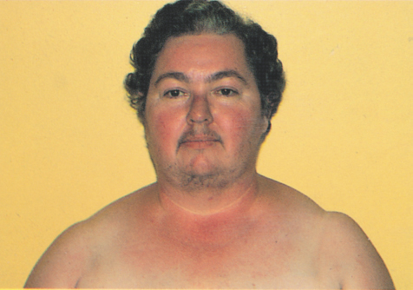
Cushing’s Syndrome
*Cause
-use of corticosteroids
-excessive glucocorticoid production

*Clinical Manifestations
-obesity
-buffalo hump
-moon face
-heavy trunk
-thin extremities
-skin is thin and fragile
-sleep is disturbed
-muscle wasting and osteoporosis
-hyperglycemia or diabetes
-excessive growth of hair in females
-diabetes
-peptic ulcer

*Medical Management
-if caused by tumor surgical removal.

Conn Syndrome – Primary Aldosteronism
-conserve body Na+

*Causes
-tumors of the adrenal gland
-ovarian tumors that secrete aldosterone
-family history

*Clinical Manifestations
-hypertension – most prominent

Medical Management
-total removal of adrenal tumor laparoscopically
-pre op: blood pressure and K+ levels are monitored
-post op: administration of corticosteroids and fluids
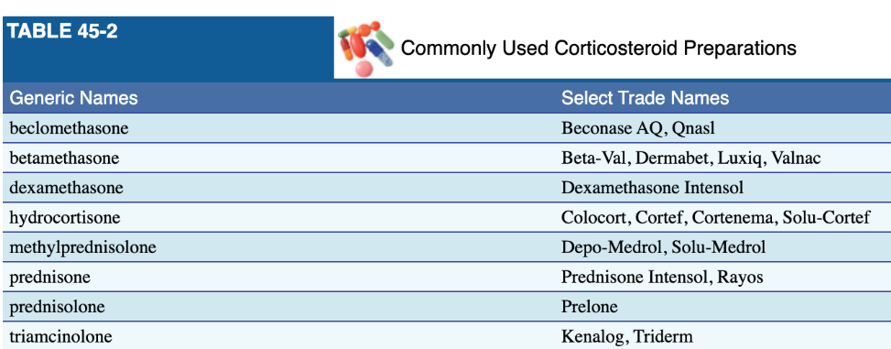
Corticosteroid Therapy
-used for adrenal insufficiency, inflammation, allergic reaction, autoimmune reactions, and reducing transplant rejection

Side Effects
-metabolic effects
-pituitary and adrenal gland suppression
-changes in CNS

ATI – page 545
Type 1: inadequate production of insulin
-autoimmune dysfunction involving destruction of beta cells
-cannot be prevented

Type 2: inability of body to respond to insulin that is present
-insulin resistance
-decreased production of insulin by beta cells
-linked to obesity, sedentary lifestyle, and heredity
-lifestyle modifications can reduce risk factors and minimize complications if you already have it.

-diabetes is a contributing factor to cardiovascular disease, hypertension, kidney disease, neuropathy, retinopathy, peripheral vascular disease, and stroke

Risk Factors
-central obesity
-hyperlipidemia: triglycerides less than 150 mg/dL
-BP greater than 130/85
-hyperglycemia: fasting blood glucose at or greater than 100 mg/dL

Insulin Resistance
-Impaired fasting glucose levels 100-125 mg/dL
-Impaired glucose tolerance 140 mg/dL
-A1C level 5.7% - 6.4%

Secondary Causes of diabetes
-pancreatitis
-Cushing’s

Expected Findings
-3 P’s: polyuria, polydipsia, polyphagia
-Kussmaul respirations
-Recurrent infections

Lab Tests
-blood glucose greater than 200 mg/dL
-Fasting blood glucose greater than 126 mg/dL
-2 hr. glucose greater than 200 mg/dL
-A1C greater than 6.5%

Insulin
Rapid Acting: lispro, aspart, glulisine, inhaled human insulin
-before meals
-onset: 10 – 30 min
-mixed with intermediate or long acting

Short Acting: regular
-30 – 60 min before meals
-Can only be mixed with intermediate insulin
-2 concentrations
1. U-500: for insulin resistance. NEVER IV.
2. U-100: most common. Can be used for IV administration.

Intermediate Acting: NPH
-between meals and at night for glycemic control
-contains protamine which delays absorption of insulin and extends duration of action
-The only insulin that can be mixed with short acting.

Based on ATI I need to study more on:
- Grave’s disease
  - Characterized by tremors, tachycardia, low grade fever, diaphoresis, and heat intolerance
- Parathyroid – controls calcium concentration

-If you have an elevated level of TSH it indicates hypothyroidism
-Cushing’s: fluid volume overload
-Thyroid storm (thyrotoxicity): tachycardia, fever, sweating, restlessness and tremors leading to CHF and pulmonary edema leading to death. Hypertension, abdominal pain, diarrhea, nausea and vomiting.

Chapter 46 – Management of Patients with Diabetes

Pg. 1487
Diabetes – a group of metabolic diseases characterized by defects in insulin secretion, action or both.

Diabetic ketoacidosis (DKA) – metabolic derangement that occurs most commonly in those with type 1 and results from a deficiency of insulin, highly acidic ketone bodies are formed, and metabolic acidosis occurs.
*Hyperglycemia
*Ketosis
*Metabolic acidosis
*Breath has a fruity odor
*DKA preceded by polyuria, polydipsia, nausea, vomiting, fatigue and eventually coma if not treated.

Fasting plasma glucose (FPG) – blood glucose testing after 8 hours of fasting

Gestational diabetes – any degree of glucose intolerance with its onset during pregnancy.

Glycated hemoglobin – glucose control over 3 months. AKA A1C

Glycemic index – the amount a given food raises the blood glucose level

Hyperglycemia – high blood glucose

Hyperglycemic hyperosmolar syndrome (HHS) – an acute problem caused by uncontrolled type 2 diabetes.

Hyperglycemia – low blood glucose

Impaired fasting glucose (IFG) or impaired glucose tolerance (IGT) – stage in between normal glucose and diabetes

Insulin – hormone secreted by beta cells required for metabolization of carbs, protein and fat.

Ketone – acidic substance formed in the liver from breakdown of fatty acids in the absence of insulin.

Latent autoimmune diabetes of adults (LADA) – slow destruction of beta cells in pancreas. Higher risk of becoming insulin dependent.
- Patients are not insulin dependent in the first 6 months of diabetes onset.

Medical Nutrition Therapy (MNT) – special diabetic diet created by registered dietician

Nephropathy – kidney disease

Neuropathy – complication of diabetes causing damage to nerve cells especially in lower extremities.

Prediabetes – impaired glucose tolerance or impaired fasting glucose

Retinopathy – blood vessels that supply eye become damaged

Self-monitoring of Blood Glucose (SMBG) – capillary blood glucose test

Type 1 diabetes – classified by destruction of pancreatic beta cells.
*a patient can be genetically predisposed for type 1 diabetes
- Insulin dependent
- Genetic and environmental factors
- 3 P’s
  - Polyuria – increased volume of urine
  - Polydipsia – increased thirst
  - Polyphagia – increased hunger
- Thin, recent weight loss
- Onset is typically < 30 y/o
-DKA happens mostly with type 1
1. hyperglycemia
2. ketosis
3. metabolic acidosis
4. blood glucose levels of ?250 mg/dL and ketones in urine

Type 2 diabetes – typically occurs in obese patients that are over 30. Two main problems are insulin resistance and impaired insulin secretion.
- Modifiable
- Affected by diet and lifestyle changes
- Typically occurs in people >30 y/o and are obese
- Insulin resistance can lead to metabolic syndrome which is characterized by hypertension, hypercholesterolemia, abdominal obesity and other abnormalities
- Uncontrolled Diabetes can lead to Hyperglycemic Hyperosmolar Syndrome - HHS

Diagnosing Diabetes
Fasting blood glucose – no caloric intake for at least 8 hours
- Greater than or equal to 126 mg/dL - DM
- 100–125 mg/dL – Prediabetes
2-hr postprandial
- Greater than or equal to 200 mg/dL - DM
- 140–199 mg/dL - Prediabetes
Hemoglobin A1c
- Greater than or equal to 6.5% - DM
Random blood glucose level
- Greater than or equal to 200 mg/dL
- DM if accompanied by classic signs/symptoms of hyperglycemia

Diabetes Management
- Nutritional therapy
- Exercise
- Monitoring
- Pharmacologic therapy
- Education
-Diabetics should not exercise if there blood glucose is higher than 250 mg/dL and their urine has ketones.

DKA
-Blood glucose 250 – 800 mg/dL
-Severely dehydrated
-Low serum bicarbonate (0-15 meq/L)
-Low pH (6.8 – 7.3)
-PaCO2 (10-30 mmHg)
-Kussmaul respirations
-Hypokalemia
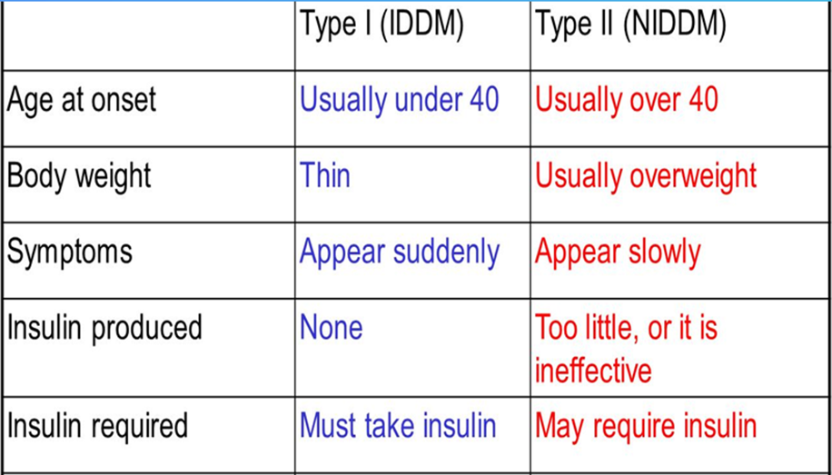

Insulin: know onset, peak, and duration for each

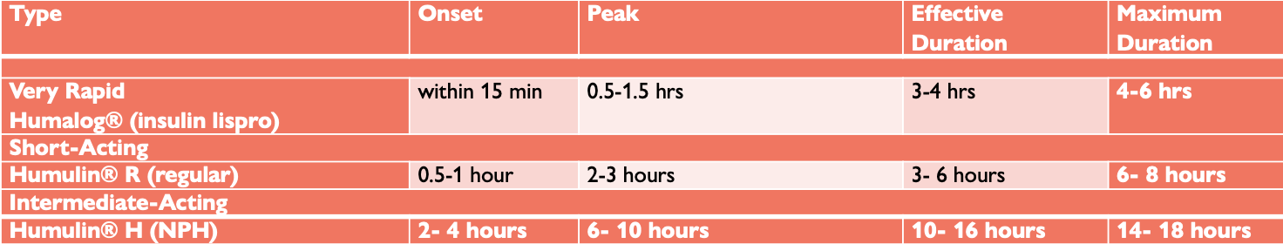

- Good for 28 days
- Clean top with alcohol
- Kept in refrigerator
- Regular and NPH can be mixed

Insulin syringes:
- U-100 – 1mL
- U-50 – 0.5mL
- U-30 – 0.3 mL(children)
- Needle size---- 27 to 28-gauge, ½ inch long

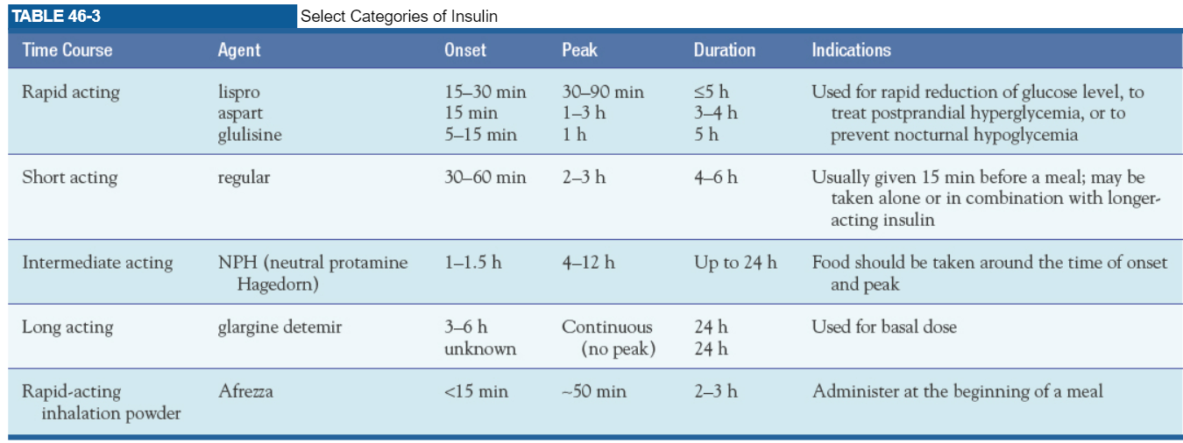

Rapid acting insulin doesn’t L.A.G. Lispro, Apart, Glulisine
- Eat within 5 – 15 minutes
- Paired with basal insulin (long acting) to maintain glucose control

Short Acting – Regular Insulin
- Clear
- Given 15 minutes before meals
- Only insulin that can be given IV
- Can be given alone or with long acting

Intermediate Acting - NPH
- Cloudy
- Not required but should eat food around the onset and peak times

Long Acting – Basal
- Continuous – no peak
- Absorbed very slowly over 24 hours
- Given once per day
- Cannot be mixed with other insulins

Stopped at page 1516 – HHS

Chapter 60 – Assessment of Neurologic Function

Pg. 1966
Agnosia
Ataxia

Autonomic nervous system – regulates the activities of internal organs such as the heart, lungs, blood vessels, digestive organs, and glands. Also responsible for maintenance and restoration of homeostasis

Two Major Divisions

Sympathetic nervous system
Parasympathetic nervous system

Fight or flight
Visceral Functions

Axon – long projection that carries electrical impulses away from the cell body.

Babinski reflex (sign) – a reflex action of the toes. In adults is indicative of abnormalities in the motor control pathways leading from the cerebral cortex.

Clonus – abnormal movement marked by alternating contraction and relaxation of a muscle occurring in rapid succession.

Delirium – acute state of confusion which begins with disorientation and if not recognized and treated early can progress to changes in level of consciousness, irreversible brain damage, and sometimes death.

Dendrite – dendrites are branch type structures for receiving electrochemical messages.

Flaccidity – lack of muscle tone

Parasympathetic nervous system – functions as the dominant controller for most visceral functions.
*Primary neurotransmitter is acetylcholine.

Position (postural) sense – awareness of position of extremities without looking at them.

Reflex – involuntary movements

Rigidity – abnormality in muscle tone. Resistance to passive stretch

Romberg test – screening test for balance. Feet together and arms at sides. Start with eyes open and then close for 20 seconds. Swaying is normal. Loss of balance is not normal. Positive Romberg test means patient has loss of balance during test.
*additional tests include heel to toe walking, hopping in place, and alternate knee bends.

Spasticity – abnormality in muscle tone. Increased muscle tone.

Sympathetic nervous system – predominantly excitatory responses (i.e., fight or flight)

Vertigo – the illusion of movement in which the individual or the surroundings are sensed as moving.
*manifestation of vestibular dysfunction
*depending on severity vertigo can cause spatial disorientation, lightheadedness, loss of equilibrium
(staggering), and nausea and vomiting

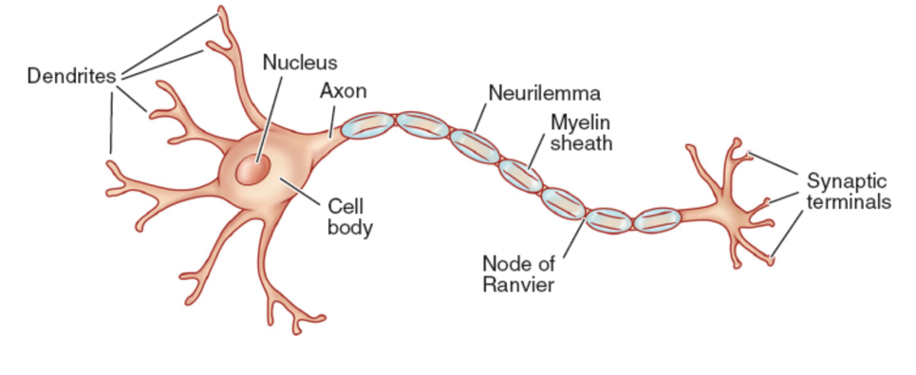
Neuron – the basic functional unit of the brain.
*some axons have myelinated sheath which increase speed of conduction.
Chapter 61 – Management of Patients with Neurologic Dysfunction

PG. 1992
Akinetic mutism – state of unresponsiveness to the environment in which the patient makes no voluntary movement

Altered level of consciousness (loc) – the patient is not oriented, does not follow commands, or needs persistent stimuli to achieve a state of alertness.

Brain death – irreversible loss of all functions of the entire brain and absence of brain stem reflexes.

Coma – clinical state of unarousable unresponsiveness in which there are no purposeful responses to internal or external stimuli. Non purposeful responses to pain and brain stem reflexes may be present.

Craniectomy – excision of a portion of the skull

Craniotomy – opening the skull surgically to gain access to intracranial structures.
*Removal of tumor
*Relieve elevated ICP
*Evacuate blood clot
*Control hemorrhage

Cushing’s response – the brain’s attempt to restore blood flow by increasing arterial pressure to overcome increased ICP.

Decerebration – extreme extension of the upper and lower extremities.

Decortication – abnormal flexion of the upper extremities and extension of the lower extremities.

Delirium – acute confusional state.

Dementia – general term for syndrome characterized by decline in higher brain function.
*Symptoms are subtle in onset
*Symptoms progress slowly until obvious and devastating

Epilepsy – more than one unprovoked seizure

Herniation – shifting of brain tissue from an area of high pressure to low pressure. When the brain tissue moves it causes pressure in the area it shifted to resulting in cutting off of the blood supply, cerebral ischemia, infarction and brain death.

Intracranial pressure (ICP) – pressure exerted by the volume of the intracranial contents within the cranial vault. Contents are brain tissue (1400g), blood (75 mL), and CSF (75 mL)
*Measured in the lateral ventricle
*Normal ICP 0 – 10 mm Hg.
*15 mm Hg upper limit of normal ICP

Locked in syndrome – lesion affecting the pons and results in paralysis and the inability to speak, but vertical eye movements and lid elevation remain intact and are used to indicate responsiveness. (Chicago Med)

Migraine – complex of syndromes characterized by periodic and recurrent attacks of severe headache lasting from hours to days in adults.

Minimally conscious state – inconsistent but reproducible signs of awareness.

Monro Kellie Hypothesis – because of limited expansion within the skull, an increase in any one of the components causes a change in the volume of the others.

Persistent vegetative state – unresponsive patient resumes sleep wake cycles after coma but has no cognitive or affective mental function.

Primary headache – a headache where no organic cause can be identified.
*Migraine
*Tension type
*Cluster headache

Pseudobulbar affect – inappropriate or exaggerated emotional expression, usually episodes of crying or laughing.

Secondary headache – symptom associated with other causes, such as brain tumor, aneurysm, or lumbar puncture

Seizures – paroxysmal transient disturbance of the brain resulting from a discharge of abnormal electrical activity.

Status epilepticus – episode in which the patient experience multiple seizures with no recovery time in between

Sudden unexpected death in epilepsy (SUDEP) – nontraumatic, nondrowning unexpected death of a patient with epilepsy.

Transsphenoidal – through the mouth and nasal sinuses.

Unarousable unresponsive.
Coma

Lesion affecting pons. Look up and down. Open and close lid.
Inconsistent purposeful movement.
No purposeful responses. Resumes sleep-wake cycle.
No response to environment.
Locked In Syndrome
Minimally Conscious State
Persistent Vegetative State
Akinetic Mutism
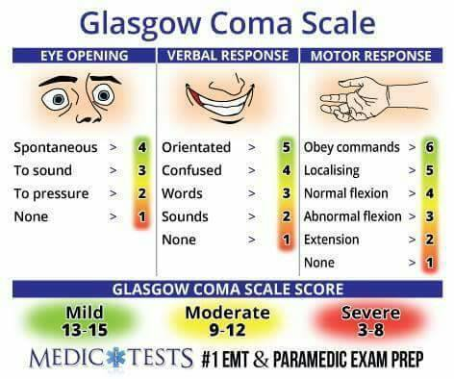
Cerebellum: responsible for coordination and movement.

Brain Stem: control heart rate, blood pressure, and respiration

Disease: comatose with abnormal pupillary and motor response
Toxic or Metabolic Disorder: coma with normal responses

Diagnostic tools: CT, MRI, PCT, EEG, PET, SPECT
*Most used for determining brain function: EEG, MRI and PET

Treatments
-Mannitol (Osmitrol): osmotic diuretic. Used to decrease ICP and inhibits reabsorption of water.
*Pulls water from interstitial spaces into the vascular space.
-Furosemide
-Morphine Sulfate
-Midazolam (Versed)
-Fentanyl (Sublimaze)
-Propofol (Diprivan)

-Decerebrate patients rigidly extend and pronate the 4 extremities and externally rotates wrists.
*Severe brain stem injury
*Late neurological decline
-Manifestations of ICP
1. Widened pulse pressure – difference between SP and DP
2. pupil changes
3. Changes in LOC
4. Nausea
5. Vomiting

Chapter 63 – Management of Patients with Neurologic Trauma

PG. 2055
Autonomic dysreflexia – acute life-threatening emergency that occurs as a result of exaggerated autonomic responses to stimuli that are harmless in people without SCI.

Complete spinal cord lesion – signifies loss of both sensory and voluntary motor communication from the brain to the periphery resulting in paraplegia or tetraplegia.

Concussion – temporary loss of neurologic function with no apparent structural damage to the brain.

Contusion – brain is bruised and damaged in a specific area because of severe acceleration-deceleration force or blunt trauma.

Incomplete spinal cord lesion – ability of the spinal cord to relay messages to and from the brain is not completely absent.
The injury can be classified according to the area of spinal cord damage
- Central
- Lateral
- Anterior
- Peripheral

Neurogenic bladder – bladder dysfunction that results from a disorder or dysfunction of the nervous system.

Paraplegia – paralysis of the lower body

Primary injury – consequence of direct contact to the head/brain during the instant of initial injury, causing extracranial focal injuries as well as possible focal brain injuries from sudden movement of the brain within the cranial vault

Secondary injury – evolves over the ensuing hours and days after the initial injury and results from inadequate delivery of glucose and oxygen to the cells.

Spinal cord injury (SCI) – an injury to the spinal cord, vertebral column, supporting soft tissue, or intervertebral discs caused by trauma. Major health disorder.

Tetraplegia – paralysis of all four extremities

Transection – complete severing of the spinal cord

Traumatic brain injury – injury that is a result of an external force and is of sufficient magnitude to interfere with daily life and prompts seeking of treatment.

Traumatic brain injury, closed (blunt) – occurs when the head accelerates and then rapidly decelerates or collides with another object and brain tissue is damaged but there is no opening through the skull and dura.

Traumatic brain injury, open (penetrating) – occurs when an object penetrates the skull, enters the brain, and damages the soft brain tissue in its path or when blunt trauma to the head is so severe that it opens the scalp, skull and dura to expose the brain.

Chapter 64 – Management of Patients with Neurologic Infection, Autoimmune disorders, and Neuropathies

PG. 2088
Ataxia – inability to coordinate movements.

Diplopia – double vision

Dysphagia – difficulty swallowing

Dysphonia – voice impairment

Hemiparesis – weakness on one side of the body.

Hemiplegia – paralysis of one side of the body

Neuropathy – disorder of the nervous system.

Paresthesia – sensation of numbness, tingling, or a pins and needles sensation.

Prion – pathogens smaller than a virus that resistant to stand methods of disinfection and sterilization.

Ptosis – drooping of the eyelids

Spasticity – muscle hypertonicity with increased resistance to stretch.

Chapter 65 – Management of Patients with Oncologic or Degenerative Neurologic Disorders

PG. 2112
Bradykinesia – overall slowing of active movement

Chorea – rapid, jerky, involuntary, purposeless movements.

Dementia – syndrome characterized by a decline in higher brain functioning, such as reasoning, with a pattern of eventual decline to perform basic ADL’s.

Dyskinesis – impaired ability to executive voluntary movements.

Dysphonia – voice impairment

Neurodegenerative – leading to deterioration of normal cells or function of the nervous system.

Papilledema – swelling of the optic nerve

Paresthesia – numbness, tingling, pins and needle sensation

Sciatica – pain and tenderness that radiates along the sciatic nerve that runs through the thigh and leg.

Spondylosis – degenerative changes occurring in a disc and adjacent to vertebral bodies.

-Read diabetes management section of ATI book: page 555, chapter 83
-Regular insulin can be given via IV
-Know whether an insulin is long or short acting
-Know which insulins can be mixed
-Know actual insulin names
-Know peak, with or w/o meal
-Dextrose 50% IV for unconscious patient
-short acting insulin eat 5 – 15 minutes after injection
-very long-acting insulin – absorbed over 24 hours – cannot be mixed – given once per day at the exact time every day.
-DKA metabolic emergency
-hyperglycemia
-fluid replacement is essential b/c of dehydration

ABG
pH: 7.35 – 7.45 (<7.35 acid and >7.45 alkaline or base)
PaCO2: 35 – 45 (<35 alkaline or base and >45 acid)
HCO3:22 – 26 (<22 acid and >26 alkaline or base)

Clinical manifestations for patients with type I diabetes and type II diabetes
Type 1
3P’s: polydipsia, polyphagia, polyuria, and weight loss
Thin
Symptoms appear suddenly
Onset <30 y/o
Islet cell antibodies
Complications: DKA
Insulin dependent

Type 2
Usually, overweight
Symptoms appear slowly.
3P’s: polydipsia, polyphagia, polyuria, and weight loss
Fatigue
Poor wound healing
Renal insufficiency
Cardio disease
Onset at any age, typically after 30 y/o
Can typically be controlled through diet and exercise
Complications: HHS
May need oral antidiabetic

Diabetic teaching/Care/nutrition/exercise/infection

Insulin administration/teaching
Administer sub q: abdomen, back of arms, thighs, upper butt
45 degrees for thin and 90 degrees if fluffy

Describe the mechanisms of action, the onset, peak and duration for each insulin
Rapid (shorter acting): eat within 5 – 15 minutes of injection
Lispro: onset 15 – 30 min, peak 30 – 90 min, less than or equal to 5 hours
Aspart: onset 15 min, peak 1 – 3 h, duration 3 – 4 hours
Glulisine: onset 5 – 15 min, peak 1 hour, duration 5 hours

Short Acting (regular): clear. Administered 20 – 30 minutes before a meal
Onset 30 – 60 min, peak 2 – 3 hours, duration 4 – 6 hours

Intermediate Acting (NPH): white and cloudy. Marked with N or L on bottle. Should eat food around peak
Onset 1 – 1.5 hrs, peak 4 – 12 hrs, duration up to 24 hours

Long Acting (glargine detemir): peakless.
Onset 3- 6 hrs, peak none, duration 24 hours

Rapid acting inhalation powder (Afrezza)
Onset less than 15 min, peak about 50 min, duration 2 – 3 hrs

Diabetes risk factors/Non & modifiable risk factors
Type 1
Family history
Obesity
Race / Ethnicity
>45 y/o
Hypertension
Hyperlipidemia
H/o gestational diabetes or baby >9 pounds

Type 2
-Genetics / lifestyle
-BMI greater than 26 kg/m²
-Physical inactivity
-HDL less than 35 mg/dL
-Triglycerides greater than 250 mg/dL
-Metabolic syndrome: cluster of risk factors for both cardio disease and type 2 diabetes
A patient has metabolic syndrome if 3 traits are present
- Central obesity
- Tryglycerides over 150 mg/dL
- HDL less than 40 mg/dL
- Hypertension greater than 130/85
- Fasting blood glucose greater than 100 mg/dL

DKA/HHS/Signs & symptoms/care/teaching/treatment
Diabetes complications/care/teaching/signs & symptoms/diet & exercise
LOC /ICP/signs & symptoms/teaching/care/medications/Cerebral Perfusion Pressure
Nursing interventions related to specific medication for the patient with increased intracranial pressure
Early signs and symptoms of intracranial pressure
Late signs and symptoms of intracranial pressure
Altered LOC signs/symptoms/care

Glasco Coma Scale/Cranial nerves

ABGs

Delegation/Prioritization
Hypoglycemia/Hyperglycemia treatments
Neurological assessment
Stroke/CVA
Clinical manifestations/nursing interventions/ medical/pharmacological treatments for patient with stroke/CVA

Deficits relating to left and right hemisphere strokes
Left side
-Responsible for language: Impaired speech / language aphasias
-Cautious
-Aware of deficits: depression, anxiety
-Impaired comprehension r/t language and math
-Impaired right/left discrimination
-Paralyzed right-side hemiplegia
-Visual field deficits
-Slow performance

Right Side
-Impulsive
-Impaired judgement
-Impaired time concept
-Rapid performance, short attention span
-Spatial-perceptual deficits
-Tends to deny or minimize problems
-Paralyzed left-side hemiplegia
-Visual field deficits
-Impaired time concept

Risk factors/ modifiable versus non-modifiable risk factors for ischemic stroke
High blood cholesterol
Smoking
Obesity
Medications
Diabetes
High BP
Alcohol
Stress
Physical activity
Medications

Seizures /types of seizures
Epilepsy – more than one unprovoked seizure
Focal (partial) onset seizure: originate in localized area of the brain
- Motor
- Nonmotor
- Awareness
  - Aware
  - Impaired awareness
  - Unknown awareness

Generalized onset seizure: involve both hemispheres which causes both sides of the body to react
- Motor
- Absence

Unknown onset seizure
- Motor
- Nonmotor
- Awareness
  - Aware
  - Impaired awareness
  - Unknown awareness
- Unclassified

Assessment/ diagnostic findings/ clinical manifestations/ medications/ for patient with seizure
Assessment: seizure history, Alcohol? Aura? Type? Limitations? Coping mechanisms? Work? Social or recreational activities?

Causes of Seizures: allergies, brain tumor cerebrovascular disease, CNS infection, withdrawal, childhood fever, head injury, hypertension, hypoxemia, metabolic and toxic conditions

-An EEG can provide diagnostic evidence of epilepsy and classify the seizure
-Medications do not cure seizures, but they do control them.
*Anticonvulsant
*Phenytoin (Dilantin)
*Levetiracetam (Keppra)
*Phenytoin metabolite (Cerebyx)

Most common drugs used to control seizures include:
- Tegretol: blood dyscrasias
- Klonopin: hepatotoxicity, thrombocytopenia
- Neurtontin: leukonpenia
- Trileptal: hepatotoxicity
- Dilantin: neuropathy, gingival hyperplasia
- Topamax: nephrolithiasis
- Depakote: hepatotoxicity
*IV diazepam (Valium), lorazepam (Ativan), fosphenytoin (Cerebyx)

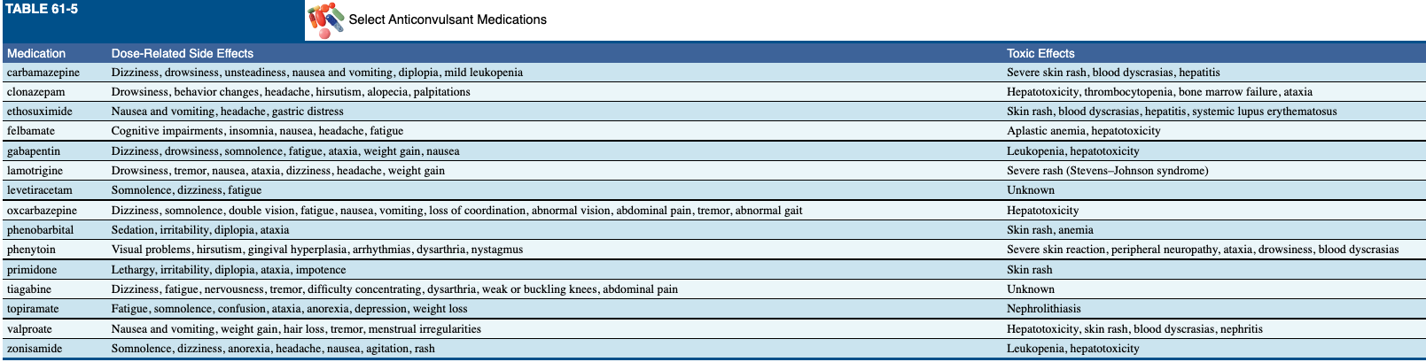

Care of the patient during and after seizure
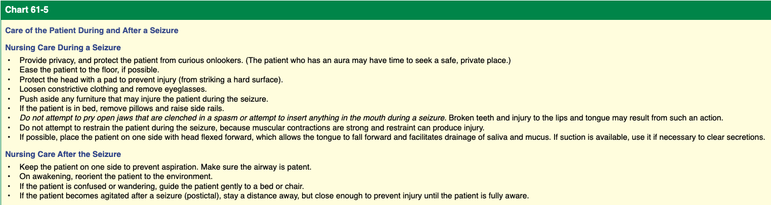

Brain Tumor/ clinical manifestation/Medical/pharmacological management/potential complications/ nursing intervention

