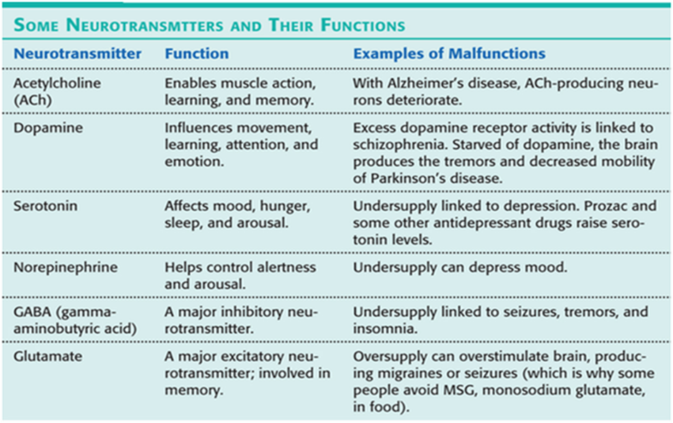
Exam # 3
Study Guide
1141
CNS / GI / PAIN

NSAIDS mechanism of action: to inhibit the enzyme COX which is needed for prostaglandin synthesis.

The importance of combining levodopa and carbidopa for a patient with Parkinson’s/Patient education
To decrease symptoms of PD and parkinsonism carbidopa permits more levodopa to reach the striatum nerve terminals where levodopa is turned into dopamine. With the use of carbidopa less levodopa is needed.
Education: taper off medication, discolored urine that darkens with exposure to air and may stain clothes, do not crush or chew extended-release tablets

Active ingredient in over the counter sleeping medication
Antihistamine like diphenhydramine

Loperamide / Lomotil patient education and mechanism of action, side effects
Loperamide (Imodium) – treats acute diarrhea caused by e. coli, opioid, decrease GI motility
-Patient teaching: may cause drowsiness, rinse mouth frequently and good oral hygiene to treat dry mouth, avoid alcohol.
-Side effects: drowsiness, constipation
-Action: inhibits or slows peristalsis, prolongs transit time in intestines
Diphenoxylate with atropine (Lomotil) – treats acute diarrhea, opioid
-Action: inhibits excessive GI motility, structured like analgesic without the effect
-Side effects: dizziness, constipation
-Patient education: do not take more than prescribed to avoid addiction, may cause drowsiness, rinse mouth and good oral hygiene to treat dry mouth, avoid alcohol

Benztropine (Cogentin)/Selegiline HCL mechanism of action and patient education
Benztropine (Cogentin) – antiparkinson agent
-Action: increase effect of dopamine by reducing effects of ACh
-Patient education: avoid alcohol, caffeine, and aspirin. Relieve dry mouth with hard candy, ice chips, or sugarless gum. Sunglasses for photophobia. Void before taking med to minimize urinary retention. Regular eye exams - Contraindicated in patients with glaucoma.

Selegiline – MAO-B inhibitor - antiparkinson agent
-Action: inhibits catabolic enzymes of dopamine and extends its action. Used for early treatment of PD. If used with carbidopa levodopa the carbidopa levodopa dose is decreased
-Patient education:

Onset of action for motion sickness medication
30 minutes before travel. Cyclizine hydrocholoride, dimenhydrinate, meclizine hydrochloride, and diphenhydramine

Signs and symptoms of neuroleptic malignant treatment and medication to treat same (antipsychotic)
-rare and potentially fatal
-S/s: Sudden high fever, muscle rigidity, tachycardia, incontinence, confusion, BP fluctuations, dysrhythmias, seizures, hyperthermia, altered mental status, profuse diaphoresis, bp fluctuations, acute renal failure, respiratory failure, coma.
-Treatment: d/c antipsychotics, hydration, hypothermic blankets, antipyretics, benzodiazepines and muscle relaxants

Patient who does not respond to a histamine 2 blocker to treat peptic ulcer disease should be changed to what class of medication?
PPI - omeprazole, lansoprazole, rabeprazole, pantoprazole, esomeprazole, dexlansoprazole

How do you test for the presence of H. pylori?
Urea breath tests detect the presence of Helicobacter pylori, the bacteria that can live in the mucosal lining of the stomach and cause peptic ulcer disease. After the patient ingests a capsule of carbon-labeled urea, a breath sample is obtained 10 to 20 minutes later. Because H. pylori metabolizes urea rapidly, the labeled carbon is absorbed quickly; it can then be measured as carbon dioxide in the expired breath to determine whether H. pylori is present.

Chlorpromazine patient education (antiemetic and antipsychotic)
-possibility of extrapyramidal symptoms and tardive dyskinesia
-change positions slowly due to orthostatic hypotension
-avoid alcohol
-wear sunscreen and protective clothing when exposed to sun
-good oral hygiene to minimize dry mouth

What over the counter medications to avoid when taking monoamine oxidase (antidepressant)?
Vasoconstrictors and cold medicines that contain phenylephrine and pseudoephedrine. Both can cause a hypertensive crisis.
-frequent BP monitoring is essential
-usually not prescribed for depression unless other drugs have failed
-very effective treatment for depression when taken properly

Normal range for salicylate level and signs of toxicity
Normal range: 15 – 30 mg/dL
Toxic range: > 30 mg/dL
Severe toxicity: >50 mg/dL
-Signs of toxicity: tinnitus, dizziness, diaphoresis, H/A?
Monitor for signs of bleeding such as tarry stools, bleeding gums, petechiae (round red spots), eccymosis (excessive bruising), purpura (large red spots)

Patient instruction regarding taking antacid with an anticholinergic
Antacid can be taken 2 hours after anticholinergic

Which laboratory test should be monitored for a patient who is taking Maalox (Magnesium hydroxide aluminum hydroxide) frequently?
Renal function, Magnesium, calcium, phosphate

Medications used to treat Parkinson’s disease
- Anticholinergics – increase the effects of dopamine by reducing the effects of Ach
- Dopaminergic replacement therapy – stimulates dopamine production in the brain
- Dopamine agonists – mimic effects of dopamine by stimulating DA receptors
- MAO-B inhibit inactivation of DA
- COMT inhibitor – inhibit COMT which deactivates DA

Allopurinol (antigout) should be used with caution with which medical condition/ patient education
-Monitor renal function since allopurinol is excreted through the kidneys.
-Teaching: keep regularly scheduled appointments for regular lab testing and increase fluid intake to increase drug and uric acid excretion

Side effects of Fluphenazine (Prolixin) (antipsychotic)
Drowsiness, dizziness, headache, dry mouth, blurred vision, hyperhidrosis, weight gain, constipation, erectile dysfunction, urinary retention, peripheral edema, skin hyperpigmentation.

Patient education and uses for Metamucil and Sucralfate
Metamucil: bulk forming laxative
-absorbs water into intestines
-increases bulk and peristalsis in 8 – 12 hours
-Side effects: abdominal cramps, nausea, vomiting, diarrhea, gas
-Should be mixed in a glass of water or juice followed by half to full glass of water. Insufficient fluid intake can cause intestinal obstruction.
Sucralfate: pepsin inhibitor
-prevents gastric mucosal injury from drug induced ulcers
-forms a protective covering on the ulcer surface: protects ulcer from acid and pepsin
-taken before meals and at bedtime
-antacid can be taken 30 minutes before or after

What medication is used to treat signs of remission and exacerbation in a patient with multiple sclerosis?

Phentermine should be avoided in patients with which condition?
Cardiovascular disease, hyperthyroidism, uncontrolled hypertension, Hx drug abuse, agitation, glaucoma, concurrent or recent use of MAO inhibitor therapy, concurrent SSRI antidepressants.

Carisoprodol (Soma) nursing indications (muscle relaxant)
-use in addition to rest and physical therapy in the treatment of muscle spasm associated with acute painful musculoskeletal conditions.

Patient education:
Ambien (sleep aid) – drowsiness, lethargy, headache, hot flashes, dizziness, edema, n/v, amnesia

Aspirin – do not take with alcohol or highly protein bound substances such as warfarin, discontinue 7 days prior to surgery, may cause GI distress

Acetaminophen – do not take for more than 10 days, do not exceed recommended dosage, avoid alcohol, hepatotoxic

Colchicine (antigout) – take with food. Contraindicated in patients with severe renal, cardiac, or GI problems. High doses cause n/v, diarrhea, and abdominal pain.

Doxepin (antianxiety agent) – given at night because of sedative effect, for agitated depressed persons, gradually decreased to avoid withdrawal. May cause drowsiness, dizziness, blurred vision, orthostatic hypotension, dry mouth, constipation, erectile dysfunction, weight gain, and skin irritation.

Indomethacin (antirheumatic) – very irritating to the stomach so take with food.

Flexeril (muscle relaxant) – do not stop abruptly: discontinue over 1 week, avoid alcohol and other depressants.

Cholestyramine (lipid lowering agent) – mix thoroughly in water or juice

Metoclopramide (antiemetic) adverse effect in children
Extrapyramidal symptoms: acute dyskinesias, akathisia: restlessness, dystonia: involuntary muscle contraction, tardive dyskinesia: involuntary facial movements

Which antacid can cause an acid rebound (excess acid secretion)?
Sodium bicarbonate
Calcium carbonate:

First line treatment for gout
Uric acid biosynthesis inhibitors i.e. Allopurinol

Which antiviral medication that can be used to treat Parkinson’s disease?
Amantadine – decreases the symptoms of PD. Synthetic antiviral agent. Used for early treatment of PD which delays the need for levodopa.

Pyridostigmine bromide (Mestinon) drug class and mode of action (muscle strengthener)
-class: antimyasthenics
-action: inhibits the breakdown of Ach and prolongs its effects

Infliximab (antirheumatic) mode of action
Binds to TNF and blocks it from attaching to TNF receptors on synovial cell surfaces; reduces infiltration of inflammatory cells and delays inflammatory process
-class: immunomodulator
-treats moderate to severe RA
-administered IV over 2 hours

Ondansetron/ metoclopramide uses and mode of action
Ondansetron (antiemetic)
-treats postoperative and chemo and radiation induced vomiting.
-blocks serotonin receptors in the CTZ and vagal nerve terminals in the upper GI tract
-most effective antiemetic in suppressing vomiting from cancer chemotherapy
Metoclopramide (antiemetic)
-prevention and treatment of postoperative and chemo-induced nausea and vomiting, diabetic gastroparesis, and GERD
-avoid alcohol and CNS depressants.
-suppresses dopamine receptors in CTZ

Chapter 17 – Stimulants

Chapter 18 - Depressants
Chapter 20 – Parkinson’s Alzheimer’s
Symptoms: rigidity, tremors, gait disturbance, and bradykinesia
-drugs used to treat PD replace the dopamine deficit.

Chapter 21 – Neuromuscular spasms
Myasthenia gravis: autoimmune disease that impairs the transmission of messages at the neuromuscular junction resulting in skeletal muscle weakness that increases with muscle use.
-symptoms are caused by autoimmune destruction of Ach.
-respiratory arrest may result from respiratory muscle paralysis
-serum testing will reveal AChR antibodies.
-Treated with AChE inhibitors which makes more ACh available.
-S/s: ptosis, diplopia, muscle weakness, dysphagia, dysarthria, respiratory muscle weakness
Multiple sclerosis: neuromuscular autoimmune disorder that attacks the myelin sheath of nerve fibers causing lesions known as plaques.
-plaques are found using MRI
Muscle spasms: causes include injury of motor neuron disorders such as MG, MS, cerebral palsy, spinal cord injuries.
-spasticity of muscles can be relieved by muscle relaxants.

Chapter 22 – Mental and Behavioral Health Drugs
Neuroleptic: any drug that modifies psychotic behavior and exerts an antipsychotic effect
-GABA transmitter regulates anxiety
-benzodiazepines: antianxiety drugs bind to GABA receptor sites

Chapter 23 – Antidepressants
Chapter 24 – Anti inflammatory

Chapter 25 - Analgesics
Chapter 42 – GI disorders
-Side effects of antihistamines antiemetic: drowsiness, constipation, and dry mouth
Antidiarrheals: taken no more than 2 days in a row and should not be taken if fever is present.

Chapter 43 – Antiulcer drugs
H2: Histamine 2 Blockers treat gastric and duodenal ulcers.
-reduce gastric acid secretion and concentration
-antacids can be given 1 hour before or after.
-Meds: famotidine, cimetidine, nizatidine
-short term use
PPI’s
-suppress gastric acid secretions by inhibiting the hydrogen/potassium ATPase enzyme system located in the gastric parietal cells.
-omeprazole, lansoprazole, rabeprazole, pantoprazole, esomeprazole, dexlansoprazole
-take before meals
-monitor liver enzymes
Antacids: neutralize HCL and reduce pepsin activity

