Peds NUR 2310

Chapter 25 – Growth and Development of the Newborn and infant (pgs. 923 – 954)
Newborn/neonatal: birth – 28 days
Infancy: birth to 12 months
Growth: increase in physical size
Development: sequential process by which infants and children gain various skills and functions.

Growth and Development
-the order in which developmental skills are acquired is consistent from infant to infant
-screening tools to assess development
1. Ages and stages questionnaire (ASQ)
2. Infant -Toddler checklist (ITC)
3. Infant Development Inventory (IDI)
4. Parents evaluation of developmental status-developmental milestones (PEDS-DM)
-adjusted age: Chronical age – the # of weeks premature

PHYSICAL GROWTH
Weight
-average newborn 3400 kg or 7.5 pounds
-gains 20 – 30 g/day on average
-double weight by 4 – 5 months of age
-triple weight by time they are 1 y/o
Length
-average newborn is 50 cm or 20 inches long
-grows more rapidly in first six months than in second six months
-length increases 50% by 1 year old
Head Circumference
-average is 35 cm or 13.5 in
-increases 10 cm from birth to 1 y/o
PHYSIOLOGIC CHANGES
Neurologic system
States of consciousness
- Deep sleep: Sleeping with eyes closed and no movement.
- Light sleep: Sleeping with eyes closed; rapid eye movements and irregular movements may be noticed.
- Drowsiness: Eyes may close or be half-lidded; the infant may be dozing.
- Quiet alert state: The infant’s eyes are wide open, and the body is calm.
- Active alert state: The infant’s eyes are open; body movements occur.
- Crying: The infant cries or screams and it is difficult to gain the infant’s attention

Brain Growth
-brain grows a lot first 2 years of life
-by 6 months the brain is half its adult size
-1 y/o brain weights 2.5 times what it did at birth
-anterior fontanelle remains open until 12-18 months of age to accommodate the growth
-during first few months of life reflex is replaced by purposeful behavior

Reflexes
-Primitive reflexes: all dimmish within first few months of life except Babinski
1. Moro: birth – 4 months
2. root: birth – 3 months
3. suck: birth – 2-5 months
4. asymmetric tonic neck: extremity extended on side of body where head is turned and opposite extremity
is flexed. Birth – 4 months
5. plantar: birth – 9 months and palmar grasp: birth – 4-6 months
6. Step: birth – 4-8 weeks
7. Babinski disappears at 1 y/o: birth – 12 months
-Protective reflexes (postural responses) – related to maintaining equilibrium – remain for life
1. Righting: develops 4-6 months
2. Parachuting: develops 6-7 months
Respiratory System
-newborn: 30-60 breaths/min
-1 y/o: 20-30 breaths/min
-the respiratory system doesn’t reach adult levels of maturity until 7 y/o
-they lack IgA/Immunoglobin A which contributes to frequent infections.
IgA are antibodies that help fight off sickness
Cardiovascular System
-heart doubles in size over the first year of life
-newborn pulse rate 120-140 bpm
-1 y/o: 100 bpm
-Newborn BP: 60/40
-1 y/o BP: 100/50
GI
Digestion
-small intestine 270 cm long and grows to adult length in first few years of life
-stomach at birth can hold 0.5 – 1 oz and at 1 y/o can hold 3 full meals and several snacks per day
Duodenum: 3 important enzymes
- Trypsin: protein digestion
- Amylase: complex carb digestion – reaches adult levels by 5 months
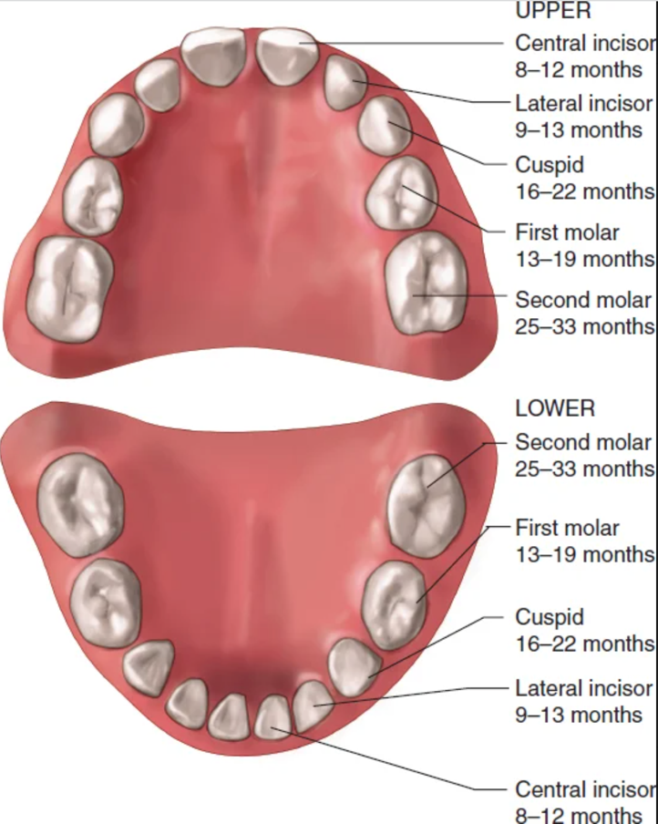
- Lipase: fat digestion – reaches adult levels by 5 months
-liver is immature at birth: it starts creating and secreting bile at about 2 weeks

Stools
-newborn stool: meconium: result of amniotic fluid swallowed in the womb
-first few days of life stools become yellowish or tan
-formula fed stools: consistency of PB
-breastfed stool: looser in texture and seedy
-call doc if stools are red, white, black, mucous like, frequent and watery, frothy and foul smelling, hard, dry, formed or pellet like or if the baby is vomiting.

GU
-in infant total body water is greater than it is in adults therefore infant is more susceptible to dehydration
Integumentary System
-in utero infant is covered with vernix caseosa
-acrocyanosis: blueness of the hands and feet is normal in newborns: decrease over first few days of life
-mottling: pink and white marbled appearance caused by immature circulatory system: decreases over the first few months of life
Hematopoietic System
-after birth erythrocyte production decreases significantly
-during last 3 months of gestation iron stores are transferred to the baby
-iron stores are sufficient for the first 6-9 months of life but will be depleted if not replenished.
Immunologic System
-IgG (most common: protect from infection by remembering which germs you’ve been exposed to) received through placenta which provides immunity for the first 3-6 months of life
-IgG reaches 60 % of adult levels by 1 y/o
-IgM (first antibody the body creates when fighting a new infection): produced in significant amounts after birth reaching adult levels by 9 months
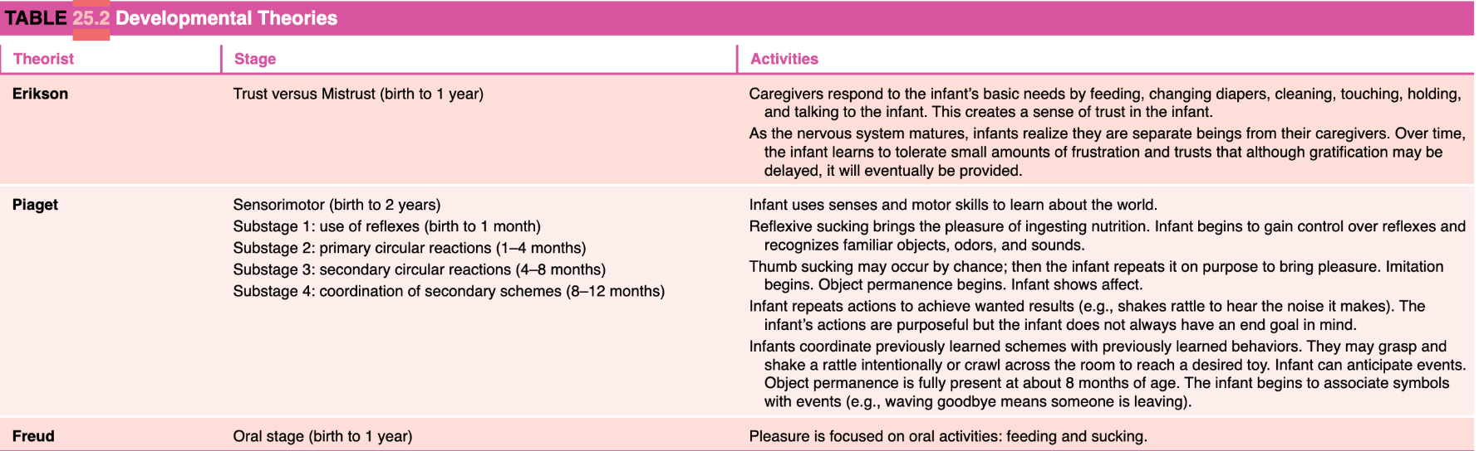
-IgA, IgD, IgE production increases rapidly and matures in early childhood

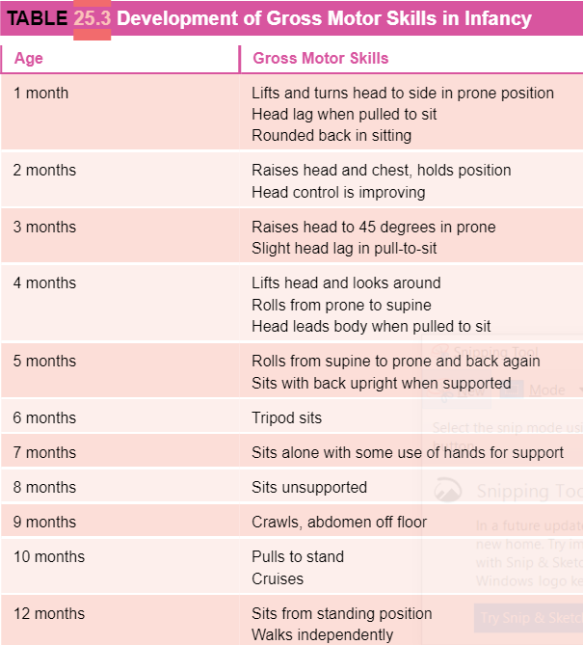
PSYCHOSOCIAL DEVELOPMENT
-infancy stage Trust vs Mistrust-development of sense of trust in 1st year is crucial

COGNITIVE DEVELOPMENT
-Piaget first stage of cognitive development: sensorimotor (birth – 2 y/o)
-object permanence develops between 4 and 7 months and solidifies by 8 months

MOTOR SKILL DEVELOPMENT
Gross Motor Skills
-gross motor skills refers to those that use the large muscles such as head control, rolling, sitting, and walking.
-develop in cephalocaudal fashion: head to tail
Fine Motor Skills
-includes maturation of hand and finger use.
-develop in proximodistal fashion (center to periphery)

SENSORY DEVELOPMENT
Sight
-newborns are nearsighted.
-at 1 month they can recognize by sight who cares for them
-binocularity: the ability to fuse two ocular images into one cerebral picture. Begins at 6 weeks and is well developed at 4. Months.
-Full color, distance vision, and tracking develops at 7 months
Hearing
-fully developed at birth
-prefer human sounds to non-human
-at 1 month recognizes sounds of those who they know best.
Smell and Taste
-smell develops rapidly. Can distinguish mom from others within 7 days.
-prefer sweet tastes to all others.
Touch
-responds to smooth strokes. Doesn’t like coarse touching.
-will cry in response to rough handling

COMMUNICATION AND LANGUAGE DEVELOPMENT
-1-3 months coos and uses differential crying
-4-5 months simple vowel sounds, laughs, raspberries, responds to name and to no
-4 – 7 months distinguish emotions based on tone of voice
-6 months squealing and yelling
-7-10 months babbling and mamamamamama w/o meaning. Responds to commands
-9-12 months attaches meaning to mama and imitates other speech sounds
-12 months two or three recognizable words with meaning. Recognizes objects by name, imitates animal sounds. Imitates words and may say uh-oh.

SOCIAL AND EMOTIONAL DEVELOPMENT
-newborn spends most of their time sleeping
-2 months ready to socialize
-real smile at 2 months
-3 months interacts with caregiver
-3-4 months mimics movements
-6-8 months patty cake and peek a boo
Stranger anxiety
-starts around 8 months
Separation anxiety
-last few months of infancy.
Temperament
-Temperament is an individual’s nature

PROMOTING HEALTH GROWTH AND DEVELOPMENT
Promoting growth through play
-infants: solitary play, prefer basic toys
Promote early learning
-reading books increases reading comprehension
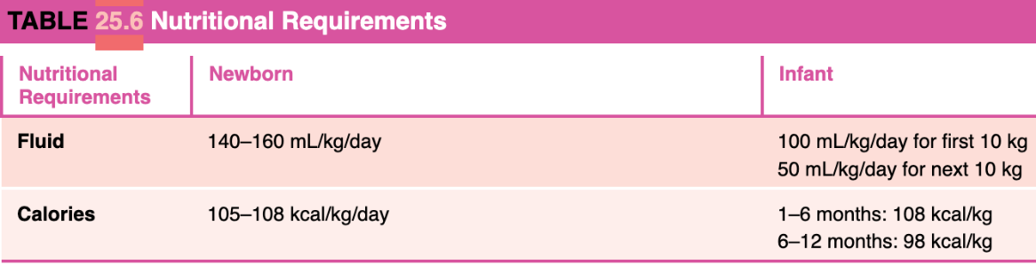
Promoting Nutrition
-solid foods can be introduced at 6 months

Class Notes
Growth and Development
-know what kids can do and what they need at each stage
-know the different types of families
-Denver chart: length and weight and we compare it to national percentiles
-Erickson’s stages of development
-Reflexes and when they disappear
-motor skills: gross motor skills and fine motor skills of holding bottle at 6 months
-car seat safety
-infant play: solitary
-sleep patterns
-immunization schedule: what are the contraindications?
-immunizations with 3 series: DTAP, RVS polio, influenza, pneumococcal
-Toddlers: 1-3 hold for physical exam b/c they are not trusting. Might have to be restrained. Examine through play
-Toddler motor skills: when do they walk? By 2 they should go up and down steps. Know when they can handle cup (15 months) and spoon (18 months)
-Hospitalized: separation anxiety and loss of self-control. Encourage parents to be there. Examine in lap. Will cry a lot.
-injury prevention
-toddlers parallel play and do not like sharing
-24-30 oz whole milk – low fat after 2 years
-they can eat finger foods cut into pieces, so they don’t choke
-sleep 11-12 hrs. per day including nap: needs bedtime routine
-3-6 y/o: preschoolers prefer sitting by themselves during examination
-give them opportunity to examine what you are using for inspection
-praise them for being good
-motor skills: ride tricycle and stand on one foot
-5 y/o jump rope and catch ball w/o problem
-separation anxiety, fear of abandonment, loss of self-control, allow choices whenever possible
-injury prevention: bodily harm – taught about safety in school
-associative play – group play – magical and dramatic play
-picky eaters: give them what they want. Become less picky until about 5 y/o
-sleep 12 hours per day
-experience sleep terrors: use night lights
-6-12 y/o school age: undress themselves, prefer standing to be examined
-hospital: issues with loss of control
-injury prevention
-cooperative play: follow rules and meet goals
-nutrition: eat anything: healthy appetite
-sleep 9 hours per day
-12-20 adolescents: undress in private and provide gown. Very private. Examine w/o parent.
-Hospital: loss of control, body image, bulimia or anorexia, withdrawn, denial
-injury: STD’s, bullying causing suicide or self harm, substance abuse
-activities: sports, socializing with friends, gaming
-Nutrition high metabolism: eating disorders
-sleep pattern: sleep needs increase
-vaccine:meningococcal vaccine booster 16-18 y/o

Safe drug administration
-how to instill drops
-injection in newborn: vastus later
2 y/o : albuterol
-toddler: oral med

-nonpharmacological interventions: kangaroo care and non nutritive sucking
-Toddlers

S/s and nursing care
Croup – bring to hospital, inspiratory stridor, put in bathroom with water running hot which helps to ease the problem

Bronchitis
Otitis media: pulling at ear – trying to relieve pressure, lymph nodes swell, fever, poor eaters
Bronchodilators
Corticosteroids
RSV
Tonsilitis: if touching – time for surgery
asthma

respiratory acidosis and alkalosis

infant RVS: nasal flaring,

treatments: chest physiotherapy, metered dose inhaler, nebulizing aerosol
pulse oximeter: where?

When do we give antibiotics? Bacterial infections

Avoid fungal oral infections? Rinse mouth and brush gums

Oxygen therapy: early vs late signs of hypoxemia
O2 delivery systems
Non rebreather: 100%
-suctioning mouth before nose

Lice
-school age
-can see eggs: shampoo, comb out, treat whole home, put everything that there head touched in wash and secondary treatment may develop infection from bites
-conjunctivitis: starts in one eye and can spread to another
-rubella: german measles: direct contact and droplet. 14-21 incubation. S/s: low grade fever, sore throat, headache, malaise
-Varicella: droplet and contact. Incubation 2-3 weeks. Communicable 1 day before when lesions appear until they crust. S/s: macules start in trunk and spread outwards
-Varicella can become herpes zoster (shingles)

Study Guide
INFANT (0-1 YEAR)
TODDLER (1-3 YRS)
PRESCHOOL (3-6 YRS)
SCHOOL AGE (6-12 YRS)
ADOLESCENT (12-20 YRS)
Growth and Development
Types of Families

Erikson’s Stages of Development
Trust vs Mistrust- birth to 1 year
Autonomy vs Shame and doubt - ages 1 to 3
Initiative vs Guilt- ages 3 to 6
Industry vs Inferiority- ages 6 to 12
Identity vs Role Confusion- ages 12 to 20

Physical Examination
Infant: supine or prone in parents lap, completely undress, leave diaper on boy, distract, smile, gentle voice
Toddler: supine or prone in parents lap, sitting or standing on/by parent, parent remove outer clothing, remove underwear as body part is examined, allow to inspect equipment, use restraint when appropriate, praise for cooperation.
Preschooler: prefer standing or sitting, self-undress, allow equipment inspection, demonstrate use, story about procedure, paper doll technique, give choices when possible
School-aged
Teenager:

Motor skills
Infant
Toddler
Preschooler
school-aged
teenager

Nursing plan for hospitalized
Infant: separation anxiety, stranger anxiety, sleep deprivation, sensory overload, excessive irritability
Toddler: separation anxiety, loss of control, fear of the dark, cries if parent leaves, associates pain with punishment, allow choices when possible, provide night light.
Preschooler: separation anxiety, fear of abandonment, loss of control, fear of dark and monsters, difficulty separating fantasy from reality, fears ghosts and monsters, withdrawal, projection, aggression, and regression., explain procedures, provide night light or flashlight
school-aged
teenager

Common Injury
Infant: aspiration, body harm, burns, drowning, falls, poisoning, MVA, suffocation
Toddler: aspiration, body harm, burns, drowning, falls, poisoning, MVA, suffocation, choking
Preschooler: bod harm, burns, drowning, MVA, learning about safety in school
school-aged
teenager

Play
Infant: rattles, teething toys, balls, mirrors, blocks, bright colored toys, pat-a cake, solitary play
Toddler: parallel play, thick crayons, large piece puzzle, finger paints, playing with blocks, push pull toys
Preschooler: associative play, play in groups but few to no rules
school-aged
teenager

Nutrition
Infant: breast is best first 6 months, solids at 4-6 months (cereal, veg and fruit, then meat. Introduced one at a time over 4-7 days to observe for allergy.
Toddler: picky eaters, 24-30 ounces milk, whole to low fat at 2 y/o, finger foods, adult supervision while snacking
Preschooler: eat ½ cals that adults do (1800 cals/day). Picky eaters until 5 y/o
school-aged
teenager

Night Terrors
-fears become apparent during toddlerhood
-preschooler: still present relieved by night light and bedtime routine.

How to administer ear drops
- <3 y/o pinna down and back
- > 3 y/o pinna up and back

Administering oral medication to a toddler

Prevent psychological and physical stress: atraumatic care

Non-pharmacological interventions
-non-nutritive sucking
-Kangaroo care

Home safety

Respiratory & EENT
Tonsillitis: inflammation of the tonsils. Can be viral or bacterial in nature.
S/s:
Treatment: management symptoms. Humidified air if mouth breathing, ibuprofen or Tylenol for fever and pain. Popsicles and ice chips for maintain hydration. Maybe tonsillectomy.
Nursing Care: promote airway clearance, maintain fluid volume

Bronchitis – inflammation of trachea and major bronchi. Usually caused by URI. Usually recovers in 5-10 days.
S/s:
Treatment: supportive care. Administer expectorant. Adequate hydration.
Nursing Care: Ascertain hx. Usually URI. Note fever, dry hacking cough that might become productive, rales.

Croup: usually 3 months – 3 y/o get croup. Larynx, trachea and bronchi affected.
S/s: barking cough, inspiratory stridor, slight temp, restlessness
Treatment: corticosteroids to decrease inflammation, racemic epinephrine aerosols to decrease edema
Nursing Care: teach parents symptoms of respiratory distress and to monitor child after treatment.

Epiglottis: usually 1-8 y/o. inflammation and swelling of the epiglottitis. Rare since extensive use of Hib vaccine.
S/s:
Treatment: airway management and support, IV antibiotics, corticosteroids
Nursing Care: if stridor occurs, take child to steamy bathroom for 10 minutes, lateral neck radiograph may be used to diagnose epiglottitis.

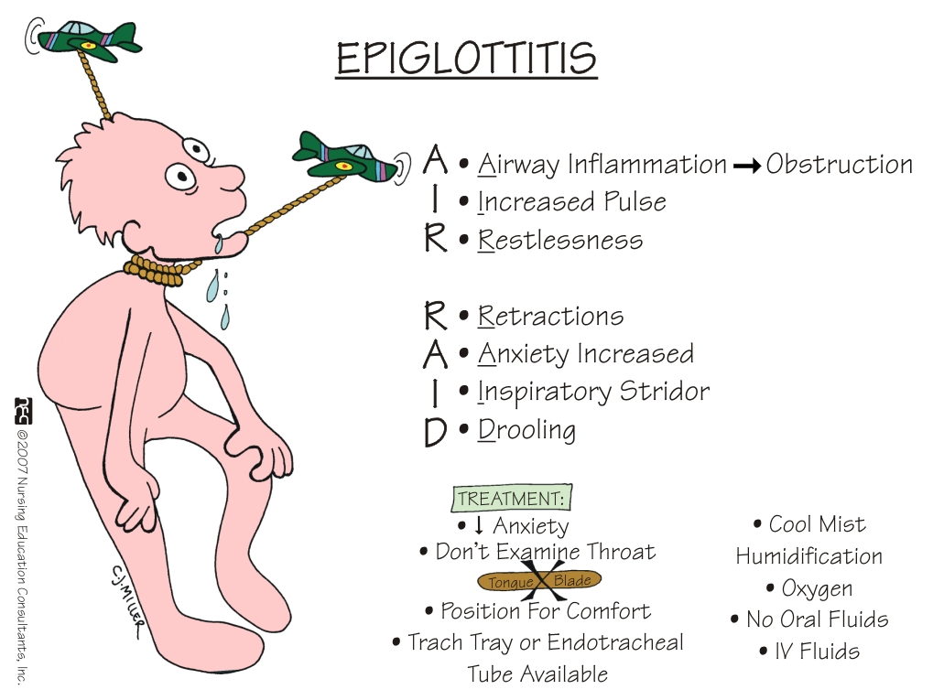

Otitis media
S/s:
Treatment:
Nursing Care:

Asthma: chronic inflammatory airway disorder: airway hyperrespon
S/s:
Treatment:
Nursing Care:

SIDS
S/s:
Treatment:
Nursing Care:

Respiratory acidosis and alkalosis
S/s:
Treatment:
Nursing Care:
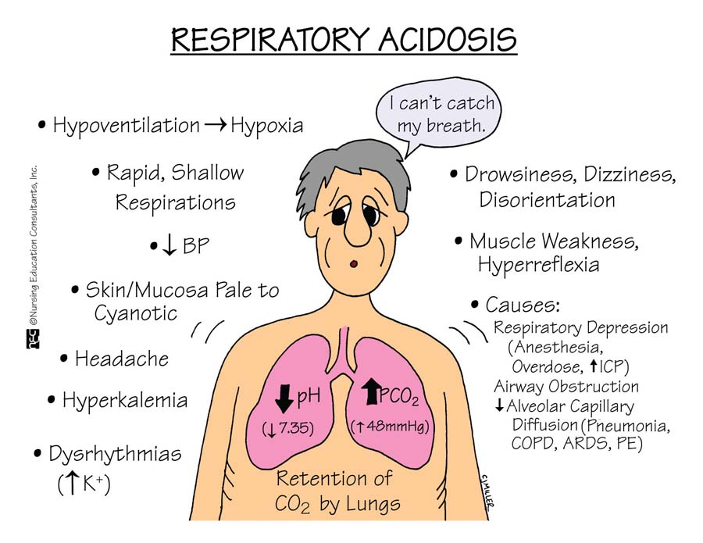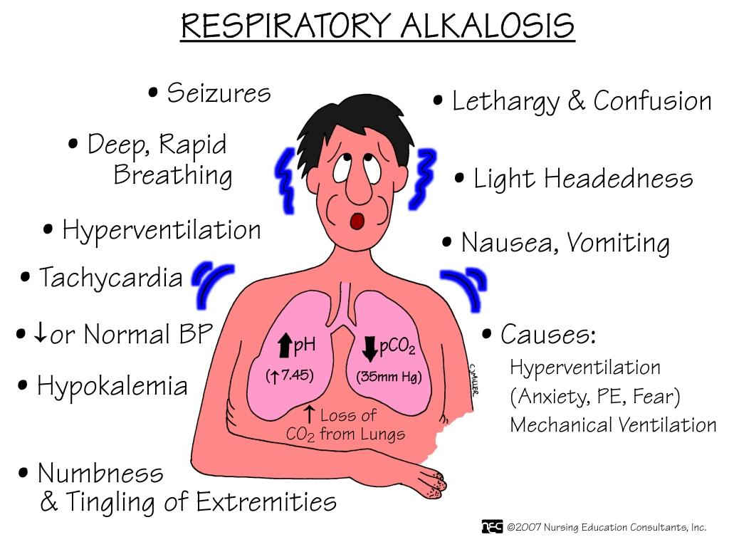

Respiratory distress syndrome
S/s: tachycardia, tachypnea, increased work of breathing, nasal flaring, retractions
Treatment:
Nursing Care: supportive in ICU. Monitor respiratory and cardiovascular function.

Chest physiotherapy
S/s:
Treatment:
Nursing Care:

Inhaler
S/s:
Treatment:
Nursing Care:

Hypoxemia early signs and late signs
S/s: early: tachypnea, tachycardia, restlessness, pallor, respiratory distress (accessory muscle use, nasal flaring, tracheal tugging, adventitious breath sounds)
Late: confusion and stupor, cyanosis, bradypnea, bradycardia, hypotension or hypertension
Treatment:
Nursing Care:

Visual impairments
S/s:
Treatment:
Nursing Care:

Hearing impairments
S/s:
Treatment:
Nursing Care:

Communicable diseases
Conjunctivitis
- Spread: direct contact
- Incubation: depends on the infection
- Communicability:
  - Viral: appears secondary to a viral infection (celars 7-14 days)
  - Bacterial: starts in one eye, spreads to the other- treat with antibiotics
  - Allergic: clears with allergy medication
Findings:
- Pink or red color in the sclera of the eyes
- Swelling of the conjunctiva
- Excessive tearing
- Yellow-green purulent discharge from the eyes
- Crusting of the eye lids in the morning

Rubella (German Measles)
- Spread: direct contact, droplet
- Incubation: 14-21 days
- Communicability: 7 days before and 5 days after the rash appears
Findings:
- Low grade fever and sore throat
- Headache
- Malaise
- Cough
- Lymphadenopathy
- Red rash that starts on the face and spreads to the rest of the body, lasting 2-3 days

Lice (pediculosis capitis)
-transmitted through direct contact
-S/s:
-Treatment: Pediculicide / ovicidal shampoo or rinse
1. permethrin (NYX)
2. Pyrethrin
3. Comb
4. Home hygiene
-Complications: secondary bacterial infection

Varicella (chicken pox)
- Spread: direct contact, droplet, contaminated objects
- Incubation: 2-3 weeks, usually 14-16 days
- Communicability: 1 day before lesions appear until all the lesions have formed crusts
Findings:
- 1-2 days prior to rash:
  - Fever
  - Fatigue
  - Loss of appetite
  - Headache
- Rash
  - Macules start in center of trunk and spread out
  - Progress from macules, to papules, to vesicles, and crust formation follows
  - Scabs appear in 1-2 weeks

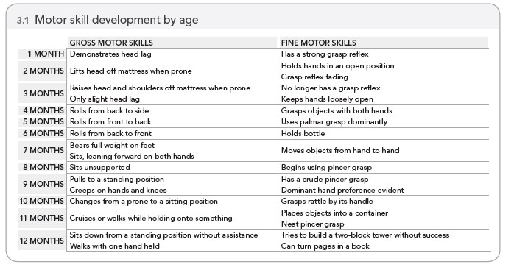
Motor Skills

