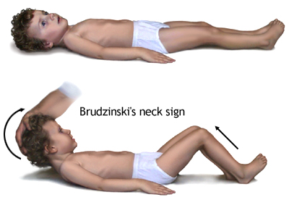
Neurological Disorders – Chapter 38 (PGS. 1327 – 1374)

Meningitis (bacterial and viral) – inflammation of meninges
-Meninges are connective tissues that cover the brain and spinal cord
-Droplet precautions
-Decrease environmental stimuli
-NPO if decreased level of consciousness
-Keep room cool, slightly elevate head of bed
-Seizure precautions
Cause
-bacteria, virus, or fungus in CSF
Expected Findings
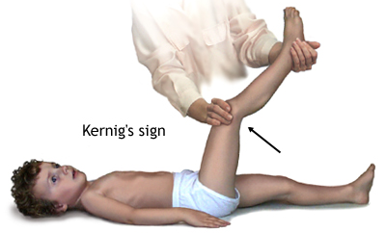
-photophobia, vomiting, irritability, and headache
-Newborn: poor muscle tone, weak cry, poor suck, refuses feeding, vomiting, diarrhea, fever, hypothermia, supple neck, LATE finding: bulging fontanel
-3 months – 2 y/o: seizures with a high-pitched cry, fever, irritability, bulging fontanels, nuchal rigidity, poor feeding, vomiting, Brudzinski’s, and Kernig’s sign
-2 y/o – adolescence: seizures, nuchal rigidity, positive Brudzinski and Kernig sign, fever and chills, headache, vomiting, irritability, restlessness leading to drowsiness, delirium, stupor, and coma
-petechiae or purpuric-type rash due to meningococcal infection
-involvement of joints with meningococcal and Hib infection
-chronic draining ear with pneumococcal infection
Complications
-neurological dysfunction
-monitor for increased ICP
Diagnostic Procedure
Lumbar Puncture: definitive test for meningitis
-insert needle into subarachnoid space between L3 and L5
-measure spinal pressure and collect a sample of CSF
-Void prior to procedure
-apply topical anesthetic 45 min – 1 hour before procedure
-side lying, head flexed, knees to chest
-use distraction methods
-can be sedated with fentanyl or midazolam
-monitor site for bleeding, hematoma or infection
-remain in bed in flat position to prevent leakage
CT scan or MRI: identifies increased ICP or an abscess

Viral Meningitis
-requires supportive care for recovery
Lab Test
-CBC
-CSF: clear, slightly elevated WBC, normal or slightly elevated protein, normal glucose, negative gram stain.
Treatment
-Analgesics: acetaminophen with codeine, ibuprofen

Bacterial Meningitis
-contagious infection.
-prognosis depends on how quickly care is initiated
Cause
-injuries that provide direct access to CSF such as skull fracture or penetrating head wound
-crowded living conditions
Lab Test
-CBC
-CSF: cloudy, elevated protein count, elevated WBC count, decreased glucose, positive gram stain.
Treatment
-IV antibiotics
-Corticosteroids: helps with ICP
-Analgesics: acetaminophen with codeine, ibuprofen

Hydrocephalus

Spina Bifida

Cerebral Palsy – non progressive impairment of motor function, especially that of motor control, coordination, and posture.
-may cause abnormal perception and sensation
-may cause visual, hearing and speech impairments
-may cause seizures and cognitive disabilities
Risk Factors
-infection, trauma, low oxygen, nutritional deficit, or drug use
Expected Findings
-failure to meet milestones
-poor suck
-poor head control
-vision, speech, or hearing impairments
Diagnostic Procedures
-Complete Neuro assessment
-Metabolic and genetic screening
-Movement assessment in 2-5 y/o
-MRI
-EEG
-Skull x-ray
-U/S

Near Drownings (pgs. 1368 – 1371)

Mental Delay (based on IQ pgs. 1849 – 1851)

Care of an unconscious child

Reye Syndrome – involves acute encephalopathy and fatty changes of the liver
-primarily affects liver and brain causing liver dysfunction and cerebral edema
-typically follows viral illness
Expected Findings: lethargy, irritability, combativeness, confusion, delirium, profuse vomiting, seizures, loss of consciousness
Labs
-elevated ALT and AST
-elevated blood ammonia level
-altered electrolytes
-extended coagulation time
Diagnostic Procedure
Liver Biopsy
-NPO prior to procedure
-monitor for hemorrhage after
-frequent vital sign checks after
CSF: used to rule out meningitis
Treatment
-Osmotic diuretics: mannitol – decreases cerebral edema
-Maintain hydration while preventing cerebral edema
-Head of bed 30 degrees,
-avoid flexion, extension, or rotation
-monitor coagulation and prevent hemorrhage
-seizure precautions
Complications
Neurologic deficits
-may include speech or hearing impairment
-developmental delays
-may need OT, PT, and/or dietician

Seizures: abnormal, involuntary, excessive electrical discharges of neurons within the brain.
Risk Factors: fever, cerebral edema, intracranial infection, hemorrhage, brain tumor, anoxia, toxins or drugs, metabolic conditions.
Lab Tests
-lead level
-CBC
-Blood glucose
-Metabolic panel
-Chromosomal analysis
-Toxicology screen
Diagnostic Procedures
EEG: can identify origin of seizure but doesn’t rule out seizures
MRI: more detailed
Lumbar Puncture: measures spinal fluid pressure and tests for meningitis
CT: detects hemorrhage, infarction, or malformations
Treatment
Antiepileptic drugs: decrease incidence and severity of seizures
Complications
Status Epilepticus: seizure lasting 30 minutes or longer

Partial (focal) seizures: involve one area of the brain
Simple with motor manifestations
-eyes and head turn away from the side of focus
-may or may not have loss of consciousness
-Rolandic seizure: tonic clonic movements involving face, salivation, arrested sleep, and most common during sleep
Simple with sensory manifestations
-tingling, numbness, or pain in one area of the body that spreads with visual sensations.
-hypertonia or posturing
Complex (psychomotor seizure)
-altered behavior
-inability to respond to environment
-impaired consciousness
-confusion
-inability to recall event
-aura

Generalized seizures: involve the entire brain
Tonic-Clonic seizure
-onset without warning
-tonic phase: 10-20 seconds
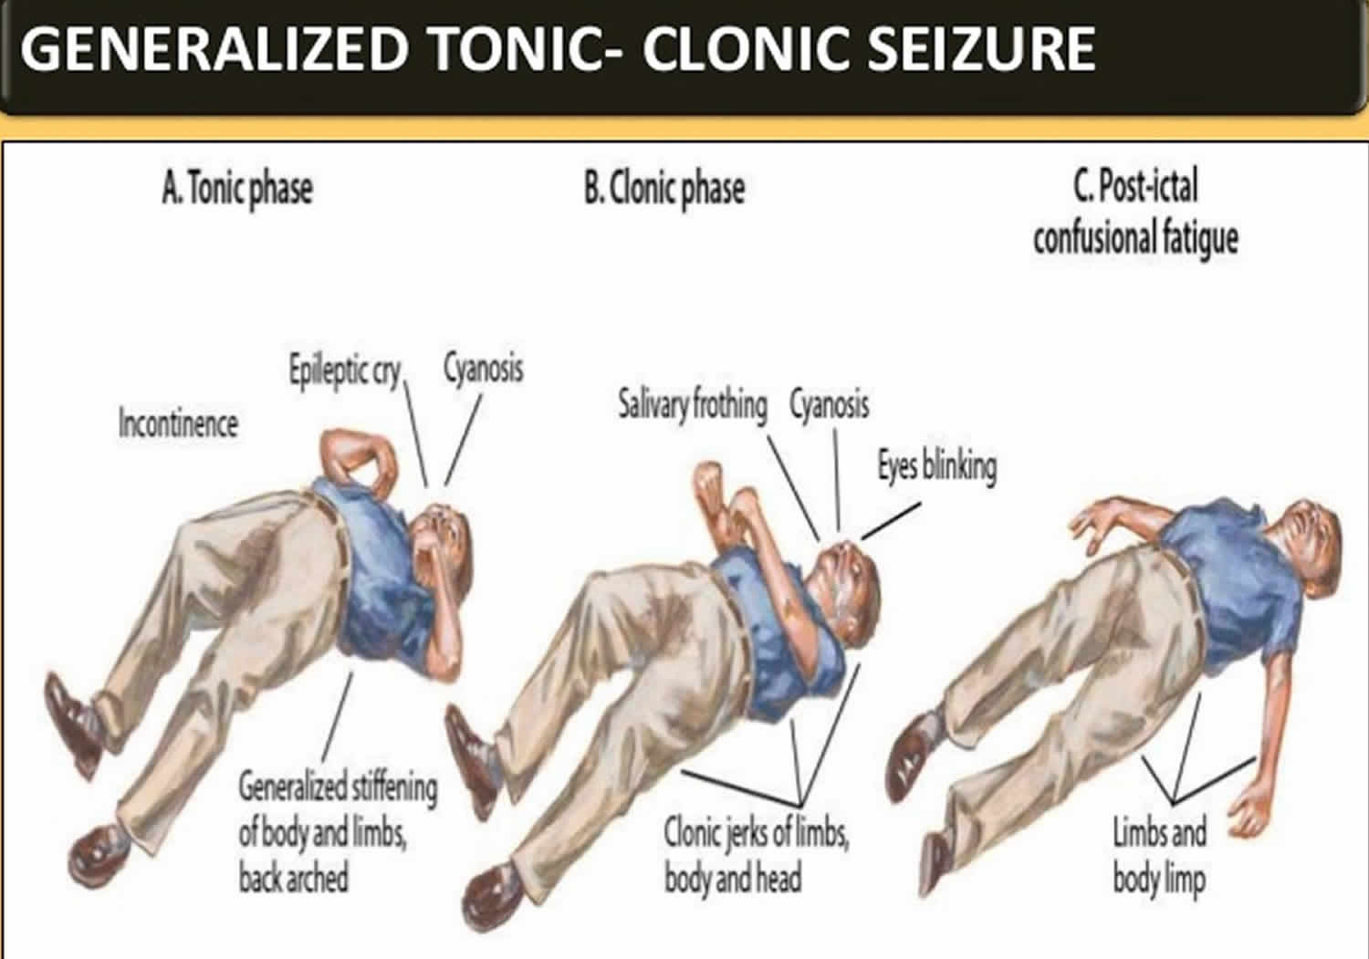
1. eyes roll upward
2. LOC
3. contraction of entire body: arms flexed with head, legs, and neck extended
4. mouth snaps shut
5. thoracic and abdominal muscles contract
6. loss of swallow reflex with increased salivation
7. apnea leading to cyanosis
-clonic phase: 30 – 50 seconds, can last up to 30 minutes
1. violent jerking body movements
2. trunk and extremities contract and then relax
3. may foam at the mouth
4. may be incontinent
5. gradual slowing of movements until cessation
-postictal state: 30 min
1. semiconscious – arouses with difficulty
2. confused for several hours
3. impairment of fine motor skills
4. lack of coordination
5. sleeps for several hours
6. no recollection of seizure
Absence seizure
-onset between 4-12 y/o and ceases by teenage years
-5-10 second LOC
-may drop items being held
-automatisms: lip smacking, twitching of eyelids or face, or slight hand movements
-unable to recall episodes
-can immediately resume activities
Myoclonic seizure
-symmetric or asymmetric involvement
-brief contraction of muscles or muscle groups
-may involve trunk and face or one or more extremities
-no postictal state
-might not lose consciousness
Atonic or Akinetic Seizure
-drop attacks
-onset between 2 and 5 y/o
-muscle tone is lost for a few seconds which causes them to fall
-followed by period of confusion
-if seizures are frequent child should wear a helmet

Vocabulary
Innervation

Decerebrate posturing

Decorticate posturing

ICP

Level of consciousness

Spasticity

Encephalopathy

Aura

Genitourinary Disorders

Hypospadias – urethral opening located just below the glans penis, behind the glans penis, or on the ventral surface of the penile shaft.
-meatus opening below the glans penis
-meatus opening along the ventral surface of the penis, scrotum, or perineum
-possible chordee (ventral curvature of the penis) present

Epispadias
Male
-widened pubic symphysis
-urethra opened on dorsal surface of penis
-possible exstrophy of the bladder
Female
-Wide urethra
-bifid clitoris
-possible exstrophy of the bladder
Therapeutic Procedure: surgery performed in first year of life

Hydrocele
-fluid in the scrotum
-enlarged scrotal sac
-can resolve spontaneously

Vesicoureteral reflux

Wilms tumor (pgs. 1734 – 1736)

Nephrotic syndrome

Acute glomerulonephritis

UTI
Risk factors
-urinary stasis
-urinary tract anomalies
-constipation
-Onset of toilet training
-bubble baths
-sex
Expected Findings
Infants: increased irritability, poor feeding, vomiting, increased thirst, foul-smelling urine, seizure, fever, dehydration, pallor, straining, or screaming with urination.
Children: abdominal or back pain, pain with urination, enuresis, frequent urination, dysuria, increased thirst, edema, tetany, blood in the urine, hypertension, pallor, fatigue
Lab Tests
-urinalysis: PH, glucose, ketones, leukocytes, nitrites, and RBC all POSITIVE
-gram stain: positive for causative bacteria
Medications
-antibiotics: PO or IV depending on severity
-acetaminophen for pain
Complications
-Progressive Kidney injury
-Pyelonephritis
-Urosepsis

Vocab
Anorexia

Erythropoietin

Anuria

Hematuria

Hydronephrosis

Oliguria

Polyuria

Gastrointestinal Disorders Ch. 42 – 43 (PGS. 1505 – 1585)

Vomiting and Diarrhea (pgs. 1522 – 1525)
Diarrhea: can be mild to severe, acute to chronic
-can result in mild dehydration
Lab Tests
-CBC with differential to determine anemia and/or infection
-Hct, Hgb, Bun, creatinine, urine specific gravity: all elevated with dehydration
-Stool test for occult blood
-urinalysis if dehydration suspected
Treatment

GERD

Cleft lip/palate

Esophageal atresia/TE fistula

Pyloric Stenosis

Hirschsprung’s disease

Intussusception

Anal malformation

Vocab
Abdominal distention

Constipation

Diarrhea

Fistula

Gastrostomy

Ileostomy

Peristalsis

Projectile Vomiting

Regurgitation

Enteral tube feeding

Guaiac testing

Respiratory and EENT Disorders – Chapters 39 – 40 (PGS. 1377 – 1457)

Pharyngitis

Tonsillitis: inflammation of the tonsils. Can be viral or bacterial in nature.
S/s:
Treatment: management symptoms. Humidified air if mouth breathing, ibuprofen or Tylenol for fever and pain. Popsicles and ice chips for maintain hydration. Maybe tonsillectomy.
Nursing Care: promote airway clearance, maintain fluid volume

Croup: usually 3 months – 3 y/o get croup. Larynx, trachea, and bronchi affected.
S/s: barking cough, inspiratory stridor, slight temp, restlessness
Treatment: corticosteroids to decrease inflammation, racemic epinephrine aerosols to decrease edema
Nursing Care: teach parents symptoms of respiratory distress and to monitor child after treatment.

Bronchitis – inflammation of trachea and major bronchi. Usually caused by URI. Usually recovers in 5-10 days.
S/s:
Treatment: supportive care. Administer expectorant. Adequate hydration.
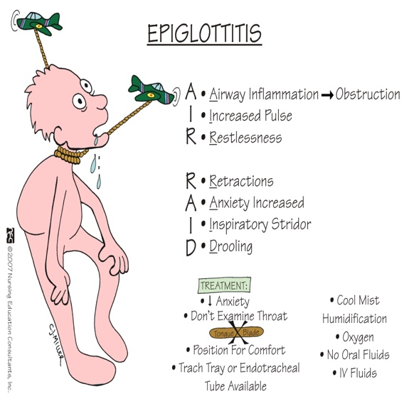
Nursing Care: Ascertain hx. Usually URI. Note fever, dry hacking cough that might become productive, rales.

Epiglottis: usually 1-8 y/o. inflammation and swelling of the epiglottitis. Rare since extensive use of Hib vaccine.
S/s:
Treatment: airway management and support, IV antibiotics, corticosteroids
Nursing Care: if stridor occurs, take child to steamy bathroom for 10 minutes, lateral neck radiograph may be used to diagnose epiglottitis.

RSV

Bronchiolitis

Asthma

Otitis Media (pgs. 1394 – 1402)

Foreign body aspiration

Cystic Fibrosis

Hearing and visual disturbances

VOCAB
Autosomal recessive

Exocrine glands

Meconium ileus

Retractions

Steatorrhea

Stridor

Dyspnea

Tachypnea

Growth and Development – Chapter 25 – 37 (pgs. 923 – 1325)
INFANT (0-1 YEAR)
TODDLER (1-3 YRS)
PRESCHOOL (3-6 YRS)
SCHOOL AGE (6-12 YRS)
ADOLESCENT (12-20 YRS)

Pediatric Medication administration Strategies
- <3 y/o pinna down and back
- > 3 y/o pinna up and back

Growth and development concepts

G&D from Infancy to Adolescence

Variations in Pediatric Physical Assessment
Infant: supine or prone in parents lap, completely undress, leave diaper on boy, distract, smile, gentle voice
Toddler: supine or prone in parents lap, sitting or standing on/by parent, parent remove outer clothing, remove underwear as body part is examined, allow to inspect equipment, use restraint when appropriate, praise for cooperation.
Preschooler: prefer standing or sitting, self-undress, allow equipment inspection, demonstrate use, story about procedure, paper doll technique, give choices when possible
School-aged:
Teenager:

Pediatric Reactions to Hospitalizations including death and dying
Infant: separation anxiety, stranger anxiety, sleep deprivation, sensory overload, excessive irritability
Toddler: separation anxiety, loss of control, fear of the dark, cries if parent leaves, associates pain with punishment, allow choices when possible, provide night light.
Preschooler: separation anxiety, fear of abandonment, loss of control, fear of dark and monsters, difficulty separating fantasy from reality, fears ghosts and monsters, withdrawal, projection, aggression, and regression., explain procedures, provide night light or flashlight
school-aged
teenager

Erikson’s Theory
Trust vs Mistrust- birth to 1 year
Autonomy vs Shame and doubt - ages 1 to 3
Initiative vs Guilt- ages 3 to 6
Industry vs Inferiority- ages 6 to 12
Identity vs Role Confusion- ages 12 to 20

Immunizations
- Birth- Hep B
- 2 Months- DTap, RV, IPV, Hib, PCV, Hep B
- 4 Months- DTap, RV, IPV, Hib, PCV
- 6 Months- DTap, RV, IPV, Hib, PCV, Hep B
- 6-12 Months- Seasonal Influenza vaccination yearly

- DTap (diptheria, tetanus, pertussis)
- RV (rotavirus)
- IPV (inactivated polio)
- Hib (haemophilus influenzae type b)
- PVC (pneumococcal conjugate

Contraindications / Precautions for immunizations:
- Child with severe febrile illness.
- Alteration in skin integrity.
- Alteration in immune system.
- Known allergic reaction to previous immunization or substance in vaccine.

Childhood Communicable diseases including head lice and parasites (pgs. 1217 – 1320)
Lice (pediculosis capitis)
-transmitted through direct contact
-S/s:
-Treatment: Pediculicide / ovicidal shampoo or rinse
1. permethrin (NYX)
2. Pyrethrin
3. Comb
4. Home hygiene
-Complications: secondary bacterial infection

Children’s play
Infant: rattles, teething toys, balls, mirrors, blocks, bright colored toys, pat-a cake, solitary play

Toddler: parallel play, thick crayons, large piece puzzle, finger paints, playing with blocks, push pull toys

Preschooler: associative play, play in groups but few to no rules

School-aged:

Teenager:

Communication and safety including poisoning, injuries, and child abuse (pgs. 1859 – 1861)

VOCAB
Associative Play: not very organized but they play with each other.
-playing ball
-riding tricycles
-pretend and dress up
-role playing
-hand puppets

Cephalocaudal

Dramatic play

Egocentrism

Object Permanence

Parallel play: toddlers play next to but not with each other.

Separation anxiety

Therapeutic play

Final Review
- Priority with newborn when you have a meningocele? Have n/s at the bedside just in case it dries up. Must have sterile wet dressing on it. Must stay wet

- Caring for a toddler who has fractured a tibia that involves growth plates. Inform parents it may cause long term growth issues.

- 5-month-old with spina bifida the gross motor skill to assess is head control

- 10 y/o with appendicitis complaining of nausea, sharp abdominal RLQ pain – ruptured appendix

- After cardiac cath – affected extremity in stretched position for at least 8 hours

- When caring for a child that is septic 5 days old – emphasize parents to call doc if temp is 104, child can’t be woken up and fontanels pulsing, purple spots on skin, and PT lethargic, irritable for 3 days.

- Prevent spread of viruses in schools sanitize everything. Separate infected child. Teach children to wash hands after using the bathroom

- Ear infection – give antibiotics for entire 10 days

- Convert oz mL for intake

- Purpose of albuterol in asthma – dilates bronchioles

- Calculate IV piggyback over 8 hours

- Kawasaki disease – most common med to treat Hgb G and aspirin

- Giving toddler med – give them choices. Take with juice or water or drink water right after

- Blood transfusion reaction – priority is to stop the infusion

- Calculate mg/kg

- Convert cups and oz to mL

- Child with kidney disease at what stage are they becoming well – convalescence

- Incubation – infection to onset of illness

- Prodromal – onset of specific manifestation

- Communicable – contagious

- Teaching parent how to prevent anemia – solid foods high in iron

- TOF – greatest cyanosis

- Croup – therapeutic: cool humidifier in room

- School age – epiglottitis with cough administer O2

- Adolescent with sickle cell anemia: abdominal pain and leg pain – give IV fluids to prevent further sickling

- Toddler – iron – sippy cup with straw to prevent stained teeth

- Child in ER – see most serious case – head injury or can’t breathe or disease that can spread so you can separate them

- Hemophilia – hemarthrosis – elevate leg above the heart

- Extensively bleeding – replace blood volume so they don’t go into hypovolemic shock

- Most malignant renal and intrabdominal tumor - Wilm’s tumor

- Regressing – will go back to wetting bed.

- Leukemia – keep them away from anyone that has an infection

- Low platelet count – bleeding precautions

- Hydration status – skin turgor, check stool, check urine and weigh

- Sickle cell new diagnosis – Vaso occlusive crises, aplastic crises, sequestration – hydrate, reduce stress, prevent infection, keep vaccines up to date

- Hemophilia A – no contact sports

- Immunization 6 months – receive influenza vaccine

- Toddler - Mass in abdomen with pink urine – don’t press on abdomen

- Toddler with new diabetes diagnosis – give them needless injector and doll to practice on

- Inadequate mobility of parts of the intestine and mechanical obstruction – Hirschsprung disease

- Pyloric stenosis – infant with vomit – evaluate hydration status

- Tonic clonic seizure and vomiting – turn head to side

- Newborn with cleft palette – breast feeding and other nutritional options – adaptors

- Runny nose, cough, conjunctivitis, and white spots on oral cavity – measles

- Appendectomy – check all orders – lactated ringers, consent signed, administer Rocephin before going to OR to decrease infection

- School age child teaching insulin – most hypoglycemic between lunch and afternoon snack

- GERD – Prilosec to decrease stomach acid

- Infant – intussusception – irritable, knees to chest when cry, lethargic – barium enema to confirm diagnosis and may fix it

- Fontanels - Sunken - dehydration or bulging – increased ICP

- Appendicitis – PT s/s perf – slight relief of pain now peritoneal problem

- Recent tonsillectomy – not concerned about halitosis

- Bacterial meningitis – antibiotics is the priority / do not have to measure head circumference every shift

- Seizures – look for respiratory distress

- Hemolytic uremic syndrome – anuric while receiving peritoneal dialysis – restrict fluids as prescribed

- 2 y/o drooling, open mouth, lethargic, just became ill – keep upright while assessing

- Moderate, persistent asthma – daily meds – inhaled corticosteroids

- SIDS – smoke free environment, breastfeed, nothing in crib

- 10 y/o rescue med with mild attacks – short acting inhaler – beta 2 antagonist

- Toddler with respiratory distress – 10 bpm or below, restless, diaphoresis

- Bilateral myringotomy tubes – fave blanket or toy from home

- Female adolescent – amoxicillin – use alternative birth control

- Tonsillectomy – jello, popsicles

- Bounding thready upper pulses and faint lower pulses – COA

- Hemophilia – minor bleeding episode – elevate, compress, rest – no heat

- Acute gastroenteritis – give oral rehydration solution

- Pathophysiology – unrestricted proliferation of immature WBC’s

- Gtt/min

- Osteogenesis imperfecta – increase bone density

- School age – vasooclusive crises – manage pain and hydrate

- AIDS – prevent infection

- SCA – after acute crises – teach parents to hydrate child well

- Varicella – airborne precautions

- Rheumatic fever – involuntary muscle movements – s/s are self-limiting – goal is to prevent injury

- Newborn – ketonuria – can’t process protein – dietary restrictions – may need special formula

- Leukemia – increased leukocytes

- Undiagnosed heart dysfunction – tachycardia, delayed cap refill, weak pulses, murmur

- Hemolytic streptococcus – finish antibiotic

- RR of infant – count for full minute

- Barking cough with no fever – mild croup – fluid and comfort measures

- Fever, headache, runny nose for few days – 5th disease

- Decreased pulmonary blood flow – tricuspid atresia

- TBI – Glasgow coma scale – eye opening, verbal response, motor response

- Bacterial pneumonia – share room with same infection

- patient meningocele – n/s and gauze over sac to keep it wet.

- Child with glomerulonephritis – sore throat for several weeks

- Preschooler with Muscular Dystrophy – progressive weakness

- Kawasaki – complication - coronary aneurysm

- UTI – hydrate, bathroom regularly, front to back wipe, take all meds

- Autism – see it in toddlers

- Chemo side effects: hair loss

- School age lice – white particles in hair

- Posterior fontanel closes at 2-3 months, and anterior at 12 months – 18 months

- Afraid of monsters – lights on

- Mumps – droplet

- Erickson – shame and doubt behaviors

- Trust vs mistrust – infant

- Bananas 3 y/o

- Babinski – reflex that stays for 12 months

- 5 y/o associative play

- Foods rich in iron: leafy greens

- Tet spells: knee to chest and give O2

