Exam # 1 Review

What is resilience

What is the DSM-5 – The diagnostic and statistical manual of mental disorders, 5th edition. The current official guidebook for categorizing and diagnosing psychiatric mental health disorders in the United States. Used by psychiatrists, psychiatric nurse practitioners, therapists, and other clinicians as a guide for assessing, diagnosing, and planning care.
-lists specific diagnostic criteria for each mental disorder

Stages of Development
Sensorimotor (birth – 2 y/o)
-basic reflexes become purposeful movements
-9 months: object permanence
Preoperational (2-7 y/o)
-language development with concrete thinking
-egocentric thinking: expect people to view the world as they do
Concrete Operational (7-11 y/o)
-logical thinking and abstract problem solving
-see another’s point of view and see many solutions to a problem
-conservation: two small cups = 1 large cup
-classify objects by characteristics, order object in a pattern, understand reversibility
Formal Operational (11 y/o – adulthood)
-conceptual reasoning and puberty occur at same time
-abstract thinking and problem-solving ability like those of an adult

Infant: Trust vs. Mistrust
Toddler: Autonomy vs. Shame/Doubt
Preschooler: Initiative vs. Guilt
School-Age Child: Industry vs. Inferiority
Adolescent: Identity vs. Role Confusion
Young Adult: Intimacy vs. Isolation
Middle-Aged Adult: Generativity vs. Stagnation
Older Adult: Integrity vs. Despair

Peplau’s Theory – the nurse nurse-patient relationship “facilitates forward movement” for both the nurse and the patient. The phases of the nurse-patient relationship are interlocking and overlapping.
Preorientation phase: the thoughts and feelings related to the first clinical session. Mild to moderate anxiety can be experienced.
Orientation Phase: can last for a few meetings or can extend over a longer period. An atmosphere is established for rapport to grow. Responsibilities of nurse and patient are defined. Confidentiality is discussed. Patient problems are discussed, and goals are agreed on.
Working Phase: gives the patient the opportunity to experience anxiety and demonstrate dysfunctional behaviors in a safe setting while learning more adaptive behaviors.
-maintain the relationship
-gather data
-promote problem solving skills
-facilitate behavioral change
-evaluate problems and goals
Termination Phase: discussed during first interview and during working phase. May occur at discharge or when clinical rotation ends.
-summarize goals
-discuss incorporating goals into daily life
-exchange memories

Principles of systematic desensitization: based on classical conditioning. Learned responses can be reversed by first promoting relaxation and then gradually facing anxiety-provoking stimulus. Successful in dealing with extreme fear.

Neurotransmitters: a neurotransmitter is a chemical messenger between neurons by which one neuron triggers another. 4 major groups
Monoamines (biogenic amines)
-dopamine, norepinephrine, serotonin
*Dopamine involves cognition, motivation, and movement. Controls emotional responses, brains reward and pleasure centers, stimulates the hear, increases blood flow to vital organs.
-drugs that stimulate dopamine activity such as amphetamines induce psychotic symptoms
-drugs that block dopamine receptors such as haloperidol have antipsychotic effect

Amino acids: GABA and glutamate balance brain activity.

Peptides: hypothalamic CRH modulate or adjust general brain function

Cholinergics (ACTH): ACTH balances dopamine. ACTH controls skeletal muscle movement, arousal, memory, and the sleep-wake cycle. ACTH is deficient in Alzheimer’s. Treatment are drugs that inhibit ACTH breakdown.
AChE – donepezil, galantamine, rivastigmine: delay cognitive decline

What is a PET scan: positron emission tomography. Shows activity of the brain. A radioactive substance is injected, travels to the brain, and appears as a bright spot on scan. Detects O2 utilization, glucose metabolism, blood flow, neurotransmitter-receptor interaction.
-Schizophrenia: decreased metabolic activity in frontal lobes, dopamine system dysregulation, blockade of dopamine receptors with antipsychotic medications.
-Depression: blockade of serotonin transporter receptors with antidepressant medication
-Alzheimer’s disease: reduction in nicotinic receptor subtype

Prefrontal Cortex – the most anterior part of the frontal cortex.
-involved in moderating social behaviors, goal setting and planning, and personality
-disrupted sensory filtering in schizophrenia is associated with alterations between thalamus and prefrontal cortex
-OCD: hyperactivity in prefrontal cortex

What is CT scan: series of Xray images is taken of brain, and computer analysis produces slices provoking a 3 D like reconstruction of each segment.
-schizophrenia: gray-matter reduction and ventricle abnormalities.

Dopamine blocking agents: MAO – monoamine oxidase – destroys monoamines.

Prozac – SSRI – antidepressant
-indications: depression, OCD, panic disorder

SSRI’s: inhibit reuptake of serotonin which makes it stay longer in the synapses. B/c it is selective there are fewer side effects b/c they don’t inhibit receptors for other neurotransmitters.
-too much serotonin can result in anxiety, insomnia, sexual dysfunction, and Gi upset.
-fluoxetine: Prozac
-sertraline: Zoloft
-paroxetine: Paxil

Registered Nurse RN https://www.youtube.com/watch?v=iRs9tbUAHAc
-Treat depression, OCD,
-block reuptake of serotonin
-serotonin is an inhibitory neurotransmitter
-symptoms improve 1-1.5 months
-taper off slowly
-suicidal thoughts
-interactions with other meds. Avoid MAOI’s, certain opioids, OTC cold meds, triptans, St. John’s Wort.
-Side effects: n/v, erectile dysfunction, weight gain, insomnia, dry mouth

Patient Rights

Autonomy

Dignity and respect

Justice

Communication/Verbal/nonverbal

Transference/Nontransference
Transference occurs as the patient projects intense feelings onto the therapist r/t unfinished work from previous relationships. Safe expression of these feelings is crucial to successful therapy.

Orientation phase of a nurse/client relationship
Orientation Phase: can last for a few meetings or can extend over a longer period. An atmosphere is established for rapport to grow. Responsibilities of nurse and patient are defined. Confidentiality is discussed. Patient problems are discussed, and goals are agreed on.

Theories
Behavioral: Promoting adaptive behaviors through reinforcement
Cognitive: Helping patients identify negative thought patterns
Psychosocial development: Providing structure for understanding critical junctures in development
Hierarchy of needs: Prioritizing nursing care

Neurotransmitters – Monoamines
Dopamine: cognition, motivation and movement
Dopamine decrease: Parkinson disease and depression
Dopamine increase: Schizophrenia and mania

Norepinephrine decrease: depression
Norepinephrine increase: anxiety

Serotonin decrease: depression
Serotonin increase: anxiety

Histamine decrease: anxiety and depression

Neurotransmitters – Amino Acids
GABA decrease: anxiety, schizo, mania, huntington
GABA increase: reduce anxiety, schizo, mania
Glutamate: involved in normal brain function. Cognition, memory, and learning.

Neurotransmitters – Cholinergics
ACh decrease: Alzheimer’s, Huntington chorea, Parkinson disease
ACh increase: depression

Antidepressant: Serotonin
Antianxiety: GABA
Sedative hypnotic: histamine
Mood stabilizer: norepinephrine
Antipsychotic: dopamine
Anticholinesterase: ACh

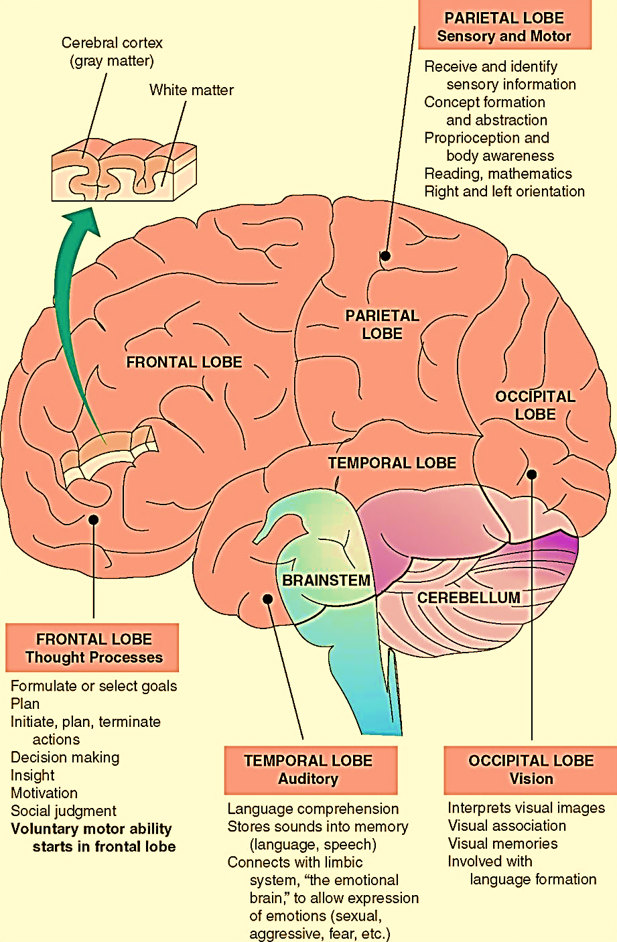

Frontal: goals, plan, motivation, social judgement

Parietal: sensory, abstract, reading and math

Occipital: vision and language formation.

Temporal: emotion and language comprehension

Chapter # 1 – Science and Therapeutic Use of Self in Psychiatric -Mental Health Nursing

Chapter # 2 – Mental Health and Mental Illness

Chapter # 3 – Theories and Therapies

Chapter # 4 – Biological Basis for Understanding Psychopharmacology

Chapter # 5 – Settings for Psychiatric Care
Health disparities: health care differences that occur by gender, race or ethnicity, education or income, disability – physical or mental, living in rural localities, or sexual orientation.

Anosognosia – neurological condition in which the patient is unaware of their neurological deficit or psychiatric condition.

Anergia – lack of energy

chlorpromazine (Thorazine) – created in the 1950’s. First antipsychotic medication.
1st Generation – addresses positive symptoms (hearing and seeing) of schizophrenia – Side effects: tardive dyskinesia
2nd Generation

OUTPATIENT CARE SETTINGS
PCP: some people feel more comfortable with their doc. Disadvantage would be time frame. 15 min is not enough time for a physical and mental health assessment, and PCP may have limited training in psychiatry.
Patient-Centered medical homes (PCMH’s): supported by Affordable Care Act. Created in response to fragmented care.

5 key characteristics
- Comprehensive care – acute, chronic, and preventative.
- Patient centered – Considers the unique needs of the whole person. Patient is core member of the team.
- Coordinated care – care is coordinated with hospitals, specialty care, and home health
- Accessible service – Extended hours, email, and phone support
- Quality and safety – continuous loop of evaluation by sharing data publicly.
Community Mental Health Centers (CMHC’s): developed from JFK’s Community Mental Health Centers Act of 1963
-regulated through state mental health departments and funded by the state
-psychiatric rehabilitation is a social model that emphasizes and supports recovery and integration into society rather than accepting a medical model of dysfunction.
1. development of social skills
2. ability to access resources
3. acquisition of optimal social, working, living, and learning environments are the focus of this treatment period.
Intensive outpatient programs (IOP’s) and partial hospitalization programs (PHP’s)
-intermediate step between inpatient and outpatient.
-IOP half day
-PHP usually 6 hours

ROLE OF NURSES IN OUTPATIENT CARE SETTINGS
-nurses exert a strong influence on medication decisions and adjustments
-Advanced Practice Registered Nurses are qualified to engage in talk therapy, group therapy, and managing patient care across the life span.

INPATIENT CARE SETTINGS
-inpatient care is the most intensive
-referrals come from PCP, mental health provider, agencies, another hospital unit, emergency facilities, or nursing homes.
-Patients can be admitted voluntary or unvoluntary and facilities may be locked or unlocked
-elopement: leaving before discharged (AWOL – away without leave)
-milieu: the environment in which holistic treatment occurs and includes all members of the treatment team in a positive physical setting, with interactions among those who are hospitalized, and activities that promote recovery.
-goals: crisis intervention and stabilization and patient safety
-average mental health length of stay is 8 days, and 4.8 days for substance abuse.
-psychiatric emergencies include suicidal or homicidal ideation, acute psychosis, or behavioral response to drugs. The stay is usually less than 24 hours.
STATE ACUTE CARE SYSTEM
-serve most seriously ill patients
-provide forensic (court-related) care and monitoring as part of their function for those found not guilty by reason of insanity (NGRI)
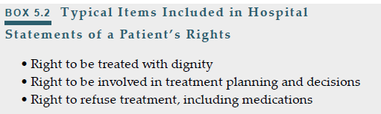

Specialty Treatment Settings
PEDIATRIC PSYCHIATRIC CARE
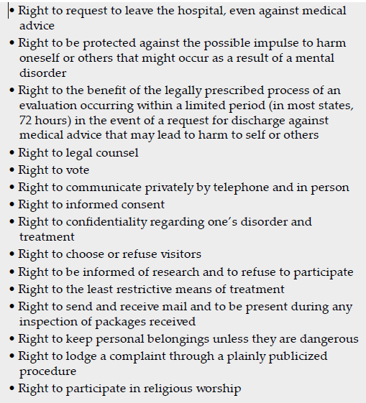
-Parental involvement in the plan of care is integral so that they understand the illness, treatment, and the family’s role in supporting the child
GERIATRIC PSYCHIATRIC CARE
-physical illness and loss of independence can be strong participants in the development of depression and anxiety.
-Dementia treatment is aimed at evaluation of the interaction of the mind and body and provision of care that optimizes strengths, promotes independence, and focuses on safety.
VETERANS ADMINISTRATION CENTERS
-PTSD has a prevalence of 7%. Solders returning from Iraq and Afghanistan have PTSD rates ranging from 9-31%
FORENSIC PSYCHIATRIC CARE
-44/50 states and D.C. have more people with mental illness in prison or jail than in the state’s largest psych hospital.
ALCOHOL AND DRUG USE DISORDER TREATMENT
-only 2.5 million out of the 22.7 million who need treatment received treatment at a specialty facility.
-typically outpatient and includes counseling, education, medication management, and 12 step programs.
SELF HELP OPTIONS
-lifestyle choices and self-help responses can have a profound effect on quality of life and the course, progression, and outcome of psychiatric disorders.

Paying for Mental Health Care
-Affordable Care Act (ACA) – signed into law March 23, 2010
-public assistance for mental health care: Medicare, Medicaid, social security, and VA.

A Vision for Mental Health Care in America
-stigma, geographic, financial, and systems factors limit access to psychiatric care.

Key Points to Remember
-psychiatric care providers are specialists who are licensed to prescribe medication and conduct therapy.
1. psychiatrists
2. advanced practice psychiatric nurses
3. physicians assistants
4. in some state’s psychologists

Class Notes
ETO – emergency treatment order: used before a doctor’s order.

Chapter Review Questions
1. A patient diagnosed with major depressive disorder tells the community mental health nurse, “I usually spend all day watching television. If there’s nothing good to watch, I just sleep or think about my problems.” What is the nurse’s best action?
a. Refer the patient for counseling with a recreational therapist.
b. Ask the patient, “What kinds of program do you like to watch?”
c. Suggest to the patient, “Are there some friends you could call instead?”
d. Advise the patient, “Watching television and thinking about problems makes depression worse.”

2. The nurse admits a patient experiencing hallucinations and delusional thinking to an inpatient mental health unit. The plan of care will require that which service occurs first?
a. Social history
b. Psychiatric history
c. Medical assessment
d. Psychological evaluation

3. A nurse working in an acute care unit for adolescents diagnosed with mental illness says, “Our patients have so much energy. We need some physical activities for them.” In recognition of needs for safety and exercise, which activity could the treatment team approve?
a. Badminton tournament
b. Competitive soccer matches
c. Intramural basketball games
d. Line dancing to popular music

4. As Election Day nears, a psychiatric nurse studies the position statements of various candidates for federal offices. Which candidate’s commentary would the nurse interpret as supportive of services for persons diagnosed with mental illness?
a. Full-parity insurance coverage for mental illness
b. Coverage for biologically based mental illnesses
c. Reimbursement for initial treatment of addictions
d. Managed care oversight for mental illness services

5. An experienced nurse in a major medical center requests a transfer from a general medical unit to an acute care psychiatric unit. Which organizational feature would best support this nurse’s successful transition?
a. Assignment to medication administration for the first 6 months
b. Working with a seasoned mental health technician for the first month
c. Co-assignment with a knowledgeable psychiatric nurse for an extended orientation
d. Staff development activities focused on developing therapeutic communication skills

Chapter #6 – Legal and Ethical Basis for Practice

-Ethics – the study of morality through a variety of different approaches. The study of philosophical beliefs about what is considered right or wrong in a society.
-Bioethics – refers to ethical questions that may arise in health care.
-Fundamental goal of psychiatric care is to strike a balance between the rights of the patient and the rights of society.

Mental Health Laws
-Community Mental Health Act of 1963 shifted mental health care from states to community-based care.
-Parity in health insurance coverage for mental health treatment was addressed in 2010 by
1. The Paul Wellstone and Pete Domenici Mental Health Parity and Addiction Equity Act
2. The 2010 Health Insurance Exchanges Program

Admission and Discharge Procedures
-writ of habeus corpus: formal written request to “deliver the body” to a court of law to challenge continued confinement.
ADMISSION TO THE HOSPITAL
-Olmstead V L.C.: patients with mental health needs should be placed in the less restrictive community setting rather than institutions.
Voluntary admission: sought by a patient or a patient’s guardian through a written application to the facility.
-have the right to demand and obtain release at any time.
Involuntary Admission (commitment): made without the patient’s consent. Typically happens when patient is a danger to themselves or others, or us unable to meet their basic needs because of mental illness.
Commitment Procedures
-judicial determination
-administrative determination
-agency determination

Nature and purpose of involuntary admission
-emergency hospitalization: usually for a few hours or days. Done by physician’s , police officers, and
mental health professionals.
-observational or temporary hospitalization
-long-term or formal commitment: for extended care and treatment of a patient with mental illness.
Done by medical certification judicial, or administrative action. Typically 60 – 180 days.
-outpatient commitment: for patients with severe mental illness that will not voluntarily commit to
outpatient treatment. The goal is for the patient to convert to voluntary therapy within weeks or months.

DISCHARGE FROM THE HOSPITAL
-conditional release: usually requires outpatient treatment for a specified period to determine the patient’s adherence to medication protocols, ability to meet basic needs, and ability to reintegrate into the community.
-unconditional release: termination of patient – institution relationship

Patient’s Rights Under the Law
RIGHT TO TREATMENT
-medical and psychiatric treatment must be provided to all patients in public hospitals.
-the environment must be humane
-staff must be qualified and sufficient to provide adequate treatment
-the plan of care must be individualized.
RIGHT TO REFUSE TREATMENT
-a patient may withdraw consent at any time
RIGHT TO INFORMED CONSENT
-a right to self determination
-medical provider has the duty to disclose all known risks and complications of a proposed treatment to allow the patient to make an informed decision as to whether to proceed with that treatment.
-consent is required for surgery, electroconvulsive treatment, or the use of experimental drugs or procedures
-POA can make decisions on a patient’s behalf but cannot override the patient’s decisions.
-Guardians appointed by the court when a patient has been declared incompetent have control over the patient’s medical, financial, and personal decision making.
RIGHTS SURROUNDING INVOLUNTARY COMMITMENT AND PSYCHIATRIC ADVANCE DIRECTIVES
-advance directive expresses patient’s treatment choices.
RIGHTS REGARDING RESTRAINT AND SECLUSION
-trending towards restraint free environment
-verbal interventions are first-line interventions
-in an emergency an appropriately trained staff member can use restraint or seclusion and obtain a written order within 1 hour.
MAINTENANCE OF PATIENT CONFIDENTIALITY
-HIPAA became effective April 2003
-psychiatric notes should be kept separate from medical notes.
-confidentiality does not apply if a provider is compelled to testify under subpoena, past, present, or future abuse or criminal activity.
EXCEPTIONS TO CONFIDENTIALITY
-duty to warn: psychotherapist must warn intended victim of potential harm
-not reporting abuse is a misdemeanor

Tort Law Applied to Psychiatric Settings
-Tort: civil wrong for which money damages may be collected by the injured party from the wrongdoer
NEGLIGENCE / MALPRACTICE
-negligence: act or failure to act that breaches the duty owed to a patient by a provider
-breach of duty: conduct that exposes the patient to an unreasonable risk of harm, through either actions or failure to act by the nurse.

Determination of a Standard of Care
-state standards are for protecting patients
-professional association standards elevate the practice of its members by setting standards of excellence

Documentation of Care
PURPOSE OF MEDICAL RECORDS
-medical records allow for continuity of care
FACILITY USE OF MEDICAL RECORDS
-medical records provide information on patient care, quality of care, and ways to improve care.
MEDICAL RECORDS AS EVIDENCE
-the medical record of data, opinions, and decisions made in the normal course of the patient’s care.
-it can be used to determine adherence to the standards of care.
-nursing notes are used to create the most thorough timeline of events

Forensic Nursing
-work with crime victims or perpetrators to gather evidence or provide expert testimony

Class Notes
MA = March Act – Substance
Voluntary hold – admits to substance use disorder
Involuntary hold – court system
Proxy – able to make medical decisions on behalf of patient
Healthcare surrogate –
Power of Attorney – Medical -

Chapter #8 – Communication Skills: Medium for all Nursing Practice
Introduction
-actions, words, and expressions convey meaning to others.
-therapeutic communication: professional, goal-directed, and scientifically based communication

Communication
-assessment: information gathering approach designed to meet the patient’s needs
-therapeutic communication: meets the patient’s needs

Will I say the wrong thing?
-communication is 90% nonverbal

The Communication Process
-stimulus: need to communicate
-sender: person sending the message
-message: info sent
-media: the way the message is sent – auditory, visual, tactile, olfactory…
-receiver: person receiving the message
-feedback: message the receiver sends back
FACTORS THAT AFFECT COMMUNICATION
Personal factors
-emotional factors (mood, responses to stress, personal bias)
-social factors (previous experience, cultural differences, language differences, lifestyle differences)
-cognitive factors (problem-solving ability, knowledge level, language use)
Environmental factors
-physical factors (background noise, lack of privacy, uncomfortable accommodations)
-societal determinants (sociopolitical, historical, economic)
Relationship factors
-symmetrical relationship: equal i.e., friends or colleagues
-complimentary relationship: unequal i.e., student/teacher
VERBAL COMMUNICATION
-when we speak, we communicate beliefs, values, perceptions, meanings, convey interest insult, or judgement.
-multicultural approach is important
NONVERBAL COMMUNICATION
-effective communicators pay attention to both the verbal and nonverbal cues
-nonverbal behaviors needs to be observed and interpreted while considering a person’s culture, class, gender, age, and spiritual norms.
INTERACTION OF VERBAL AND NONVERBAL COMMUNICATION
-verbal message: content
-nonverbal message: process
-congruent message: content = process
-incongruent = double message

Effective Communication Skills for Nurses
USE OF SILENCE
-silence is not the absence of communication. It is a specific channel for transmitting and receiving messages.
ACTIVE LISTENING
-patients want more than just a body. They want a person to be psychologically, socially, and emotionally there for them.
CLARIFYING TECHNIQUES
-requesting feedback on the accuracy of the message
Paraphrasing
-restating in different words the basic content of a patient’s message
Restating
-the nurse mirrors patient’s covert and overt messages
-it can echo feelings and content
-repeat same words
Reflection of Feelings
-helps patient to better understand their own thoughts and feelings
-sharing observations with a patient shows acceptance
Exploring
-Tell me more…
-Describe…
-Give me an example…
What if questions?
-projective questions can help people imagine the conflicts, thoughts, values, feelings and behaviors hey might have in certain situation.
-If you had 3 wishes…
-What would you do if you were given 1 mil no strings attached?
Miracle Questions?
-Suppose you woke up in the morning and a miracle happened and this problem had gone away.
-What would be different? How would it change your life?

Nontherapeutic Techniques
ASKING EXCESSIVE QUESTIONS
-multiple q’s at same time, closed-ended q’s makes the nurse an interrogator.
-very controlling tactic
GIVING APPROVAL OR DISAPPROVAL
-giving approval can make the patient act to please you instead of acting of their own will.
-giving approval stops communication
ADVISING
-giving a person a solution robs the patient of self-responsibility
ASKING WHY QUESTIONS
-imply criticism
-can be interpreted as intrusive and judgmental
-most effective to ask what as opposed to why.

Guarding Against Miscommunication
-miscommunication is the 3rd leading cause of medical deaths behind heart disease and cancer.

Communicating Across Cultures
COMMUNICATION STYLES
-Hispanic, French, and Italian Americans have animated facial expressions and intensely emotional styles of communication.
-Asians: open expression of emotions is considered in bad taste and possibly a weakness.
-Germans and British Americans value self-control and show little facial emotion in the presence of great distress or emotional turmoil.
Eye Contact
-Hispanics avoid eye contact with authority figures
-Asians: respect is shown by avoiding eye contact
-Native Americans: disrespectful and aggressive to engage in direct eye contact
-Germans: direct and sustained eye contact indicates trust, may be aggressive, may be sexually interested.
-French, British, AA: maintain eye contact
-Greece: staring is acceptable
Touch
-German, Swedish, and British: touch is infrequent
Cultural Filters
-it is impossible to listen to people in an unbiased way.
-cultural filters: cultural bias or cultural prejudice that determines what we notice and what we ignore.

Chapter #9 – Therapeutic Relationships and the Clinical Interview

