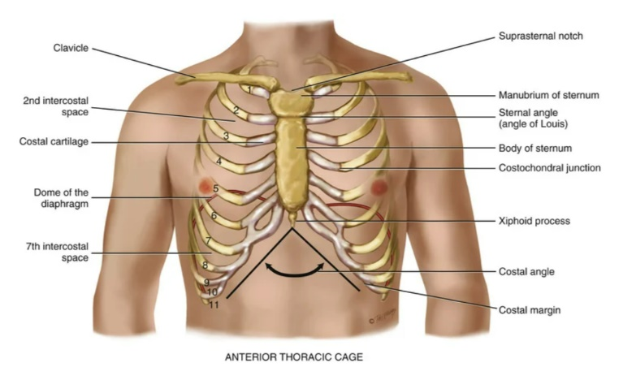
Abnormal findings of an infant
Normal: 30 – 40 breaths / min may spike to 60
Abnormal: * 50 – 100 breaths / min while sleeping.
* retraction of sternum
* retraction of intercostal muscles

Pregnancy and breathing
* Thoracic cage appears wider
* costal angle widens 50%
* respirations deeper
* 40% increase in tidal volume

Assessment findings of Asthma
*Chronic lung condition of airflow obstruction and airway inflammation.
*Triggers: smoking, pets, chemicals, household allergens, extreme cold, anxiety
*Noisy breathing occurs with severe asthma
*Expiratory wheezing from lower airway obstruction
*In infants marked retraction of sternum

Costal angle
The right and left costal margins form an angle where they meet at the xiphoid process.
*90 degrees
*Angle increases when rib cage is chronically overinflated i.e. emphysema

Auscultations of breath sounds- proper technique/ changes in older adults
- Instruct patient to breathe in every time they feel the stethoscope.
- Clean diaphragm and hold it firmly against chest
- Listen from C7 – T10 and from axilla – 7th or 8th rib.
*Normal Breath sounds
1. Bronchial (tracheal or tubular) – high pitch, loud, expiration longer than inspiration, located near trachea and larynx
2. Bronchovesicular – moderate pitch and amplitude, inspiration=expiration
3. Vesicular – low pitch, soft, inspiration longer than expiration

Crepitus/tactile fremitus/adventitious sounds
Tactile fremitus: palpable vibration
* Vibrations should feel the same on both sides – breast tissue and bone dampen the sound
* Decrease fremitus – indicates obstruction – pneumothorax or emphysema
* Increased fremitus – indicates compression or consolidation of lung tissue

Crepitus: coarse, crackling sensation palpable over the skin surface
* example: subcutaneous emphysema

Adventitious Lung Sounds
Crackles: discontinuous popping sounds heard over inspiration
Wheezing: continuous musical sounds heard mainly over expiration

Percussion over lung fields /primary muscles of respiration
*Diaphragm
*Intercostal muscles – lift the sternum and elevate the ribs
*Forced inspiration - Accessory muscles of the neck: sternomastoid, scaleni, and trapezii
*Forced expiration – abdominal muscles

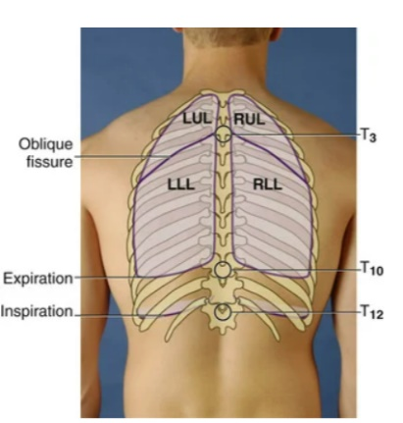
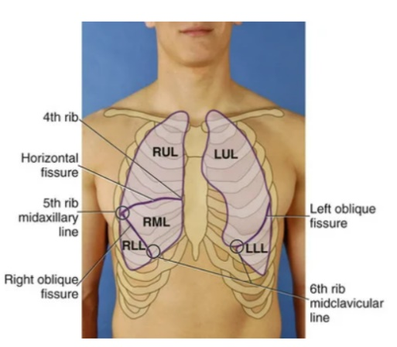
Right lung/versus left lung anatomy
Anterior
RL – 3 lobes: upper, middle, lower
LL – 2 lobes: upper and lower
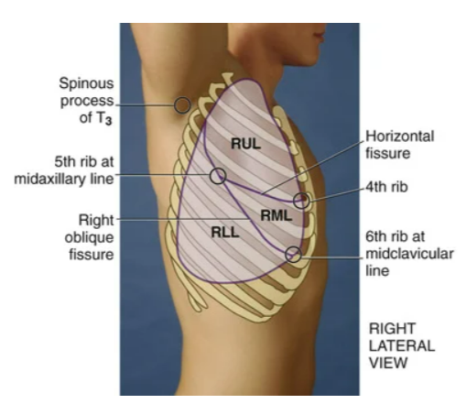
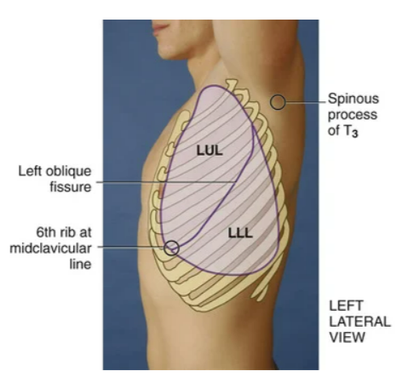
Posterior
RL – 2 lobes: upper and lower
LL – 2 lobes: upper and lower – mostly lower lobe

Lateral
RL – 3 lobes: upper, middle, lower
LL – 2 lobes: upper and lower

Assessment of a healthy heart – location of heart sounds
S1 – first heard sound – occurs with the closure of the AV valves and signals the beginning of systole.
*loudest at the apex
*heard at Tricuspid and Bicuspid valve

S2 – second heart sound – occurs with closure of the semilunar valves and signals the end of systole.
*loudest at the base
* heard at Aortic and Pulmonic Valve

*Diastole – the ventricles relax and fill with blood 2/3 cardiac cycle
*Systole – heart contraction – blood is pumped from the ventricles and fills the pulmonary and systemic arteries 1/3 cardiac cycle
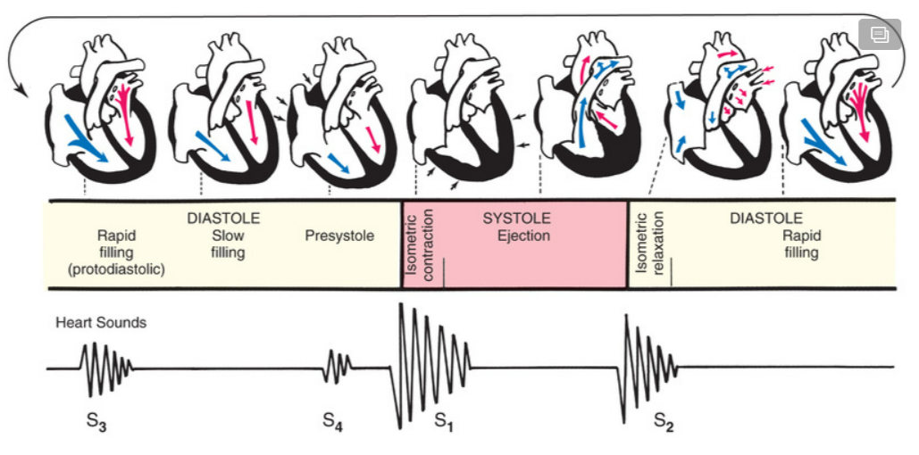

Interview questions for heart disease
*Family history
*Smoke or drink
*Swelling
*Hypertension, diabetes?
*Chest pain?
*Nausea or vomiting?
*Cough?
*Fatigue?
*Cyanosis or pallor?
*Nutrition? Exercise?
*Nocturia?

How you assess for S4 / Direction of blood flow through the heart/Proper technique to auscultate heart
Auscultation: Aortic, Pulmonic, Erb’s Point, Tricuspid, Mitral

S3 – vibration created by ventricular filling
*occurs immediately after S2 lub, dub, TUH
*heard at the apex
* hypovolemia or heart failure

S4 – occurs at the end of diastole. Vibration created by atria contracting and blood being pushed into a noncompliant ventricle
*occurs just before S1 TUH, lub, dub
*heard at the apex
*atrium pushing blood into resistant ventricle
Murmurs
*blowing or swishing
*wall defect
*valves too narrow
*regurgitation issues or backflow

Grade 1 – hard to hear
Grade 2 – faint, but you can hear it
Grade 3 – easy to hear
Grade 4 – loud with thrill
Grade5 – very loud with a thrill. Lift corner of chest piece off chest and still hear murmur.
Grade 6 –loudest with a thrill. Lift entire chest piece off chest and still hear murmur.

*oxygen poor blood pumps from the superior and inferior vena cava to the right artrium of the heart. The right atrium pumps blood through the right AV valve (tricuspid) into the right ventricle. The right ventricle pumps blood through the pulmonary semilunar valve to the pulmonary trunk which flows through the pulmonary arteries to the RT and L lung.
*oxygen rich blood flows through pulmonary veins to the left atrium. The left atrium pumps blood throught the left AV valve (bicuspid or mitral valve) to the left ventricle. The L ventricle pumps blood through the aortic semilunar valve to the aorta. The L and RT coronary arteries supply oxygen rich blood to the myocardium. The brachiocephalic artery provides blood to the right arm and brain. The left common carotid provides blood to the left side of the brain. The left subclavian provides blood to the left arm.

sounds/Best description of S1/ What is S2 associated with
S1 – lub – closure of tricuspid and mitral valves – contraction
S2 – dub – closure of aortic and pulmonic valves – rest

Tetralogy of Fallot/ventricular septal defect/Atrial septal defect
*Atrial septal defect: Abnormal opening in the atrial septum
*Ventricular septal defect: abnormal opening in septum between the ventricles
*Tetralogy of Fallot: Four defects
1.) pulmonic stenosis
2.) VSD
3.) Compensatory right ventricular hypertrophy
4.) overriding aorta that receives blood from both R an L ventricles
RESULT: blood redirected directly into aorta away from pulmonary system, so blood never gets oxygenated

Normal apical pulse rate for adults and infants/ Findings of cardiac assessment for a child
Adult 60 – 100 bpm
Newborn 100 – 180 bpm
Infant 120 – 140 bpm

Population with the highest risk factor for hypertension
Black Americans – men: 45% and women: 46.3%
*compared to whites African Americans develop high blood pressure earlier in life
*Average BP’s are higher which causes stroke, death from heart disease and end stage kidney disease

What is a thrill/pacemaker of the heart/sac that protects the heart?
Thrill – palpable vibration
SA (sinoatrial) node – pacemaker of the heart
Pericardium – tough fibrous double walled sac that surrounds and protects the heart
What valve closer are heard at the base of the heart?
S2 semilunar valves – atrial and pulmonic valves

What is claudication/arterial ischemic ulcer/ Deep vein thrombophlebitis/ Varicose veins/ Raynaud phenomenon/lymphedema?
Claudication – muscle fatigue or pain when walking

Arterial Ischemic Ulcer – caused by poor perfusion

DVT – caused by prolonged bed rest, prolonged immobilization, and heart failure. Presents with unilateral swelling of the affected leg, tenderness to severe pain, possibly warmth and redness accompanying inflammation, and possibly superficial venous dilation.

Varicose veins – dilated and tortuous (repeated twists, bends, or turns) veins create incompetent valves, wherein the lumen is so wide that the valve cups cannot approximate. Caused by venous pooling in obese people, or multiple pregnancies or genetic predisposition.

Raynaud phenomenon – episodes of abrupt, progressive tricolor changes of the fingers in response to cold, vibration, or stress

Lymphedema – accumulation of protein rich fluid in the interstitial spaces of the arm following breast surgery or treatment. Buildup of fluid in soft body tissues when the lymph system is damaged or blocked.

Normal physiologic changes of aging/ normal capillary refill time
Cap Refill time less than 2 seconds
* cap refill is indicative of peripheral perfusion and cardiac output.
* more than 2 second refill indicates vasoconstriction or decreased cardiac output

How to document edema/ pulses
Edema
4+ - very deep pitting, indentation lasts a long time, leg is grossly swollen and distorted
3+ - deep pitting, indentation remains for a short time, leg looks swollen
2+ - moderate pitting, indentation subsides, rapidly subsides
1+ - mild pitting, slight indentation, no perceptible swelling of the leg

Pulses
3+ - Full, bounding
2+ - Normal
1+ - Weak
0 - Absent

How you assess femoral pulse / location of the dorsalis pedis pulse
Femoral Pulse
- Just below inguinal ligament halfway between the pubis and anterior superior iliac spines
- Bend knee into side in frog like position
- Press firmly and then slowly release

Dorsalis pedis pulse can be found on the top of the foot near big toe

Flow of lymph/pulsus paradoxus/ What does a bruit indicate?
Bruit – for people middle aged or older or who show symptoms or signs of CVD auscultate each carotid artery for the presence of a bruit (blowing, swishing sound indicating blood flow turbulence). Palpate for femoral, popliteal, dorsalis pedis and posterior tibial. If pulse is weak or diminished auscultate for a bruit.

When using a Doppler ultrasonic stethoscope to assess venous flow what sound is heard?
Swishing, whooshing sound

