Study Guide
NUR1211
Respiratory and GI

Function of the respiratory system normal and abnormal breath sounds/ sputum studies and nursing interventions
- Upper respiratory tract, known as the upper airway, warms and filters inspired air so that the lower respiratory tract (the lungs) can accomplish gas exchange or diffusion.
- Gas exchange involves delivering oxygen to the tissues through the bloodstream and expelling waste gases, such as carbon dioxide, during expiration.

Oxygen delivery: method of oxygen delivery types of masks and percentages, and safety measures
- Low-flow Oxygen delivery systems
- Nasal cannula: delivers Fi02 of 24% to 44% at a flow rate of 1 to 6 L/min
- Simple face mask: delivers an Fi02 of 40 -60% at a flow rates of 5 to 8 L/min
- Partial rebreather mask: cover the client the client’s nose and mouth, delivers an Fi02 of 50 to 75% at a flow rates of 8 to 11 L/min
- Nonrebreather mask: Covers the client’s nose and mouth, delivers an Fi02 of 80% to 95% at a flow rate of 10 to 15 L/min to keep the reservoir bag 1/2 full during inspiration and expiration this system has known to deliver the highest amount of oxygen.
- High-flow oxygen delivery systems
- Venturi Mask: covers the clients nose and mouth delivers a Fi02 of 24% to 60- 100% at a flow rates of ¼-4 to L/min via different size adapters, which allow specific amounts of air mix with oxygen. The venture deliver precise amount of oxygen to patients helpful to patient with COPD
- Aerosol: face tent: loosely around the face and neck
- Transtracheal oxygen 8-10 L/min 28-100%
- Face tent 10-40 mL/breath deliver o2 only on inspiration

Management of patients with chest and lower respiratory tract disorders
Atelectasis: signs and symptoms prevention/ nursing intervention, and client teaching
Care of patients with pneumonia, Diagnostics, treatments/ types/classification of pneumonia, nursing intervention/medical management /risk factors/ clinical manifestation/ pharmacologic and prevention
Pneumonia is an inflammation of the lung parenchyma caused by various microorganisms, including bacteria, mycobacteria, fungi, and viruses.
-S/s: fever, cough, sputum production, rigors, pleuritic chest pain, dyspnea, tachycardia, tachypnea, pleural pain, respiratory distress
-Diagnosis: Hx, physical exam, chest x-ray, blood culture (looking for bloodstream invasion [bacteremia]), and sputum examination.
-Treatment: antibiotic
If there is no known MDR ceftriaxone, ampicillin, levofloxacin, or ertapenem are used.
Care of patients with Pulmonary Tuberculosis; transmission and risk factors/ pathophysiology/clinical manifestations diagnostic test, type of isolation treatment, and nursing action
-bacterial infection causing fever, coughing, weight loss, and chest pain, diminished bronchial sounds, cracles, fremitus
-affects lung parenchyma
-spreads by airborne transmission: talking, coughing, sneezing, laughing, or singing
-pathophysiology: infection occurs 2-10 weeks after exposure
-tests: Hx, physical exam, tuberculin test, chest x ray
Reaction of 0 to 4 mm is considered not significant.
Reaction of 5 mm or greater may be(significant in people considered to be at risk= HIV risk factor).
Induration of 10 mm or greater is usually considered (significant in people who have normal or mildly impaired immunity).
-Drugs:
isoniazid -bactericidal, take on empty stomach, prescribed with B6, monitor for hepatotoxicity
rifampin – bacteriostatic and bactericidal, monitor liver function, urine may change to orange color, may interfere with oral birth control
pyrazinamide – bacteriostatic and bactericidal, observe for hepatotoxicity, increase fluids, report yellowing of skin or eyes
ethambutol – bacteriostatic, represses RNA, monthly eye exams, stop meds if ocular toxicity occurs

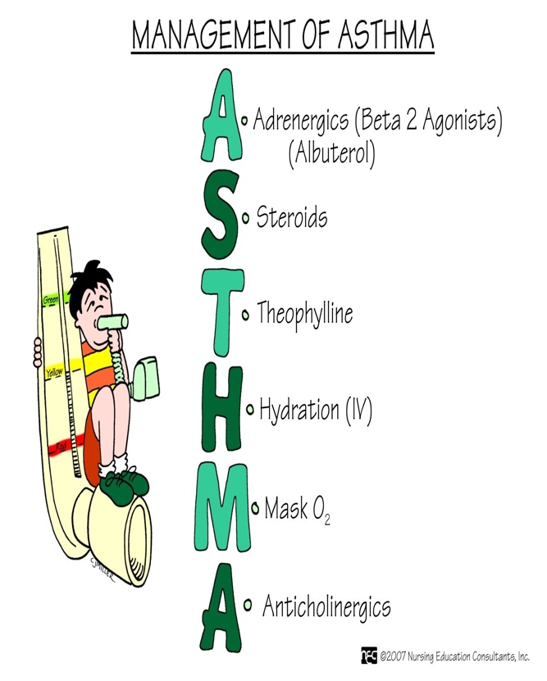
Care of patient with asthma, treatments, diagnostic procedures, and nursing actions
-chronic airway inflammation: airway edema, mucous hypersecretion, formation of mucous plugs
-S/s: cough, chest tightness, wheezing, dyspnea
-Testing: sputum and blood test, serum levels of IgE if allergy, ABG
-Treatment: corticosteroids – most effective anti-inflammatories (theophylline)

COPD/ signs and symptoms/ diagnostic procedures, treatments, and nursing interventions
-slowly progressive respiratory disease of airflow obstruction involving the airways, pulmonary parenchyma, or both.
*characterized by airflow limitation or obstruction that is not fully reversible
-Treatment: inhaled bronchodilator, non invasive ventilation, corticosteroids (roflumilast, macrolides), smoking cessation, physical activity, vaccination. Diagnosis and treatment of comorbidities
-Diagnosis: ABG, chest xray, CT

SPIROMETRY TEST | NORMAL | ABNORMAL
FVC and FEV1 | Equal to or greater than 80% | Mild 70-79%  Moderate 60-69%  Severe less than 60%
FEV1/FVC | Equal to or greater than 70% | Mild 60-69%  Moderate 50-59%  Severe less than 50%

-Obstructive lung disease is FEV1/FVC ration of less than 70%

Emphysema signs and symptoms, nursing interventions
-impaired gas exchanged because of alveolar wall damage
-S/s: increased CO2 retention, minimal cyanosis, purse lip breathing, dyspnea, orthopneic, barrel chest, exertional dyspnea, anxious, speaks in short jerky sentences, thin appearance, use of accessory muscles to breath.

Bronchitis: signs and symptoms/ diagnostic tests/ medical managements, medication, and nursing intervention
-disease of the airway with presence of cough and sputum production for at least 3 months in each of 2 consecutive years
-increased mucous production, thickened bronchial walls, alveolar damage, more susceptible to respiratory infection,
-S/s: dusky to cyanotic, recurrent cough and sputum, hypoxia, hypercapnia, acidosis, edematous, increased RR, exertional dyspnea, digital clubbing, cardiac enlargement, use of accessory muscles to breath, crackles, wheezing

Gastritis: signs and symptoms, pathophysiology, diagnostic procedures, medical managements, and nursing intervention
-localized or patchy inflammation of the gastric mucosa or stomach lining
-can be acute or chronic
-GI mucosa damaged by NSAIDS, aspirin, alcohol, most common cause is infection from H Pylori
-Gastritis prohibits absorption of B12 which leads to pernicious anemia.
*Schilling test = B12
-patho: the mucosal barrier is penetrated, hydrochloric aids comes in contact with mucosa, injury to small vessels, edema, hemorrhage, and possible ulcer formation
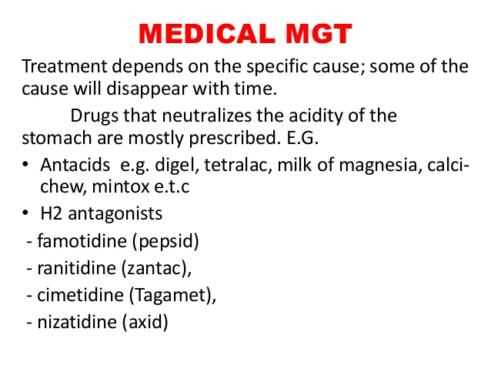
-S/s: epigastric pain, n/v, weight loss, decreased appetite, changes in stool color, anorexia, feeling of fullness, black tarry stools
-Diagnostic procedures: upper GI xray, upper GI endoscopy, stool test, urea breath test for h pylori, CBC to check for anemia
-med management: GI rest: 6-12 hours NPO and then slowly introduce clear liquids followed by heavier liquids and gradual introduction of solid foods.
  - Esomeprazole, lansoprazole, or pantoprazole 30 to 60 mg intravenously twice daily may be given initially, increased as necessary to maintain intragastric pH greater than 4.
  - Administer H₂-receptor antagonists: Block gastric secretions.
  - Administer antacids as prescribed: Buffering agents to correct pH balance of acidic gastric environment.
  - Administer PPIs as prescribed: ¬Antisecretory agents to suppress gastric acid secretion.

Peptic ulcers, signs and symptoms, diagnostics procedure/ medical management/risk factors/ complications/ surgical management and diet
-an ulcer is a break in the lining of the mucosa
-peptic ulcers and erosion in the stomach and duodenum
-2 types: duodenal make up 80% and gastric 5-10%

Gastric cancer: risk factors, signs and symptoms, clinical manifestation, treatments, diagnostic tests, medication and surgical management, nursing interventions and complication

Gastroesophageal Reflux Disease (GERD): Clinical Manifestations of Gerd, medical managements/medications, diet and nursing management

Hernias; Types of Hernias and clinical manifestation, medical and surgical management, nursing intervention and teaching.

Appendicitis; Pathophysiology, Clinical Manifestations diagnostic findings and medical managements;

Nursing Interventions,

Diverticulitis; Pathophysiology, Clinical Manifestations; risk factors; medical management

Diverticulosis; clinical manifestation of diverticulosis. Medical management, diet

Irritable Bowel Syndrome; clinical manifestation and management, treatment for IBS Dietary Modification

Crohn’s Disease; Diagnostic Findings.

Ulcerative Colitis; Diagnostics findings, medical management, medications, nutrition, complication nursing interventions
IBS and IBD; signs and symptoms, pathophysiology

COLORECTAL CANCER; Risk factors for colorectal cancer, Pathophysiology; Clinical Manifestations; signs and symptoms Diagnostic Studies for Colorectal Cancer, treatments and nursing intervention

Intestinal Obstruction; clinical manifestation, nursing intervention medical management

Know pre-and post-procedures nursing interventions for the following:
  - UGI
  - BE-enema
  - Colonoscopy
  - Endoscopy

Hematocrit: men 41-50% women 36-48
Hemoglobin: men 14-18g/100mL women12-16g/100mL
WBC: 4500-11,000
BUN: 10-31 mg/dL
Common Respiratory Medications
- Acetylcysteine (Mucomyst)
- Guaifenesin (Robitussin)
- Codeine
- Hydrocodone bitartrate (Hycodan)
- Diphenhydramine HCL (Benadryl)
- Promethazine HCL (Phenergan)
- Methyprednisone (Solumedrol)
- Acetylcysteine (Mucomyst)
- Guaifenesin (Robitussin)
- Codeine
- Hydrocodone bitartrate (Hycodan)
- Diphenhydramine HCL (Benadryl)
- Promethazine HCL (Phenergan)
- Methyprednisone (Solumedrol)
Book Notes
Chapter 17
Ventilation: movement of air in and out of the airways
Upper respiratory tract – (upper airway) warms and filters inhaled air
-Nose: filters impurities and warms inhaled air
-Paranasal sinuses
-Pharynx, tonsils, and adenoids

Lower respiratory tract – (lungs) gas exchange and diffusion

